2026

MPLS & VPLS Backbone Design based on Islington College Using GNS3 and MikroTik

MPLS & VPLS

**SUBASH SUBEDI**

Project@suashsubedi0.com.np

**Scenario**

Islington College operates a multi-block campus network consisting of 9 academic and administrative blocks. The college owns a public IPv4 address range (160.30.132.0/24), which must be used for router loopback interfaces within an MPLS backbone.

We are required to design, implement, and verify an MPLS-based core network using MikroTik routers in GNS3, providing VPLS-based Layer-2 connectivity across all blocks while using a centralized DHCP server.

The LONDON_BLOCK is the main block, connected to the Internet (ISP), and all other blocks connect to it directly and via additional mesh links for redundancy and load balancing.

**Network Architecture and IP Addressing Plan:**

Core Design

* All block routers act as MPLS core routers
* OSPF is the IGP across all routers
* MPLS with LDP must be enabled on all core and mesh links
* ECMP / Load balancing must be implemented
* VPLS must be used to extend VLANs across all blocks
* No DHCP service should run on any router

Use the following explicit IP addressing scheme. All loopback addresses are from the public IPv4 range 160.30.132.0/24 (160.30.132.0 to 160.30.132.255). Do not use any other IPs for loopbacks or links.

**Block Routers and Loopback IPs**

* LONDON_BLOCK (main block, connected to ISP): Loopback IP 160.30.132.1/32
* UK_BLOCK: Loopback IP 160.30.132.11/32
* NEPAL_BLOCK: Loopback IP 160.30.132.12/32
* HIMAL_BLOCK: Loopback IP 160.30.132.13/32
* BRIT_BLOCK: Loopback IP 160.30.132.14/32
* SKILL_BLOCK: Loopback IP 160.30.132.15/32
* ALUMNI_BLOCK: Loopback IP 160.30.132.16/32
* KUMARI _BLOCK: Loopback IP 160.30.132.17/32

**Point-to-Point Links from LONDON_BLOCK (Private IPs, /30 subnets):**

* LONDON_BLOCK to UK_BLOCK: 10.0.0.0/30 (LONDON_BLOCK: 10.0.0.1, UK_BLOCK: 10.0.0.2)
* LONDON_BLOCK to NEPAL_BLOCK: 10.0.0.4/30 (LONDON_BLOCK: 10.0.0.5, NEPAL_BLOCK: 10.0.0.6)
* LONDON_BLOCK to HIMAL_BLOCK: 10.0.0.8/30 (LONDON_BLOCK: 10.0.0.9, HIMAL_BLOCK: 10.0.0.10)
* LONDON_BLOCK to BRIT_BLOCK: 10.0.0.12/30 (LONDON_BLOCK: 10.0.0.13, BRIT_BLOCK: 10.0.0.14)
* LONDON_BLOCK to SKILL_BLOCK: 10.0.0.16/30 (LONDON_BLOCK: 10.0.0.17, SKILL_BLOCK: 10.0.0.18)
* LONDON_BLOCK to KUMARI_BLOCK: 10.0.0.20/30 (LONDON_BLOCK: 10.0.0.21, KUMARI_BLOCK: 10.0.0.22)
* LONDON_BLOCK to ALUMNI_BLOCK: 10.0.0.24/30 (LONDON_BLOCK: 10.0.0.25, ALUMNI_BLOCK: 10.0.0.26)

**Mesh Connections (Router-to-Router Private IPs, /30 subnets for redundancy):**

* UK_BLOCK to NEPAL_BLOCK: 10.0.0.28/30 (UK_BLOCK: 10.0.0.29, NEPAL_BLOCK: 10.0.0.30)
* UK_BLOCK to HIMAL_BLOCK: 10.0.0.32/30 (UK_BLOCK: 10.0.0.34, HIMAL_BLOCK: 10.0.0.33)
* NEPAL_BLOCK to BRIT_BLOCK: 10.0.0.36/30 (NEPAL_BLOCK: 10.0.0.37, BRIT_BLOCK: 10.0.0.38)
* HIMAL_BLOCK to SKILL_BLOCK: 10.0.0.40/30 (HIMAL_BLOCK: 10.0.0.42, SKILL_BLOCK: 10.0.0.41)
* BRIT_BLOCK to KUMARI_BLOCK: 10.0.0.44/30 (BRIT_BLOCK: 10.0.0.46, KUMARI_BLOCK: 10.0.0.45)
* SKILL_BLOCK to ALUMNI_BLOCK: 10.0.0.48/30 (SKILL_BLOCK: 10.0.0.50, ALUMNI_BLOCK: 10.0.0.49)
* ALUMNI_BLOCK to KUMARI_BLOCK: 10.0.0.52/30 (ALUMNI_BLOCK: 10.0.0.53, KUMARI_BLOCK: 10.0.0.54)

**VLANs and End-Device Subnets (Provided by Centralized DHCP):**

* VLAN 100 (STUDENT): 172.16.0.0/19 (capacity for 5,000 student IPs)
* VLAN 200 (TEACHER): 172.16.32.0/19 (capacity for 1,000 teacher IPs)
* VLAN 300 (STAFF): 172.16.36.0/21 (capacity for 2,000 staff IPs)

**Table of Contents**

1. Set Identity, Loopback Address and RoMON to all Routers 1

1.1. LONDON-BLOCK 1

1.2. UK-BLOCK 1

1.3. NEPAL-BLOCK 2

1.4. HIMAL-BLOCK 3

1.5. BRIT-BLOCK 4

1.6. SKILL-BLOCK 5

1.7. ALUMNI-BLOCK 5

1.8. KUMARI-BLOCK 6

2. Set description on the Interface to all router 8

2.1. LONDON-BLOCK 8

2.2. UK-BLOCK 8

2.3. NEPAL-BLOCK 8

2.4. HIMAL-BLOCK 8

2.5. BRIT-BLOCK 9

2.6. SKILL-BLOCK 9

2.7. ALUMNI-BLOCK 9

2.8. KUMARI-BLOCK 10

3. Configuration IP in the Core Interface of all Routers 11

3.1. LONDON-BLOCK 11

3.2. UK-BLOCK 13

3.3. NEPAL-BLOCK 13

3.4. HIMAL-BLOCK 14

3.5. BRIT-BLOCK 15

3.6. SKILL-BLOCK 16

3.7. ALUMNI-BLOCK 17

3.8. KUMARI-BLOCK 18

4. Configuration OSPF to all Core Routers 20

4.1. LONDON-BLOCK 20

4.2. UK-BLOCK 23

4.3. NEPAL-BLOCK 25

4.4. HIMAL-BLOCK 27

4.5. BRIT-BLOCK 29

4.6. SKILL-BLOCK 31

4.7. ALUMNI-BLOCK 33

4.8. KUMARI-BLOCK 35

5. Configure Management Access from PC to MPLS Loopback 37

5.1. PC (VMware Host) – Static Route Configuration 37

5.2. UK-BLOCK – OSPF Configuration (No Management Network Advertisement) 37

5.3. Disable RoMON temporarily to avoid confusion 38

5.4. End-to-End Verification (From PC) 38

6. Configuration MPLS to all Core Routers 39

6.1. LONDON-BLOCK 39

6.2. UK-BLOCK 39

6.3. NEPAL-BLOCK 40

6.4. HIMAL-BLOCK 41

6.5. BRIT-BLOCK 42

6.6. SKILL-BLOCK 42

6.7. ALUMNI-BLOCK 43

6.8. KUMARI-BLOCK 44

7. MPLS & LDP Configuration on Core Interfaces (with MTU) 45

7.1. LONDON-BLOCK 45

7.1.1. Enable LDP on Core Interfaces ONLY 45

7.1.2. Enable MPLS & Set MPLS MTU on interfaces 46

7.2. UK-BLOCK 47

7.2.1. Enable LDP on Core Interfaces ONLY 47

7.2.2. Enable MPLS & Set MPLS MTU on interfaces 47

7.3. NEPAL-BLOCK 48

7.3.1. Enable LDP on Core Interfaces ONLY 48

7.3.2. Enable MPLS & Set MPLS MTU on interfaces 49

7.4. HIMAL-BLOCK 50

7.4.1. Enable LDP on Core Interfaces ONLY 50

7.4.2. Enable MPLS & Set MPLS MTU on interfaces 50

7.5. BRIT-BLOCK 51

7.5.1. Enable LDP on Core Interfaces ONLY 51

7.5.2. Enable MPLS & Set MPLS MTU on interfaces 52

7.6. SKILL-BLOCK 53

7.6.1. Enable LDP on Core Interfaces ONLY 53

7.6.2. Enable MPLS & Set MPLS MTU on interfaces 54

7.7. ALUMNI-BLOCK 55

7.7.1. Enable LDP on Core Interfaces ONLY 55

7.7.2. Enable MPLS & Set MPLS MTU on interfaces 56

7.8. KUMARI-BLOCK 57

7.8.1. Enable LDP on Core Interfaces ONLY 57

7.8.2. Enable MPLS & Set MPLS MTU on interfaces 58

8. VPLS Configuration for VLAN Transport (Points to Points) Routers 60

8.1. LONDON-BLOCK 60

8.1.1. Create VPLS BRIDGES (L2 DOMAINS) 60

8.1.2. VPLS Full-Mesh for LONDON-BLOCK 60

8.2. UK-BLOCK 62

8.2.1. Create VPLS BRIDGES (L2 DOMAINS) 62

8.2.2. VPLS Full-Mesh for UK-BLOCK 62

8.3. NEPAL-BLOCK 64

8.3.1. Create VPLS BRIDGES (L2 DOMAINS) 64

8.3.2. VPLS Full-Mesh for NEPAL-BLOCK 64

8.4. HIMAL-BLOCK 66

8.4.1. Create VPLS BRIDGES (L2 DOMAINS) 66

8.4.2. VPLS Full-Mesh for HIMAL-BLOCK 66

8.5. BRIT-BLOCK 68

8.5.1. Create VPLS BRIDGES (L2 DOMAINS) 68

8.5.2. VPLS Full-Mesh for BRIT-BLOCK 68

8.6. SKILL-BLOCK 70

8.6.1. Create VPLS BRIDGES (L2 DOMAINS) 70

8.6.2. VPLS Full-Mesh for SKILL-BLOCK 70

8.7. ALUMNI-BLOCK 72

8.7.1. Create VPLS BRIDGES (L2 DOMAINS) 72

8.7.2. VPLS Full-Mesh for ALUMNI-BLOCK 72

8.8. KUMARI-BLOCK 74

8.8.1. Create VPLS BRIDGES (L2 DOMAINS) 74

8.8.2. VPLS Full-Mesh for KUMARI -BLOCK 74

9. Switch TO Router Configuration of Each Block 77

9.1. LONDON-BLOCK 77

9.2. UK-BLOCK 79

9.3. NEPAL-BLOCK 82

9.4. HIMAL-BLOCK 85

9.5. BRIT-BLOCK 88

9.6. SKILL-BLOCK 91

9.7. ALUMNI-BLOCK 91

9.8. KUMARI-BLOCK 91

10. Router TO Switch Configuration of Each Block 92

10.1. LONDON-BLOCK 92

10.2. UK-BLOCK 92

10.2.1. UK-BLOCK (VLAN 100 ACTIVE HERE) 92

10.2.2. NEPAL-BLOCK (VLAN 200 & 300 ACTIVE HERE) 92

10.3. NEPAL-BLOCK 93

10.4. HIMAL-BLOCK 93

10.5. BRIT-BLOCK 93

10.6. SKILL-BLOCK 93

10.7. ALUMNI-BLOCK 93

10.8. KUMARI-BLOCK 93

11. Centralized DHCP Server Configuration 93

11.1. LONDON-BLOCK 93

11.2. UK-BLOCK 93

11.3. NEPAL-BLOCK 94

11.4. HIMAL-BLOCK 94

11.5. BRIT-BLOCK 94

11.6. SKILL-BLOCK 94

11.7. ALUMNI-BLOCK 94

11.8. KUMARI-BLOCK 94

12. Redundancy and Load Balancing 95

12.1. LONDON-BLOCK 95

12.2. UK-BLOCK 95

12.3. NEPAL-BLOCK 95

12.4. HIMAL-BLOCK 95

12.5. BRIT-BLOCK 95

12.6. SKILL-BLOCK 95

12.7. ALUMNI-BLOCK 95

12.8. KUMARI-BLOCK 95

13. End-to-End Verification and Traffic Analysis 96

13.1. LONDON-BLOCK 96

13.2. UK-BLOCK 96

13.3. NEPAL-BLOCK 96

13.4. HIMAL-BLOCK 96

13.5. BRIT-BLOCK 96

13.6. SKILL-BLOCK 96

13.7. ALUMNI-BLOCK 96

13.8. KUMARI-BLOCK 96

14. Network Topology and Diagrams 97

14.1. Full Network Topology Diagram 97

14.2. MPLS LSP Paths Illustration 97

14.3. VPLS VLAN Extension Diagram 97

15. Troubleshooting Guide 97

15.1. Common OSPF Issues 97

15.2. MPLS / LDP Problems 97

15.3. VPLS VLAN Bridging Errors 97

15.4. DHCP Failures 97

15.5. ECMP / Load Balancing Verification Tips 97

16. Security and Access Control 97

16.1. Management Access (SSH / Winbox) 97

16.2. ACLs / Firewall Rules for Router Interfaces 97

17. 98

18. Conclusion and Future Enhancements 98

19. a 98

**List of Figures**

Figure 1: Set Identity, Loopback Address and RoMoN of LONDON_BLOCK Router Through CMD 1

Figure 2: Set Identity, Loopback Address and RoMoN of LONDON_BLOCK Router Through WINBOX 1

Figure 3: Set Identity, Loopback Address and RoMoN of UK-BLOCK Router Through CMD 2

Figure 4: Set Identity, Loopback Address and RoMoN of UK-BLOCK Router Through WINBOX 2

Figure 5: Set Identity, Loopback Address and RoMoN of NEPAL-BLOCK Router Through CMD 3

Figure 6: Set Identity, Loopback Address and RoMoN of NEPAL-BLOCK Router Through WINBOX 3

Figure 7: Set Identity, Loopback Address and RoMoN of NEPAL-BLOCK Router Through CMD 4

Figure 8: Set Identity, Loopback Address and RoMoN of NEPAL-BLOCK Router Through WINBOX 4

Figure 9: Set Identity, Loopback Address and RoMoN of BRIT-BLOCK Router Through CMD 4

Figure 10: Set Identity, Loopback Address and RoMoN of BRIT-BLOCK Router Through WINBOX 5

Figure 11: Set Identity, Loopback Address and RoMoN of SKILL-BLOCK Router Through CMD 5

Figure 12: Set Identity, Loopback Address and RoMoN of SKILL-BLOCK Router Through WINBOX 5

Figure 13: Set Identity, Loopback Address and RoMoN of ALUMNI-BLOCK Router Through CMD 6

Figure 14: Set Identity, Loopback Address and RoMoN of ALUMNI-BLOCK Router Through WINBOX 6

Figure 15: Set Identity, Loopback Address and RoMoN of KUMARI-BLOCK Router Through CMD 6

Figure 16: Set Identity, Loopback Address and RoMoN of KUMARI-BLOCK Router Through WINBOX 7

Figure 17: Configuration IP in the Core Interface of LONDON-BLOCK Router Through CMD 11

Figure 18: Configuration IP in the Core Interface of LONDON-BLOCK Router Through WINBOX 12

Figure 19: Configuration IP in the Core Interface of UK-BLOCK Router Through CMD 13

Figure 20: Configuration IP in the Core Interface of UK-BLOCK Router Through WINBOX 13

Figure 21: Configuration IP in the Core Interface of NEPAL-BLOCK Router Through CMD 14

Figure 22: Configuration IP in the Core Interface of NEPAL-BLOCK Router Through WINBOX 14

Figure 23: Configuration IP in the Core Interface of HIMAL-BLOCK Router Through CMD 15

Figure 24: Configuration IP in the Core Interface of HIMAL-BLOCK Router Through WINBOX 15

Figure 25: Configuration IP in the Core Interface of BRIT-BLOCK Router Through CMD 15

Figure 26: Configuration IP in the Core Interface of BRIT-BLOCK Router Through WINBOX 16

Figure 27: Configuration IP in the Core Interface of SKILL-BLOCK Router Through CMD 16

Figure 28: Configuration IP in the Core Interface of SKILL-BLOCK Router Through WINBOX 17

Figure 29: Configuration IP in the Core Interface of ALUMNI-BLOCK Router Through CMD 17

Figure 30: Configuration IP in the Core Interface of ALUMNI-BLOCK Router Through WINBOX 18

Figure 31: Configuration IP in the Core Interface of KUMARI-BLOCK Router Through CMD 18

Figure 32: Configuration IP in the Core Interface of KUMARI-BLOCK Router Through WINBOX 19

Figure 33: Configuration OSPF to Core LONDON-BLOCK Router Through CMD 21

Figure 34: Configuration OSPF Instances to Core LONDON-BLOCK Router Through WINBOX 22

Figure 35: Configuration OSPF Area to Core LONDON-BLOCK Router Through WINBOX 22

Figure 36: Configuration OSPF Interface-template to Core LONDON-BLOCK Router Through WINBOX 22

Figure 37: Configuration OSPF to UK-BLOCK Router Through CMD 23

Figure 38: Configuration OSPF Instances to UK-BLOCK Router Through WINBOX 24

Figure 39: Configuration OSPF Area to UK-BLOCK Router Through WINBOX 24

Figure 40: Configuration OSPF Interface-template to UK-BLOCK Router Through WINBOX 24

Figure 41: Configuration OSPF to NEPAL-BLOCK Router Through CMD 25

Figure 42: Configuration OSPF Instances to NEPAL-BLOCK Router Through WINBOX 26

Figure 43: Configuration OSPF Area to NEPAL-BLOCK Router Through WINBOX 26

Figure 44: Configuration OSPF Interface-template to NEPAL-BLOCK Router Through WINBOX 26

Figure 45: Configuration OSPF to HIMAL-BLOCK Router Through CMD 27

Figure 46: Configuration OSPF Instances to HIMAL-BLOCK Router Through WINBOX 28

Figure 47: Configuration OSPF Area to HIMAL-BLOCK Router Through WINBOX 28

Figure 48: Configuration OSPF Interface-template to HIMAL-BLOCK Router Through WINBOX 28

Figure 49: Configuration OSPF to BRIT-BLOCK Router Through CMD 29

Figure 50: Configuration OSPF Instances to BRIT-BLOCK Router Through WINBOX 30

Figure 51: Configuration OSPF Area to BRIT-BLOCK Router Through WINBOX 30

Figure 52: Configuration OSPF Interface-template to BRIT-BLOCK Router Through WINBOX 30

Figure 53: Configuration OSPF to SKILL-BLOCK Router Through CMD 31

Figure 54: Configuration OSPF Instances to SKILL-BLOCK Router Through WINBOX 32

Figure 55: Configuration OSPF Area to SKILL-BLOCK Router Through WINBOX 32

Figure 56: Configuration OSPF Interface-template to SKILL-BLOCK Router Through WINBOX 32

Figure 57: Configuration OSPF to ALUMNI-BLOCK Router Through CMD 33

Figure 58: Configuration OSPF Instances to ALUMNI-BLOCK Router Through WINBOX 34

Figure 59: Configuration OSPF Area to ALUMNI-BLOCK Router Through WINBOX 34

Figure 60: Configuration OSPF Interface-template to ALUMNI-BLOCK Router Through WINBOX 34

Figure 61: Configuration OSPF to KUMARI-BLOCK Router Through CMD 35

Figure 62: Configuration OSPF Instances to KUMARI-BLOCK Router Through WINBOX 36

Figure 63: Configuration OSPF Area to KUMARI-BLOCK Router Through WINBOX 36

Figure 64: Configuration OSPF Interface-template to KUMARI-BLOCK Router Through WINBOX 36

Figure 65: Configuration MPLS to LONDON-BLOCK Router Through CMD 39

Figure 66: Configuration MPLS to LONDON-BLOCK Router Through WINBOX 39

Figure 67: Configuration MPLS to UK-BLOCK Router Through CMD 40

Figure 68: Configuration MPLS to UK-BLOCK Router Through WINBOX 40

Figure 69: Configuration MPLS to NEPAL-BLOCK Router Through CMD 40

Figure 70: Configuration MPLS to NEPAL-BLOCK Router Through WINBOX 41

Figure 71: Configuration MPLS to HIMAL-BLOCK Router Through CMD 41

Figure 72: Configuration MPLS to HIMAL-BLOCK Router Through WINBOX 41

Figure 73: Configuration MPLS to BRIT-BLOCK Router Through CMD 42

Figure 74: Configuration MPLS to BRIT-BLOCK Router Through WINBOX 42

Figure 75: Configuration MPLS to SKILL-BLOCK Router Through CMD 42

Figure 76: Configuration MPLS to SKILL-BLOCK Router Through WINBOX 43

Figure 77: Configuration MPLS to ALUMNI-BLOCK Router Through CMD 43

Figure 78: Configuration MPLS to ALUMNI-BLOCK Router Through WINBOX 44

Figure 79: Configuration MPLS to KUMARI-BLOCK Router Through CMD 44

Figure 80: Configuration MPLS to KUMARI-BLOCK Router Through CMD 44

Figure 81: Configuration MPLS LDP Interfaces to LONDON-BLOCK Router Through CMD 45

Figure 82: Configuration MPLS LDP nterfaces to LONDON-BLOCK Router Through WINBOX 45

Figure 83: Configuration MPLS MTU on Interfaces to LONDON-BLOCK Router Through CMD 46

Figure 84: Configuration MPLS MTU on Interfaces to LONDON-BLOCK Router Through WINBOX 46

Figure 85: Configuration MPLS LDP Interfaces to UK-BLOCK Router Through CMD 47

Figure 86: Configuration MPLS LDP Interfaces to UK-BLOCK Router Through WINBOX 47

Figure 87: Configuration MPLS MTU on Interfaces to UK-BLOCK Router Through CMD 48

Figure 88: Configuration MPLS MTU on Interfaces to UK-BLOCK Router Through WINBOX 48

Figure 89: Configuration MPLS LDP Interfaces to NEPAL-BLOCK Router Through CMD 48

Figure 90: Configuration MPLS LDP Interfaces to NEPAL-BLOCK Router Through WINBOX 49

Figure 91: Configuration MPLS MTU on Interfaces to NEPAL-BLOCK Router Through CMD 49

Figure 92: Configuration MPLS MTU on Interfaces to NEPAL-BLOCK Router Through WINBOX 49

Figure 93: Configuration MPLS LDP Interfaces to HIMAL-BLOCK Router Through CMD 50

Figure 94: Configuration MPLS LDP Interfaces to HIMAL-BLOCK Router Through WINBOX 50

Figure 95: Configuration MPLS MTU on Interfaces to HIMAL-BLOCK Router Through CMD 51

Figure 96: Configuration MPLS MTU on Interfaces to HIMAL-BLOCK Router Through WINBOX 51

Figure 97: Configuration MPLS LDP Interfaces to BRIT-BLOCK Router Through CMD 51

Figure 98: Configuration MPLS LDP Interfaces to BRIT-BLOCK Router Through WINBOX 52

Figure 99: Configuration MPLS MTU on Interfaces to BRIT-BLOCK Router Through CMD 52

Figure 100: Configuration MPLS MTU on Interfaces to BRIT-BLOCK Router Through WINBOX 53

Figure 101: Configuration MPLS LDP Interfaces to SKILL-BLOCK Router Through CMD 53

Figure 102: Configuration MPLS LDP Interfaces to SKILL-BLOCK Router Through WINBOX 54

Figure 103: Configuration MPLS MTU on Interfaces to SKILL-BLOCK Router Through CMD 54

Figure 104: Configuration MPLS MTU on Interfaces to SKILL-BLOCK Router Through WINBOX\ 55

Figure 105: Configuration MPLS LDP Interfaces to ALUMNI-BLOCK Router Through CMD 55

Figure 106: Configuration MPLS LDP Interfaces to ALUMNI-BLOCK Router Through WINBOX 56

Figure 107: Configuration MPLS MTU on Interfaces to ALUMNI-BLOCK Router Through CMD 56

Figure 108: Configuration MPLS MTU on Interfaces to ALUMNI-BLOCK Router Through WINBOX 57

Figure 109: Configuration MPLS LDP Interfaces to KUMARI-BLOCK Router Through CMD 57

Figure 110: Configuration MPLS LDP Interfaces to KUMARI-BLOCK Router Through WINBOX 58

Figure 111: Configuration MPLS MTU on Interfaces to KUMARI-BLOCK Router Through CMD 58

Figure 112: Configuration MPLS MTU on Interfaces to KUMARI-BLOCK Router Through WINBOX 59

Figure 113: Configuration of Switch to Router Links at LONDON-BLOCK (i) 79

Figure 114: Configuration of Switch to Router Links at LONDON-BLOCK (ii) 79

Figure 115: Configuration of Switch to Router Links at UK-BLOCK (i) 82

Figure 116: Configuration of Switch to Router Links at UK-BLOCK (ii) 82

Figure 117: Configuration of Switch to Router Links at NEPAL-BLOCK (i) 85

Figure 118: Configuration of Switch to Router Links at NEPAL-BLOCK (ii) 85

Figure 119: Configuration of Switch to Router Links at HIMAL-BLOCK (i) 88

Figure 120: Configuration of Switch to Router Links at HIMAL-BLOCK (ii) 88

Figure 121: Configuration of Switch to Router Links at BRIT-BLOCK (i) 91

Figure 122: Configuration of Switch to Router Links at BRIT-BLOCK (ii) 91

**List of Tables**

# Set Identity, Loopback Address and RoMON to all Routers

## LONDON-BLOCK

**CMD**

|  |
| --- |
| /system identity set name=LONDON-BLOCK  /interface bridge add name=loopback comment="LONDON-BLOCK_160.30.132.1_LOOPBACK"  /ip address add address=160.30.132.1/32 interface=loopback comment="LONDON-BLOCK_160.30.132.1_LOOPBACK"  /tool/romon/set enabled=yes |

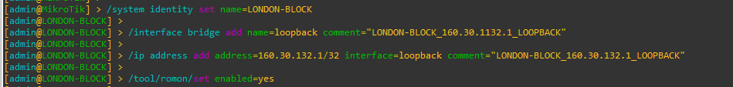

Figure 1: Set Identity, Loopback Address and RoMoN of LONDON_BLOCK Router Through CMD

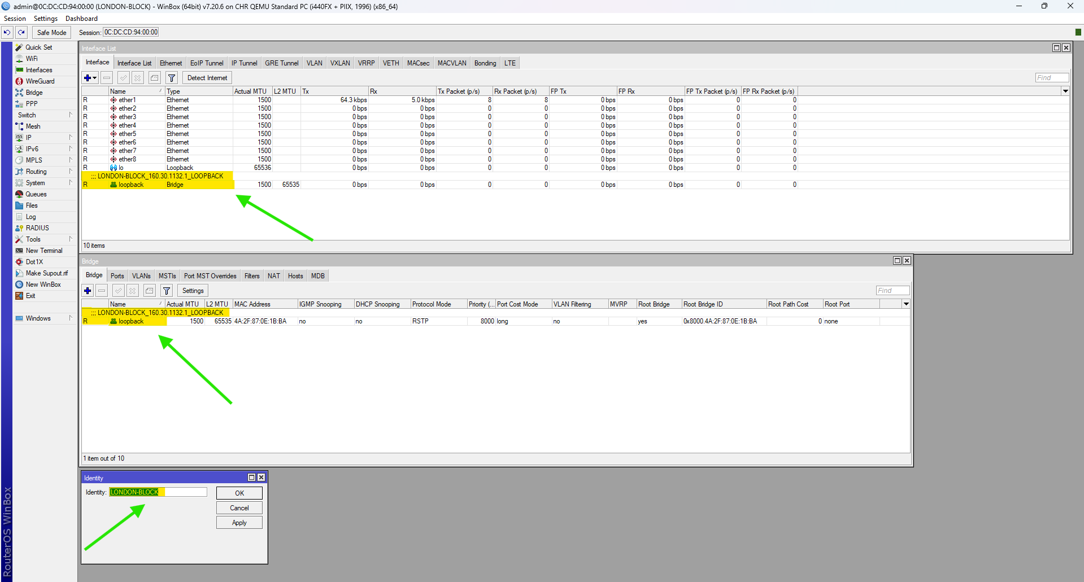

Figure 2: Set Identity, Loopback Address and RoMoN of LONDON_BLOCK Router Through WINBOX

## UK-BLOCK

**CMD**

|  |
| --- |
| /system identity set name= UK-BLOCK  /interface bridge add name=loopback comment=" UK-BLOCK_160.30.132.11_LOOPBACK"  /ip address add address=160.30.132.11/32 interface=loopback comment=" UK-BLOCK_160.30.132.11_LOOPBACK"  /tool/romon/set enabled=yes |

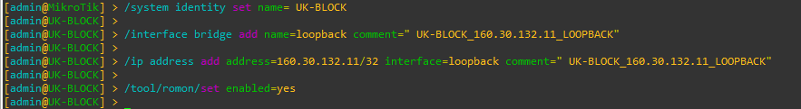

Figure 3: Set Identity, Loopback Address and RoMoN of UK-BLOCK Router Through CMD

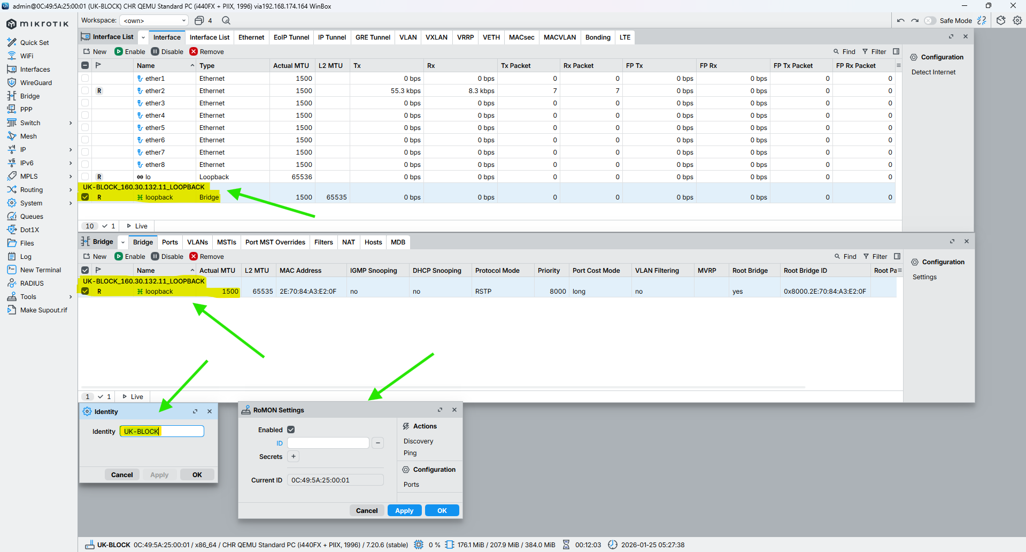

Figure 4: Set Identity, Loopback Address and RoMoN of UK-BLOCK Router Through WINBOX

## NEPAL-BLOCK

**CMD**

|  |
| --- |
| /system identity set name=NEPAL-BLOCK  /interface bridge add name=loopback comment="NEPAL-BLOCK_160.30.132.12_LOOPBACK"  /ip address add address=160.30.132.12/32 interface=loopback comment="NEPAL-BLOCK_160.30.132.12_LOOPBACK"  /tool/romon/set enabled=yes |

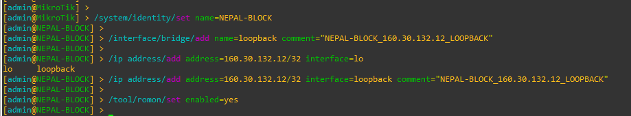

Figure 5: Set Identity, Loopback Address and RoMoN of NEPAL-BLOCK Router Through CMD

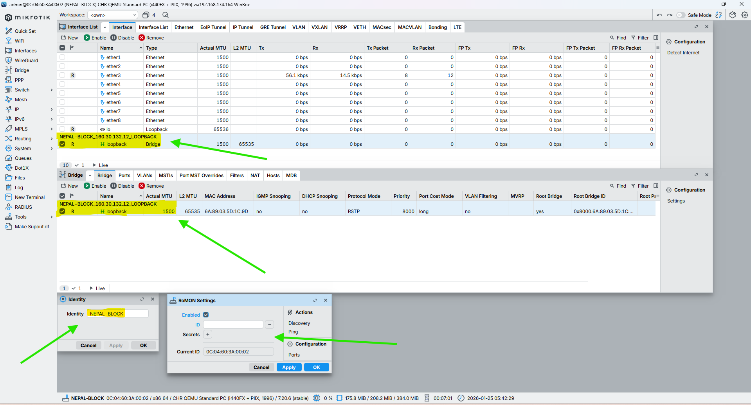

Figure 6: Set Identity, Loopback Address and RoMoN of NEPAL-BLOCK Router Through WINBOX

## HIMAL-BLOCK

**CMD**

|  |
| --- |
| /system identity set name=HIMAL-BLOCK  /interface bridge add name=loopback comment="HIMAL-BLOCK_160.30.132.13_LOOPBACK"  /ip address add address=160.30.132.13/32 interface=loopback comment="HIMAL-BLOCK_160.30.132.13_LOOPBACK"  /tool/romon/set enabled=yes |

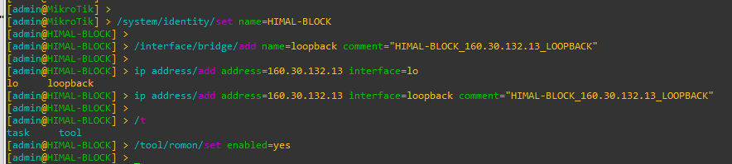

Figure 7: Set Identity, Loopback Address and RoMoN of NEPAL-BLOCK Router Through CMD

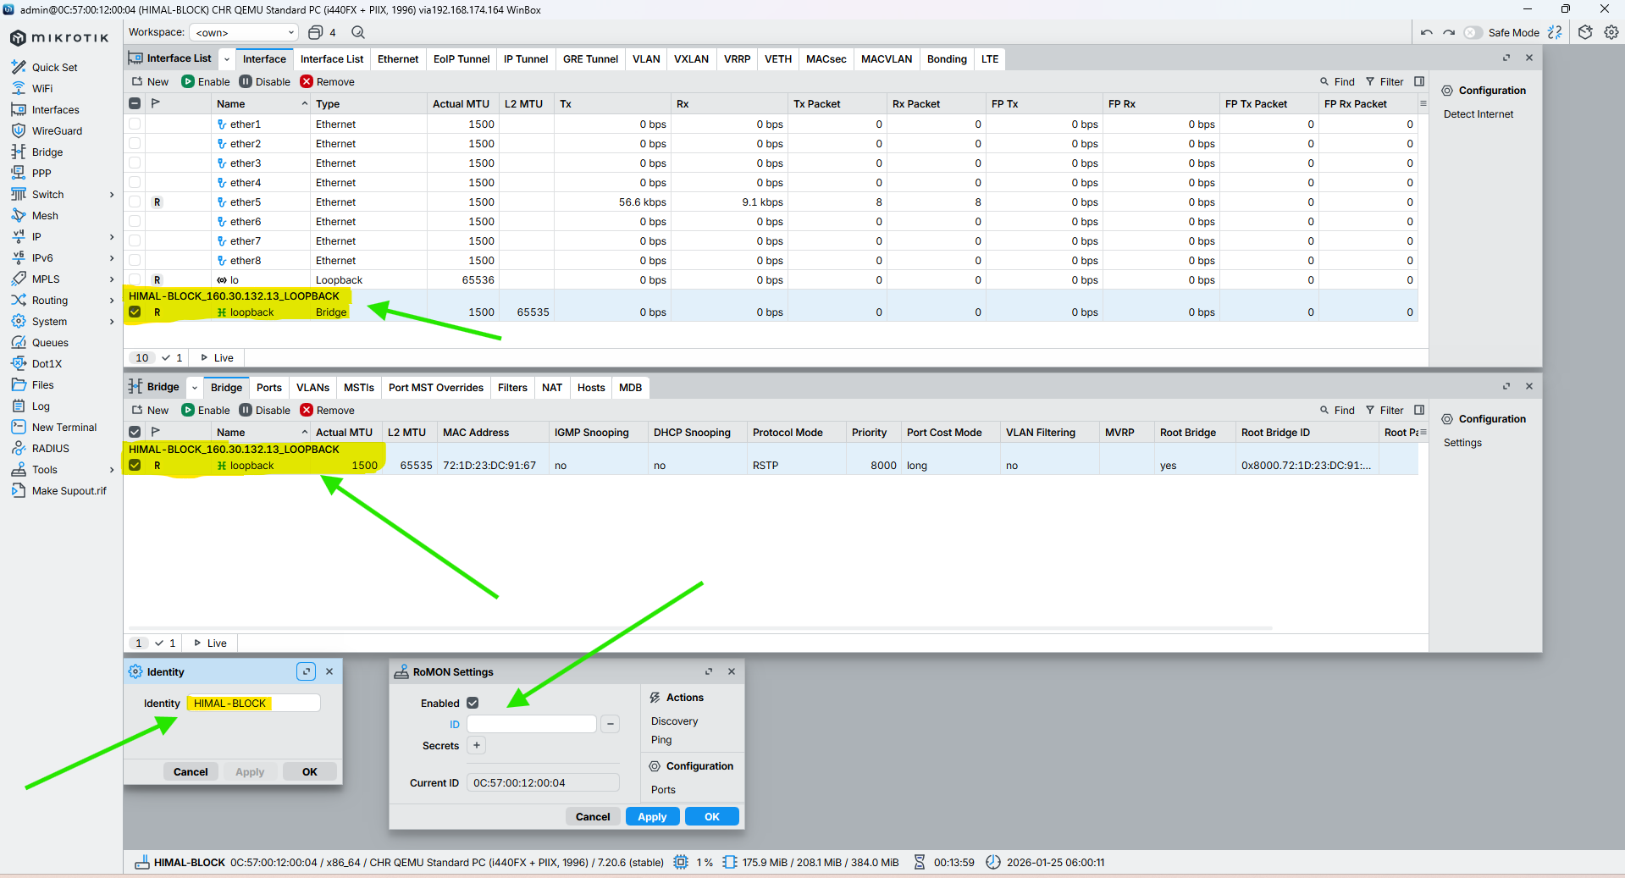

Figure 8: Set Identity, Loopback Address and RoMoN of NEPAL-BLOCK Router Through WINBOX

## BRIT-BLOCK

**CMD**

|  |
| --- |
| /system identity set name=BRIT-BLOCK  /interface bridge add name=loopback comment="BRIT-BLOCK_160.30.132.14_LOOPBACK"  /ip address add address=160.30.132.14/32 interface=loopback comment="BRIT-BLOCK_160.30.132.14_LOOPBACK"  /tool/romon/set enabled=yes |

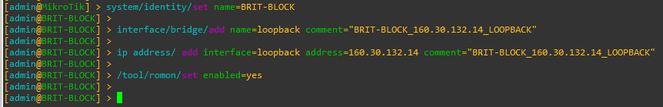

Figure 9: Set Identity, Loopback Address and RoMoN of BRIT-BLOCK Router Through CMD

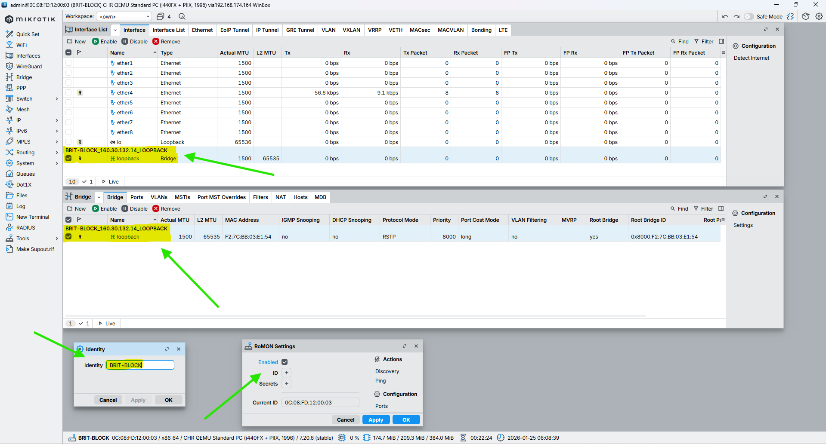

Figure 10: Set Identity, Loopback Address and RoMoN of BRIT-BLOCK Router Through WINBOX

## SKILL-BLOCK

**CMD**

|  |
| --- |
| /system identity set name=SKILL-BLOCK  /interface bridge add name=loopback comment="SKILL-BLOCK_160.30.132.15_LOOPBACK"  /ip address add address=160.30.132.15/32 interface=loopback comment="SKILL-BLOCK_160.30.132.15_LOOPBACK"  /tool/romon/set enabled=yes |

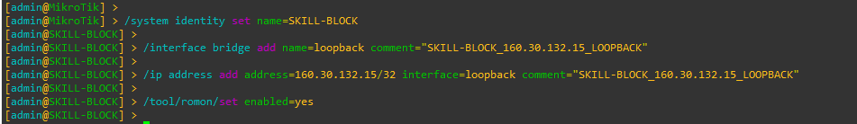

Figure 11: Set Identity, Loopback Address and RoMoN of SKILL-BLOCK Router Through CMD

Figure 12: Set Identity, Loopback Address and RoMoN of SKILL-BLOCK Router Through WINBOX

## ALUMNI-BLOCK

**CMD**

|  |
| --- |
| /system identity set name=ALUMNI-BLOCK  /interface bridge add name=loopback comment="ALUMNI-BLOCK_160.30.132.16_LOOPBACK"  /ip address add address=160.30.132.16/32 interface=loopback comment="ALUMNI-BLOCK_160.30.132.16_LOOPBACK"  /tool/romon/set enabled=yes |

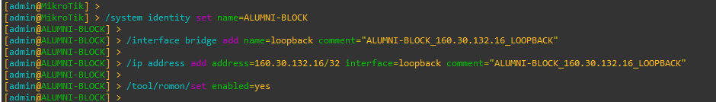

Figure 13: Set Identity, Loopback Address and RoMoN of ALUMNI-BLOCK Router Through CMD

Figure 14: Set Identity, Loopback Address and RoMoN of ALUMNI-BLOCK Router Through WINBOX

## KUMARI-BLOCK

**CMD**

|  |
| --- |
| /system identity set name=KUMARI-BLOCK  /interface bridge add name=loopback comment="KUMARI-BLOCK_160.30.132.17_LOOPBACK"  /ip address add address=160.30.132.17/32 interface=loopback comment="KUMARI-BLOCK_160.30.132.17_LOOPBACK"  /tool/romon/set enabled=yes |

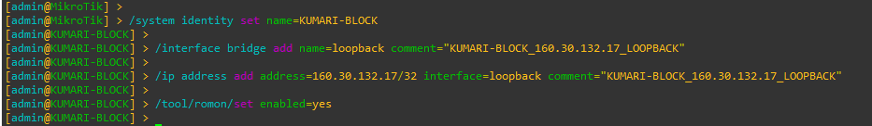

Figure 15: Set Identity, Loopback Address and RoMoN of KUMARI-BLOCK Router Through CMD

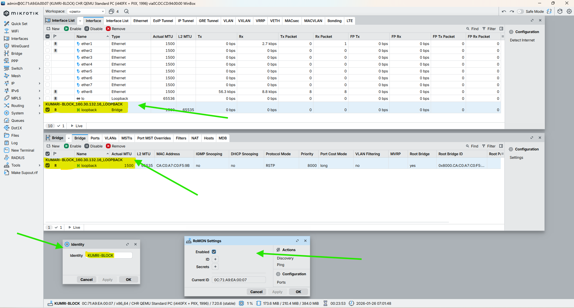

Figure 16: Set Identity, Loopback Address and RoMoN of KUMARI-BLOCK Router Through WINBOX

# Set description on the Interface to all router

## LONDON-BLOCK

CMD

|  |
| --- |
| /interface set ether2 comment="Link from LONDON-BLOCK (10.0.0.1/30) to UK-BLOCK (10.0.0.2/30)"  /interface set ether3 comment="Link from LONDON-BLOCK (10.0.0.5/30) to NEPAL-BLOCK (10.0.0.6/30)"  /interface set ether4 comment="Link from LONDON-BLOCK (10.0.0.9/30) to HIMAL-BLOCK (10.0.0.10/30)"  /interface set ether5 comment="Link from LONDON-BLOCK (10.0.0.13/30) to BRIT-BLOCK (10.0.0.14/30)"  /interface set ether6 comment="Link from LONDON-BLOCK (10.0.0.17/30) to SKILL-BLOCK (10.0.0.18/30)"  /interface set ether7 comment="Link from LONDON-BLOCK (10.0.0.21/30) to ALUMNI-BLOCK (10.0.0.22/30)"  /interface set ether8 comment="Link from LONDON-BLOCK (10.0.0.25/30) to KUMARI-BLOCK (10.0.0.26/30)"  /interface set ether9 comment="LAN / Management link from LONDON-BLOCK to Local Network (192.168.174.0/24)" |

## UK-BLOCK

CMD

|  |
| --- |
| /interface set ether2 comment="Link from UK-BLOCK (10.0.0.2/30) to LONDON-BLOCK (10.0.0.1/30)"  /interface set ether1 comment="Link from UK-BLOCK (10.0.0.29/30) to NEPAL-BLOCK (10.0.0.30/30)"  /interface set ether3 comment="Link from UK-BLOCK (10.0.0.34/30) to HIMAL-BLOCK (10.0.0.33/30)" |



## NEPAL-BLOCK

CMD

|  |
| --- |
| /interface set ether3 comment="Link from NEPAL-BLOCK (10.0.0.6/30) to LONDON-BLOCK (10.0.0.5/30)"  /interface set ether1 comment="Link from NEPAL-BLOCK (10.0.0.30/30) to UK-BLOCK (10.0.0.29/30)"  /interface set ether2 comment="Link from NEPAL-BLOCK (10.0.0.37/30) to BRIT-BLOCK (10.0.0.38/30)" |



## HIMAL-BLOCK

CMD

|  |
| --- |
| /interface set ether3 comment=”Link from HIMAL-BLOCK (10.0.0.33/30) to UK-BLOCK (10.0.0.34/30)”  /interface set ether4 comment=”Link from HIMAL-BLOCK (10.0.0.10/30) to LONDON-BLOCK (10.0.0.9/30)”  /interface set ether2 comment=”Link from HIMAL-BLOCK (10.0.0.42/30) to SKILL-BLOCK (10.0.0.41/30)” |



## BRIT-BLOCK

CMD

|  |
| --- |
| /interface set ether2 comment="Link from BRIT-BLOCK (10.0.0.38/30) to NEPAL-BLOCK (10.0.0.37/30)"  /interface set ether5 comment="Link from BRIT-BLOCK (10.0.0.14/30) to LONDON-BLOCK (10.0.0.13/30)"  /interface set ether1 comment="Link from BRIT-BLOCK (10.0.0.46/30) to KUMARI-BLOCK (10.0.0.44/30)" |



## SKILL-BLOCK

CMD

|  |
| --- |
| /interface set ether2 comment="Link from SKILL-BLOCK (10.0.0.41/30) to HIMAL-BLOCK (10.0.0.42/30)"  /interface set ether6 comment="Link from SKILL-BLOCK (10.0.0.18/30) to LONDON-BLOCK (10.0.0.17/30)"  /interface set ether1 comment="Link from SKILL-BLOCK (10.0.0.50/30) to KUMARI-BLOCK (10.0.0.49/30)" |



## ALUMNI-BLOCK

CMD

|  |
| --- |
| /interface set ether7 comment="Link from ALUMNI-BLOCK (10.0.0.22/30) to LONDON-BLOCK (10.0.0.21/30)"  /interface set ether1 comment="Link from ALUMNI-BLOCK (10.0.0.49/30) to SKILL-BLOCK (10.0.0.50/30)"  /interface set ether2 comment="Link from ALUMNI-BLOCK (10.0.0.53/30) to KUMARI-BLOCK (10.0.0.54/30)" |



## KUMARI-BLOCK

CMD

|  |
| --- |
| /interface set ether8 comment=”Link from KUMARI-BLOCK (10.0.0.26/30) to LONDON-BLOCK (10.0.0.25/30)”  /interface set ether2 comment=”Link from KUMARI-BLOCK (10.0.0.54/30) to ALUMNI-BLOCK (10.0.0.53/30)”  /interface set ether1 comment=”Link from KUMARI-BLOCK (10.0.0.44/30) to BRIT-BLOCK (10.0.0.46/30)” |



# Configuration IP in the Core Interface of all Routers

## LONDON-BLOCK

**CMD**

|  |
| --- |
| /ip address add address=10.0.0.1/30 interface=ether2 comment="NETWORK-ID_10.0.0.0/30_LINK_FROM_LONDON-BLOCK_10.0.0.1/30_TO_UK-BLOCK_10.0.0.2/30"  /ip address add address=10.0.0.5/30 interface=ether3 comment="NETWORK-ID_10.0.0.4/30_LINK_FROM_LONDON-BLOCK_10.0.0.5/30_TO_NEPAL-BLOCK_10.0.0.6/30"  /ip address add address=10.0.0.9/30 interface=ether4 comment="NETWORK-ID_10.0.0.8/30_LINK_FROM_LONDON-BLOCK_10.0.0.9/30_TO_HIMAL-BLOCK_10.0.0.10/30"  /ip address add address=10.0.0.13/30 interface=ether5 comment="NETWORK-ID_10.0.0.12/30_LINK_FROM_LONDON-BLOCK_10.0.0.13/30_TO_BRIT-BLOCK_10.0.0.14/30"  /ip address add address=10.0.0.17/30 interface=ether6 comment="NETWORK-ID_10.0.0.16/30_LINK_FROM_LONDON-BLOCK_10.0.0.17/30_TO_SKILL-BLOCK_10.0.0.18/30"  /ip address add address=10.0.0.21/30 interface=ether7 comment="NETWORK-ID_10.0.0.20/30_LINK_FROM_LONDON-BLOCK_10.0.0.21/30_TO_ALUMNI-BLOCK_10.0.0.22/30"  /ip address add address=10.0.0.25/30 interface=ether8 comment="NETWORK-ID_10.0.0.24/30_LINK_FROM_LONDON-BLOCK_10.0.0.25/30_TO_KUMARI-BLOCK_10.0.0.26/30" |

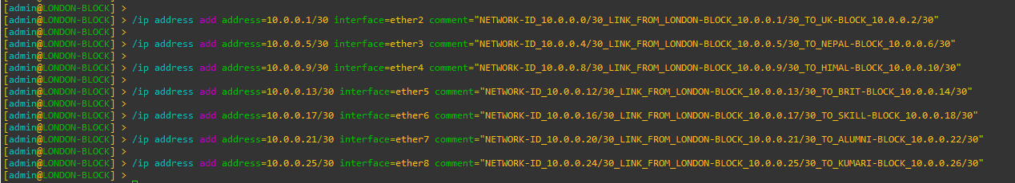

Figure 17: Configuration IP in the Core Interface of LONDON-BLOCK Router Through CMD

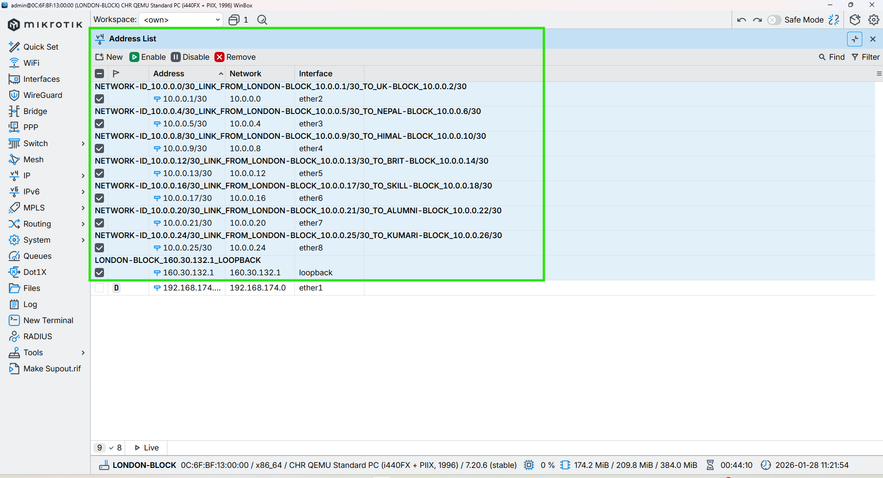

Figure 18: Configuration IP in the Core Interface of LONDON-BLOCK Router Through WINBOX

## UK-BLOCK

**CMD**

|  |
| --- |
| /ip address add address=10.0.0.2/30 interface=ether2 comment="NETWORK-ID_10.0.0.0/30_LINK_FROM_UK-BLOCK_10.0.0.2/30_TO_LONDON-BLOCK_10.0.0.1/30"  /ip address add address=10.0.0.29/30 interface=ether1 comment="NETWORK-ID_10.0.0.28/30_LINK_FROM_UK-BLOCK_10.0.0.29/30_TO_NEPAL-BLOCK_10.0.0.30/30"  /ip address add address=10.0.0.34/30 interface=ether3 comment="NETWORK-ID_10.0.0.32/30_LINK_FROM_UK-BLOCK_10.0.0.34/30_TO_HIMAL-BLOCK_10.0.0.33/30" |



Figure 19: Configuration IP in the Core Interface of UK-BLOCK Router Through CMD

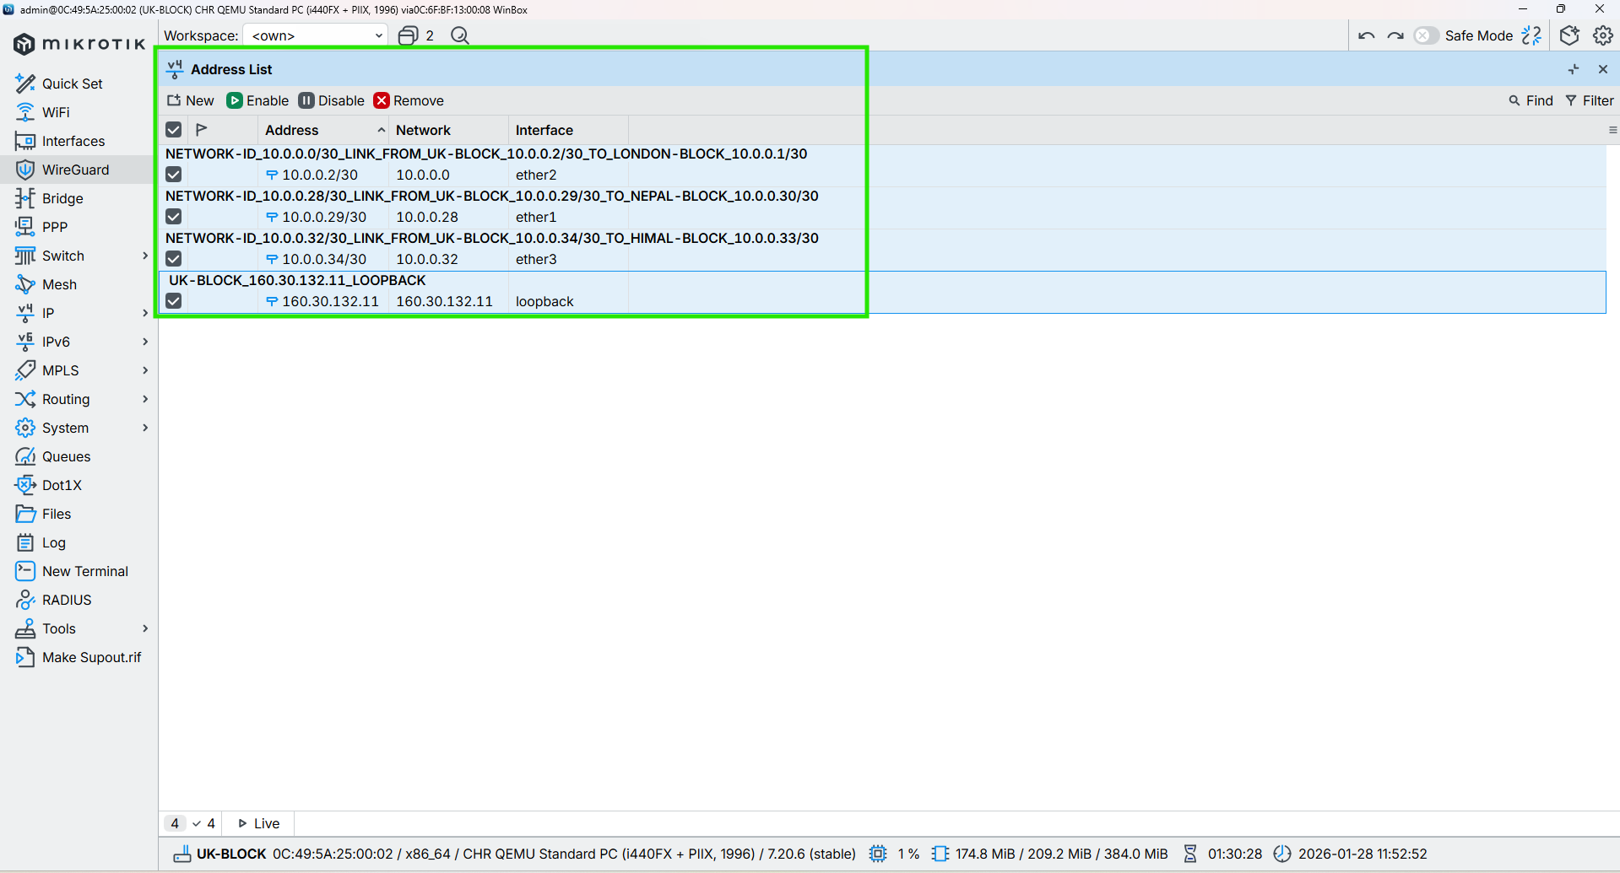

Figure 20: Configuration IP in the Core Interface of UK-BLOCK Router Through WINBOX

## NEPAL-BLOCK

**CMD**

|  |
| --- |
| /ip address add address=10.0.0.6/30 interface=ether3 comment="NETWORK-ID_10.0.0.4/30_LINK_FROM_NEPAL-BLOCK_10.0.0.6/30_TO_LONDON-BLOCK_10.0.0.5/30"  /ip address add address=10.0.0.30/30 interface=ether1 comment="NETWORK-ID_10.0.0.28/30_LINK_FROM_NEPAL-BLOCK_10.0.0.30/30_TO_UK-BLOCK_10.0.0.29/30"  /ip address add address=10.0.0.37/30 interface=ether2 comment="NETWORK-ID_10.0.0.36/30_LINK_FROM_NEPAL-BLOCK_10.0.0.37/30_TO_BRIT-BLOCK_10.0.0.38/30" |



Figure 21: Configuration IP in the Core Interface of NEPAL-BLOCK Router Through CMD

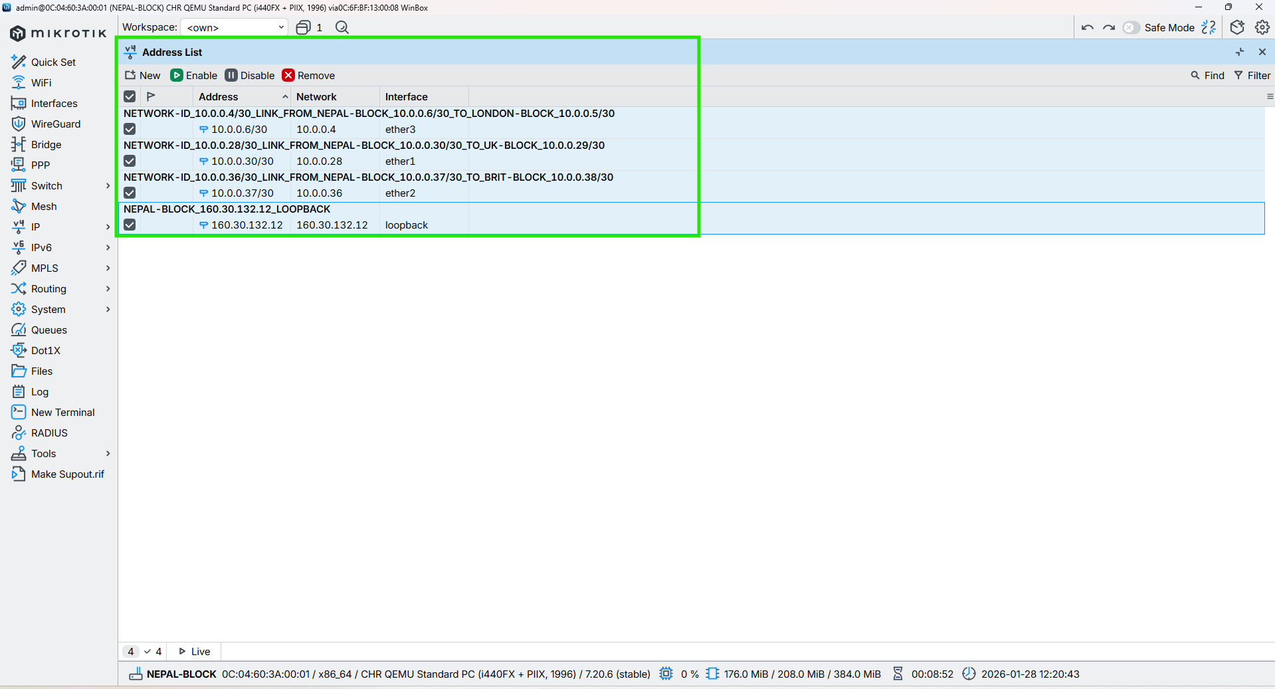

Figure 22: Configuration IP in the Core Interface of NEPAL-BLOCK Router Through WINBOX

## HIMAL-BLOCK

**CMD**

|  |
| --- |
| /ip address add address=10.0.0.33/30 interface=ether3 comment="NETWORK-ID_10.0.0.32/30_LINK_FROM_HIMAL-BLOCK_10.0.0.33/30_TO_UK-BLOCK_10.0.0.34/30"  /ip address add address=10.0.0.10/30 interface=ether4 comment="NETWORK-ID_10.0.0.8/30_LINK_FROM_HIMAL-BLOCK_10.0.0.10/30_TO_LONDON-BLOCK_10.0.0.9/30"  /ip address add address=10.0.0.42/30 interface=ether2 comment="NETWORK-ID_10.0.0.40/30_LINK_FROM_HIMAL-BLOCK_10.0.0.42/30_TO_SKILL-BLOCK_10.0.0.41/30"c |



Figure 23: Configuration IP in the Core Interface of HIMAL-BLOCK Router Through CMD

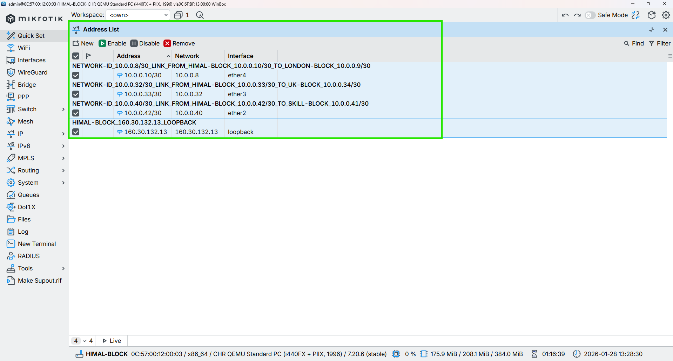

Figure 24: Configuration IP in the Core Interface of HIMAL-BLOCK Router Through WINBOX

## BRIT-BLOCK

**CMD**

|  |
| --- |
| /ip address add address=10.0.0.38/30 interface=ether2 comment="NETWORK-ID_10.0.0.36/30_LINK_FROM_BRIT-BLOCK_10.0.0.38/30_TO_NEPAL-BLOCK_10.0.0.37/30"  /ip address add address=10.0.0.14/30 interface=ether5 comment="NETWORK-ID_10.0.0.12/30_LINK_FROM_BRIT-BLOCK_10.0.0.14/30_TO_LONDON-BLOCK_10.0.0.13/30"  /ip address add address=10.0.0.46/30 interface=ether1 comment="NETWORK-ID_10.0.0.44/30_LINK_FROM_BRIT-BLOCK_10.0.0.46/30_TO_KUMARI-BLOCK_10.0.0.45/30" |



Figure 25: Configuration IP in the Core Interface of BRIT-BLOCK Router Through CMD

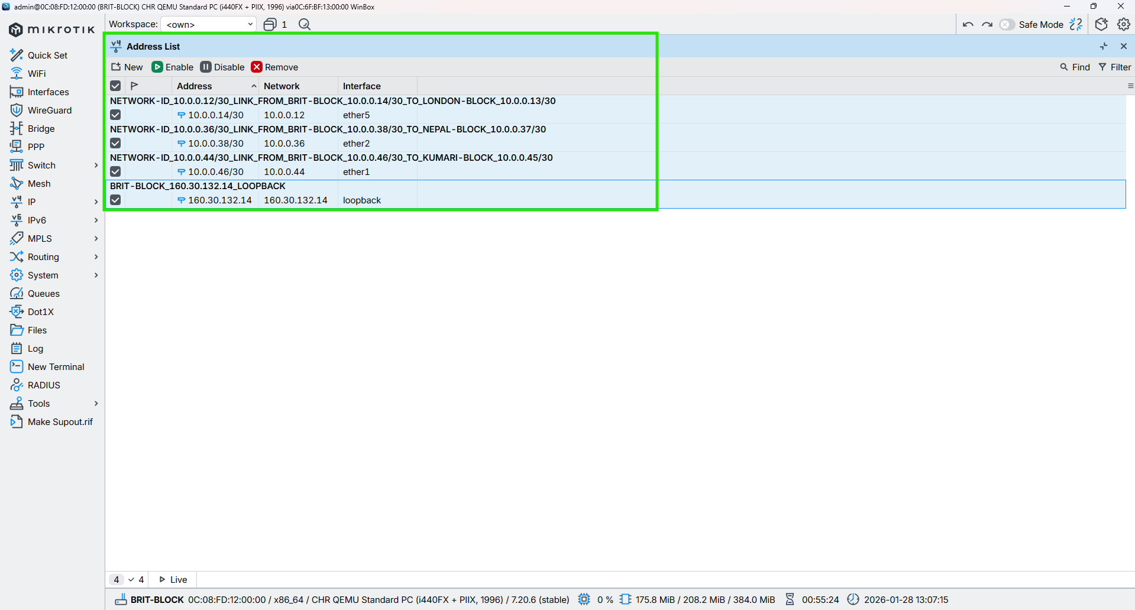

Figure 26: Configuration IP in the Core Interface of BRIT-BLOCK Router Through WINBOX

## SKILL-BLOCK

**CMD**

|  |
| --- |
| /ip address add address=10.0.0.41/30 interface=ether2 comment=”NETWORK-ID_10.0.0.40/30_LINK_FROM_SKILL-BLOCK_10.0.0.41/30_TO_NEPAL-BLOCK_10.0.0.42/30”  /ip address add address=10.0.0.18/30 interface=ether6 comment=”NETWORK-ID_10.0.0.16/30_LINK_FROM_SKILL-BLOCK_10.0.0.18/30_TO_LONDON-BLOCK_10.0.0.17/30”  /ip address add address=10.0.0.50/30 interface=ether1 comment=”NETWORK-ID_10.0.0.48/30_LINK_FROM_SKILL-BLOCK_10.0.0.50/30_TO_KUMARI-BLOCK_10.0.0.49/30” |



Figure 27: Configuration IP in the Core Interface of SKILL-BLOCK Router Through CMD

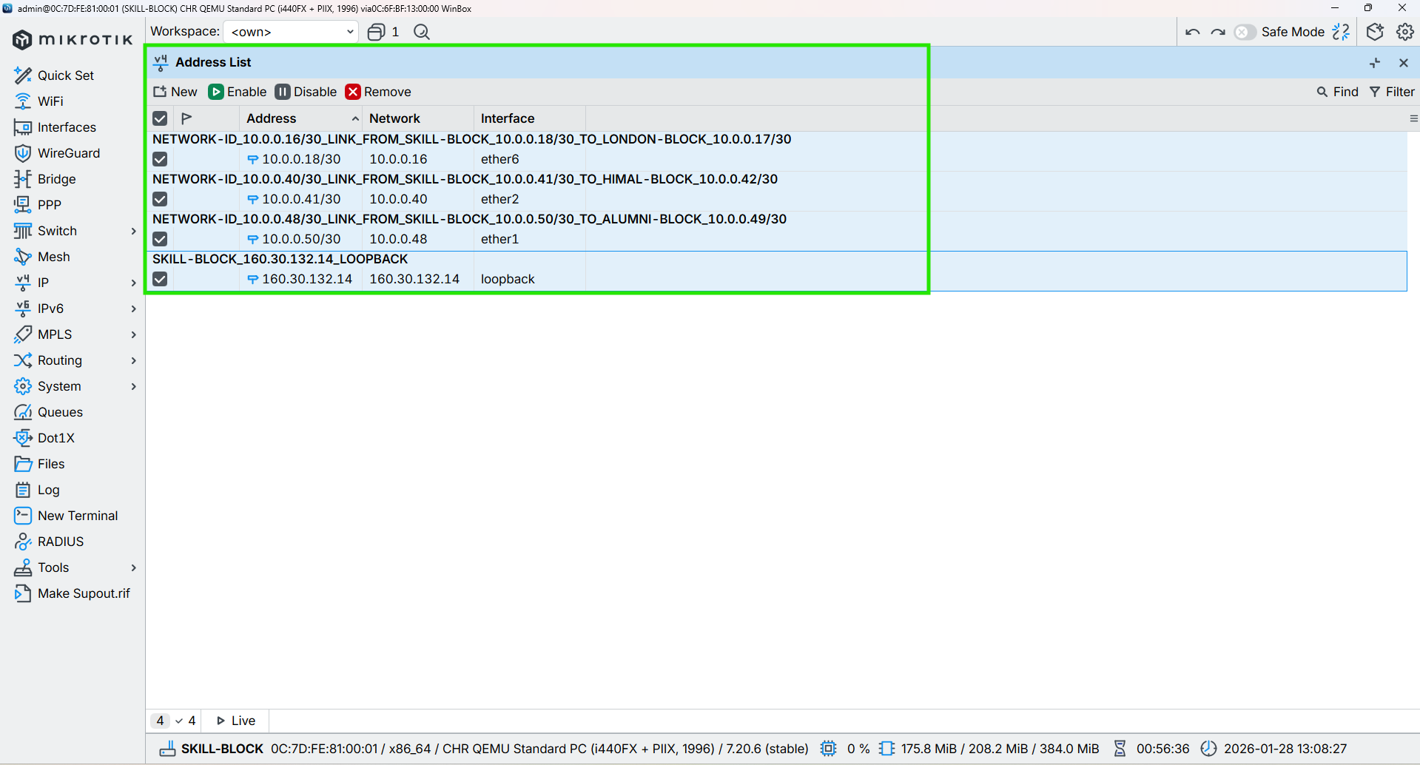

Figure 28: Configuration IP in the Core Interface of SKILL-BLOCK Router Through WINBOX

## ALUMNI-BLOCK

**CMD**

|  |
| --- |
| /ip address add address=10.0.0.22/30 interface=ether7 comment="NETWORK-ID_10.0.0.20/30_LINK_FROM_ALUMNI-BLOCK_10.0.0.22/30_TO_LONDON-BLOCK_10.0.0.21/30"  /ip address add address=10.0.0.49/30 interface=ether1 comment="NETWORK-ID_10.0.0.48/30_LINK_FROM_ALUMNI-BLOCK_10.0.0.49/30_TO_SKILL-BLOCK_10.0.0.50/30"  /ip address add address=10.0.0.53/30 interface=ether2 comment="NETWORK-ID_10.0.0.52/30_LINK_FROM_ALUMNI-BLOCK_10.0.0.53/30_TO_KUMARI-BLOCK_10.0.0.54/30" |

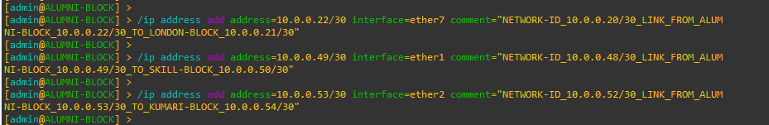

Figure 29: Configuration IP in the Core Interface of ALUMNI-BLOCK Router Through CMD

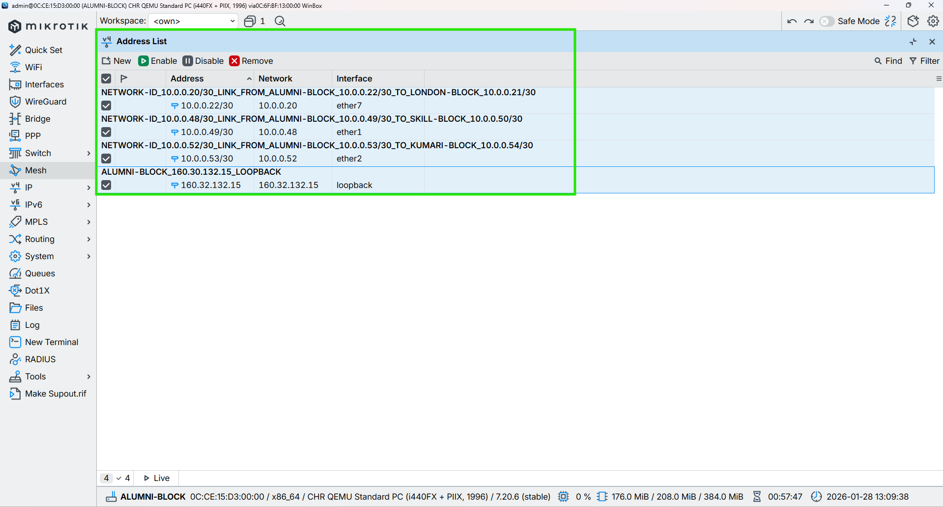

Figure 30: Configuration IP in the Core Interface of ALUMNI-BLOCK Router Through WINBOX

## KUMARI-BLOCK

**CMD**

|  |
| --- |
| /ip address add address=10.0.0.26/30 interface=ether8 comment="NETWORK-ID_10.0.0.24/30_LINK_FROM_KUMARI-BLOCK_10.0.0.26/30_TO_LONDON-BLOCK_10.0.0.25/30"  /ip address add address=10.0.0.54/30 interface=ether2 comment="NETWORK-ID_10.0.0.52/30_LINK_FROM_KUMARI-BLOCK_10.0.0.54/30_TO_ALUMNI-BLOCK_10.0.0.53/30"  /ip address add address=10.0.0.44/30 interface=ether1 comment="NETWORK-ID_10.0.0.44/30_LINK_FROM_KUMARI-BLOCK_10.0.0.44/30_TO_BRIT-BLOCK_10.0.0.46/30" |



Figure 31: Configuration IP in the Core Interface of KUMARI-BLOCK Router Through CMD

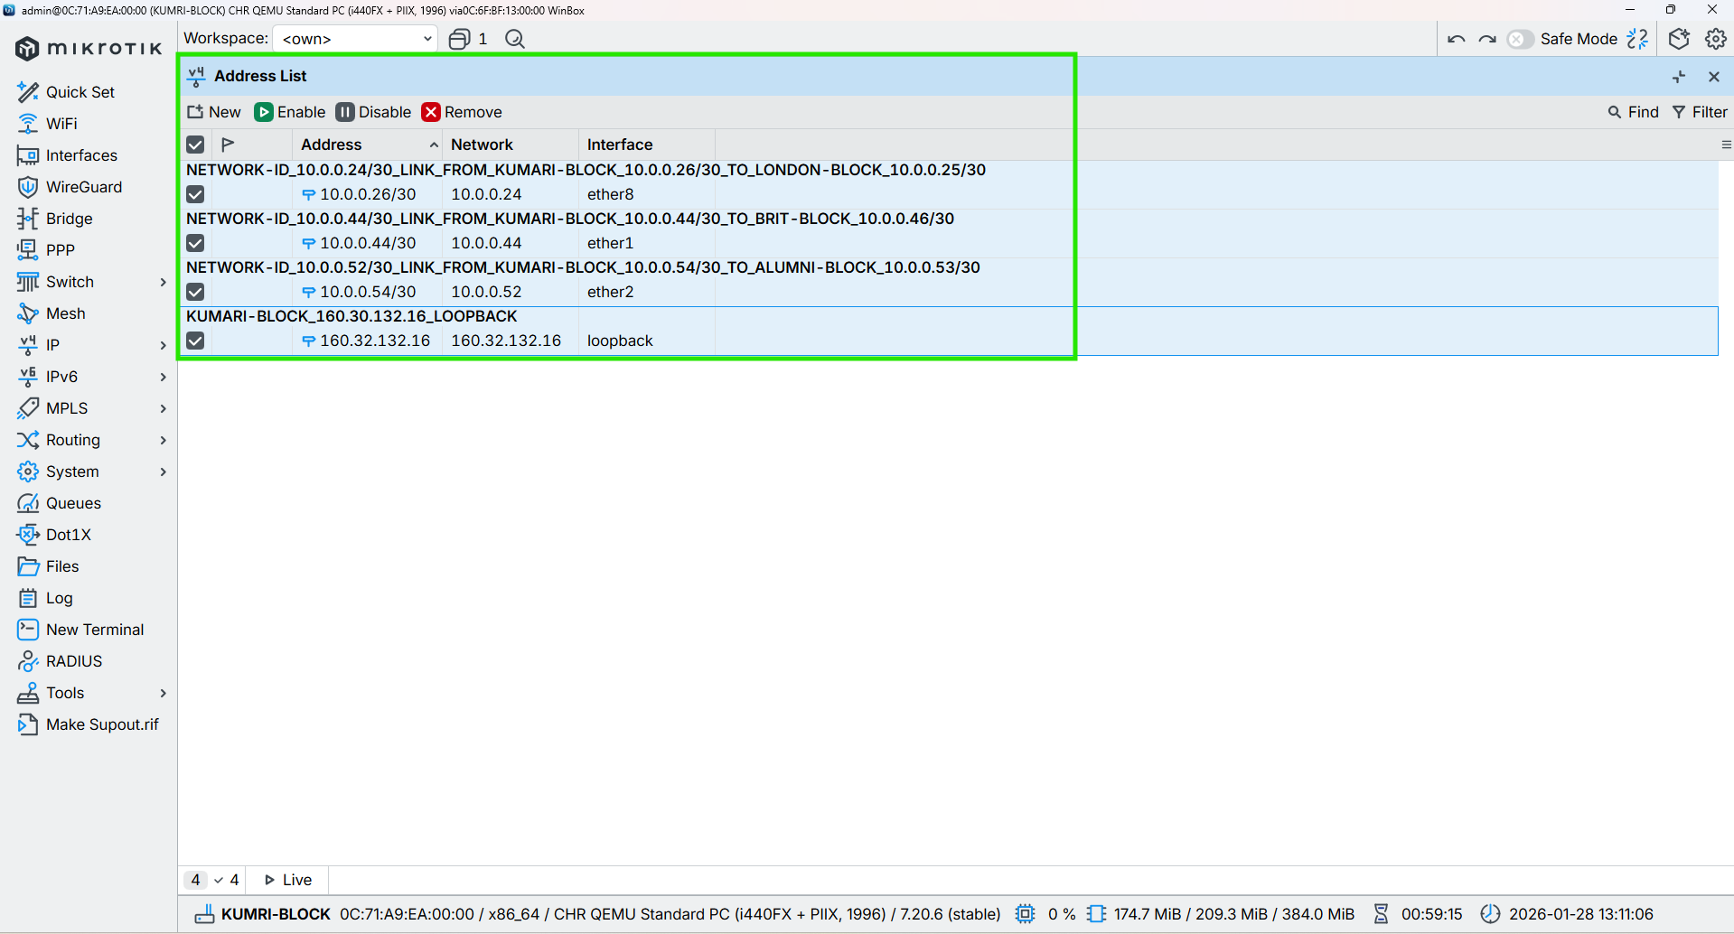

Figure 32: Configuration IP in the Core Interface of KUMARI-BLOCK Router Through WINBOX

# Configuration OSPF to all Core Routers

## LONDON-BLOCK

CMD

|  |
| --- |
| /routing ospf instance add name=OSPF_LONDON_BLOCK router-id=160.30.132.1 comment="OSPF instance for London block, router-id 160.30.132.1"  /routing ospf area add name=backbone area-id=0.0.0.0 instance=OSPF_LONDON_BLOCK comment="Backbone area 0.0.0.0 for London OSPF"  /routing ospf interface-template  add interfaces=loopback area=backbone passive comment="Loopback London router-id 160.30.132.1 (passive)"  add networks=10.0.0.0/30 interfaces=ether2 area=backbone comment="ETHER-2_LINK_FROM_LONDON-BLOCK_10.0.0.1_TO_UK-BLOCK_10.0.0.2"  add networks=10.0.0.4/30 interfaces=ether3 area=backbone comment="ETHER-3_LINK_FROM_LONDON-BLOCK_10.0.0.5_TO_NEPAL-BLOCK_10.0.0.6"  add networks=10.0.0.8/30 interfaces=ether4 area=backbone comment="ETHER-4_LINK_FROM_LONDON-BLOCK_10.0.0.9_TO_HIMAL-BLOCK_10.0.0.10"  add networks=10.0.0.12/30 interfaces=ether5 area=backbone comment="ETHER-5_LINK_FROM_LONDON-BLOCK_10.0.0.13_TO_BRIT-BLOCK_10.0.0.14"  add networks=10.0.0.16/30 interfaces=ether6 area=backbone comment="ETHER-6_LINK_FROM_LONDON-BLOCK_10.0.0.17_TO_SKILL-BLOCK_10.0.0.18"  add networks=10.0.0.20/30 interfaces=ether7 area=backbone comment="ETHER-7_LINK_FROM_LONDON-BLOCK_10.0.0.21_TO_ALUMNI-BLOCK_10.0.0.22"  add networks=10.0.0.24/30 interfaces=ether8 area=backbone comment="ETHER-8_LINK_FROM_LONDON-BLOCK_10.0.0.25_TO_KUMARI-BLOCK_10.0.0.26" |

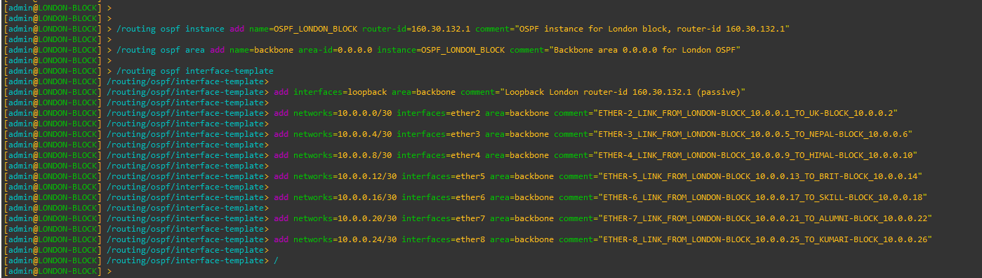

Figure 33: Configuration OSPF to Core LONDON-BLOCK Router Through CMD

|  |
| --- |
| Figure 34: Configuration OSPF Instances to Core LONDON-BLOCK Router Through WINBOX |
| Figure 35: Configuration OSPF Area to Core LONDON-BLOCK Router Through WINBOX |
| Figure 36: Configuration OSPF Interface-template to Core LONDON-BLOCK Router Through WINBOX |

## UK-BLOCK

CMD

|  |
| --- |
| /routing ospf instance add name=OSPF_UK_BLOCK router-id=160.30.132.11 comment="OSPF instance for UK block, router-id 160.30.132.11"  /routing ospf area add name=backbone area-id=0.0.0.0 instance=OSPF_UK_BLOCK comment="Backbone area 0.0.0.0 for UK OSPF"  /routing ospf interface-template  add interfaces=loopback area=backbone comment="Loopback UK router-id 160.30.132.11 (passive)"  add networks=10.0.0.0/30 interfaces=ether2 area=backbone comment="ETHER-2_LINK_FROM_UK-BLOCK_10.0.0.2_TO_LONDON-BLOCK_10.0.0.1"  add networks=10.0.0.28/30 interfaces=ether1 area=backbone comment="ETHER-3_LINK_FROM_UK-BLOCK_10.0.0.29_TO_NEPAL-BLOCK_10.0.0.30"  add networks=10.0.0.32/30 interfaces=ether3 area=backbone comment="ETHER-3_LINK_FROM_UK-BLOCK_10.0.0.34_TO_HIMAL-BLOCK_10.0.0.33" |

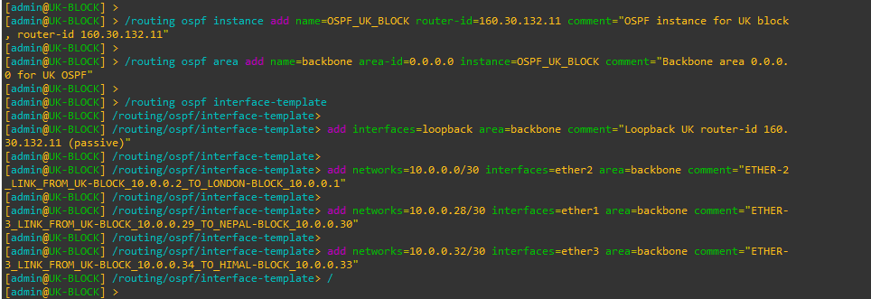

Figure 37: Configuration OSPF to UK-BLOCK Router Through CMD

|  |
| --- |
| Figure 38: Configuration OSPF Instances to UK-BLOCK Router Through WINBOX |
| Figure 39: Configuration OSPF Area to UK-BLOCK Router Through WINBOX |
| Figure 40: Configuration OSPF Interface-template to UK-BLOCK Router Through WINBOX |

## NEPAL-BLOCK

**CMD**

|  |
| --- |
| /routing ospf instance add name=OSPF_NEPAL_BLOCK router-id=160.30.132.12 comment="OSPF instance for NEPAL block, router-id 160.30.132.12"  /routing ospf area add name=backbone area-id=0.0.0.0 instance=OSPF_NEPAL_BLOCK comment="Backbone area 0.0.0.0 for NEPAL OSPF"  /routing ospf interface-template  add interfaces=loopback area=backbone comment="Loopback NEPAL router-id 160.30.132.12 (passive)"  add networks=10.0.0.28/30 interfaces=ether1 area=backbone comment="ETHER-1_LINK_FROM_NEPAL-BLOCK_10.0.0.30_TO_UK-BLOCK_10.0.0.29"  add networks=10.0.0.4/30 interfaces=ether3 area=backbone comment="ETHER-3_LINK_FROM_NEPAL-BLOCK_10.0.0.6_TO_LONDON-BLOCK_10.0.0.5"  add networks=10.0.0.36/30 interfaces=ether2 area=backbone comment="ETHER-2_LINK_FROM_NEPAL-BLOCK_10.0.0.37_TO_BRIT-BLOCK_10.0.0.38" |

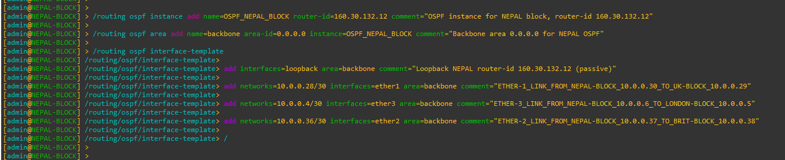

Figure 41: Configuration OSPF to NEPAL-BLOCK Router Through CMD

|  |
| --- |
| Figure 42: Configuration OSPF Instances to NEPAL-BLOCK Router Through WINBOX |
| Figure 43: Configuration OSPF Area to NEPAL-BLOCK Router Through WINBOX |
| Figure 44: Configuration OSPF Interface-template to NEPAL-BLOCK Router Through WINBOX |

## HIMAL-BLOCK

CMD

|  |
| --- |
| /routing ospf instance add name=OSPF_HIMAL_BLOCK router-id=160.30.132.13 comment="OSPF instance for HIMAL block, router-id 160.30.132.13"  /routing ospf area add name=backbone area-id=0.0.0.0 instance=OSPF_HIMAL_BLOCK comment="Backbone area 0.0.0.0 for HIMAL OSPF"  /routing ospf interface-template  add interfaces=loopback area=backbone comment="Loopback HIMAL router-id 160.30.132.13 (passive)"  add networks=10.0.0.32/30 interfaces=ether3 area=backbone comment="ETHER-3_LINK_FROM_HIMAL-BLOCK_10.0.0.33_TO_UK-BLOCK_10.0.0.34"  add networks=10.0.0.8/30 interfaces=ether4 area=backbone comment="ETHER-4_LINK_FROM_HIMAL-BLOCK_10.0.0.10_TO_LONDON-BLOCK_10.0.0.9"  add networks=10.0.0.40/30 interfaces=ether2 area=backbone comment="ETHER-2_LINK_FROM_HIMAL-BLOCK_10.0.0.42_TO_SKILL-BLOCK_10.0.0.41" |

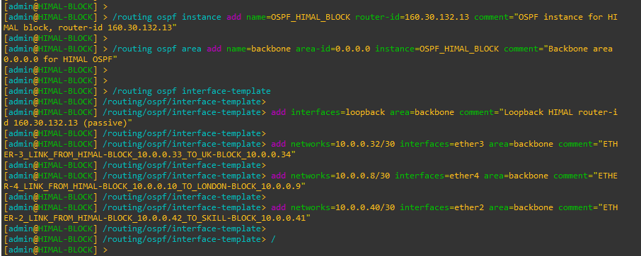

Figure 45: Configuration OSPF to HIMAL-BLOCK Router Through CMD

|  |
| --- |
| Figure 46: Configuration OSPF Instances to HIMAL-BLOCK Router Through WINBOX |
| Figure 47: Configuration OSPF Area to HIMAL-BLOCK Router Through WINBOX |
| Figure 48: Configuration OSPF Interface-template to HIMAL-BLOCK Router Through WINBOX |

## BRIT-BLOCK

**CMD**

|  |
| --- |
| /routing ospf instance add name=OSPF_BRIT_BLOCK router-id=160.30.132.14 comment="OSPF instance for BRIT block, router-id 160.30.132.14"  /routing ospf area add name=backbone area-id=0.0.0.0 instance=OSPF_BRIT_BLOCK comment="Backbone area 0.0.0.0 for BRIT OSPF"  /routing ospf interface-template  add interfaces=loopback area=backbone comment="Loopback BRIT router-id 160.30.132.14 (passive)"  add networks=10.0.0.36/30 interfaces=ether2 area=backbone comment="ETHER-2_LINK_FROM_BRIT-BLOCK_10.0.0.38_TO_NEPAL-BLOCK_10.0.0.37"  add networks=10.0.0.12/30 interfaces=ether5 area=backbone comment="ETHER-5_LINK_FROM_BRIT-BLOCK_10.0.0.14_TO_LONDON-BLOCK_10.0.0.13"  add networks=10.0.0.44/30 interfaces=ether1 area=backbone comment="ETHER-1_LINK_FROM_BRIT-BLOCK_10.0.0.46_TO_SKILL-BLOCK_10.0.0.45" |

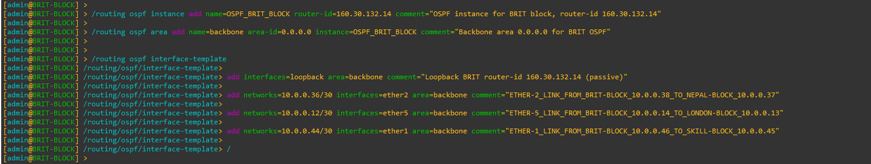

Figure 49: Configuration OSPF to BRIT-BLOCK Router Through CMD

|  |
| --- |
| Figure 50: Configuration OSPF Instances to BRIT-BLOCK Router Through WINBOX |
| Figure 51: Configuration OSPF Area to BRIT-BLOCK Router Through WINBOX |
| Figure 52: Configuration OSPF Interface-template to BRIT-BLOCK Router Through WINBOX |

## SKILL-BLOCK

CMD

|  |
| --- |
| /routing ospf instance add name=OSPF_SKILL_BLOCK router-id=160.30.132.15 comment="OSPF instance for SKILL block, router-id 160.30.132.15"  /routing ospf area add name=backbone area-id=0.0.0.0 instance=OSPF_SKILL_BLOCK comment="Backbone area 0.0.0.0 for SKILL OSPF"  /routing ospf interface-template  add interfaces=loopback area=backbone comment="Loopback SKILL router-id 160.30.132.15 (passive)"  add networks=10.0.0.40/30 interfaces=ether2 area=backbone comment="ETHER-2_LINK_FROM_SKILL-BLOCK_10.0.0.41_TO_HIMAL-BLOCK_10.0.0.42"  add networks=10.0.0.16/30 interfaces=ether6 area=backbone comment="ETHER-6_LINK_FROM_SKILL-BLOCK_10.0.0.18_TO_LONDON-BLOCK_10.0.0.17"  add networks=10.0.0.48/30 interfaces=ether1 area=backbone comment="ETHER-1_LINK_FROM_SKILL-BLOCK_10.0.0.50_TO_ALUMNI-BLOCK_10.0.0.49" |

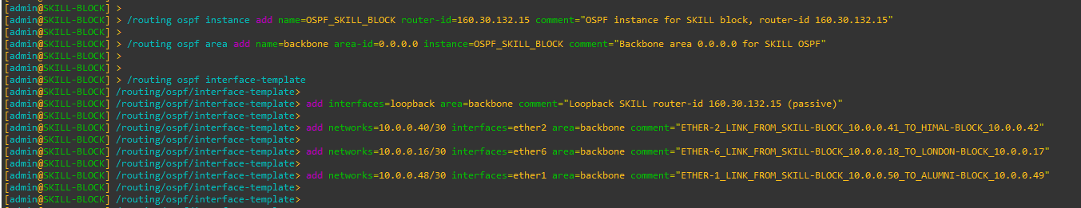

Figure 53: Configuration OSPF to SKILL-BLOCK Router Through CMD

|  |
| --- |
| Figure 54: Configuration OSPF Instances to SKILL-BLOCK Router Through WINBOX |
| Figure 55: Configuration OSPF Area to SKILL-BLOCK Router Through WINBOX |
| Figure 56: Configuration OSPF Interface-template to SKILL-BLOCK Router Through WINBOX |

## ALUMNI-BLOCK

CMD

|  |
| --- |
| /routing ospf instance add name=OSPF_ALUMNI_BLOCK router-id=160.30.132.16 comment="OSPF instance for ALUMNI block, router-id 160.30.132.16"  /routing ospf area add name=backbone area-id=0.0.0.0 instance=OSPF_ALUMNI_BLOCK comment="Backbone area 0.0.0.0 for ALUMNI OSPF"  /routing ospf interface-template  add interfaces=loopback area=backbone comment="Loopback ALUMNI router-id 160.30.132.16 (passive)"  add networks=10.0.0.48/30 interfaces=ether1 area=backbone comment="ETHER-1_LINK_FROM_ALUMNI-BLOCK_10.0.0.49_TO_SKILL-BLOCK_10.0.0.50"  add networks=10.0.0.20/30 interfaces=ether7 area=backbone comment="ETHER-7_LINK_FROM_ALUMNI-BLOCK_10.0.0.22_TO_LONDON-BLOCK_10.0.0.21"  add networks=10.0.0.52/30 interfaces=ether2 area=backbone comment="ETHER-2_LINK_FROM_ALUMNI-BLOCK_10.0.0.53_TO_KUMARI-BLOCK_10.0.0.54" |

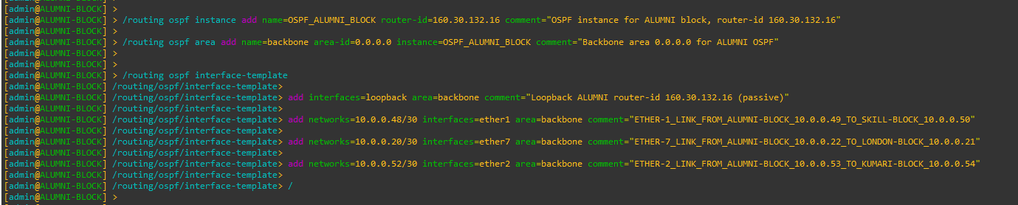

Figure 57: Configuration OSPF to ALUMNI-BLOCK Router Through CMD

|  |
| --- |
| Figure 58: Configuration OSPF Instances to ALUMNI-BLOCK Router Through WINBOX |
| Figure 59: Configuration OSPF Area to ALUMNI-BLOCK Router Through WINBOX |
| Figure 60: Configuration OSPF Interface-template to ALUMNI-BLOCK Router Through WINBOX |

## KUMARI-BLOCK

CMD

|  |
| --- |
| /routing ospf instance add name=OSPF_KUMARI_BLOCK router-id=160.30.132.17 comment="OSPF instance for KUMARI block, router-id 160.30.132.17"  /routing ospf area add name=backbone area-id=0.0.0.0 instance=OSPF_KUMARI_BLOCK comment="Backbone area 0.0.0.0 for KUMARI OSPF"  /routing ospf interface-template  add interfaces=loopback area=backbone comment="Loopback KUMARI router-id 160.30.132.17 (passive)"  add networks=10.0.0.44/30 interfaces=ether1 area=backbone comment="ETHER-1_LINK_FROM_KUMARI-BLOCK_10.0.0.45_TO_BRIT-BLOCK_10.0.0.46"  add networks=10.0.0.24/30 interfaces=ether8 area=backbone comment="ETHER-8_LINK_FROM_KUMARI-BLOCK_10.0.0.26_TO_LONDON-BLOCK_10.0.0.25"  add networks=10.0.0.52/30 interfaces=ether2 area=backbone comment="ETHER-2_LINK_FROM_KUMARI-BLOCK_10.0.0.54_TO_ALUMNI-BLOCK_10.0.0.53" |

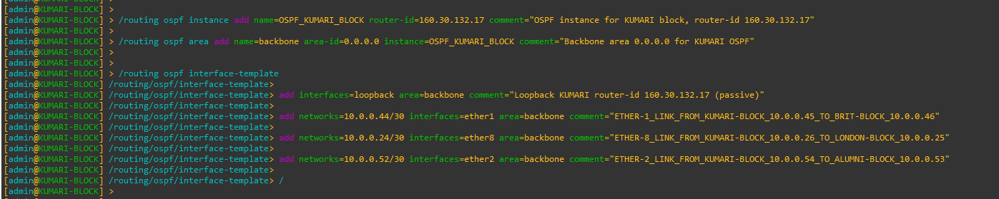

Figure 61: Configuration OSPF to KUMARI-BLOCK Router Through CMD

|  |
| --- |
| Figure 62: Configuration OSPF Instances to KUMARI-BLOCK Router Through WINBOX |
| Figure 63: Configuration OSPF Area to KUMARI-BLOCK Router Through WINBOX |
| Figure 64: Configuration OSPF Interface-template to KUMARI-BLOCK Router Through WINBOX |

# Configure Management Access from PC to MPLS Loopback

## PC (VMware Host) – Static Route Configuration

To allow the PC (VMware host) to reach the MPLS loopback network

160.30.132.0/24, a persistent static route is added on the PC pointing to the

LONDON-BLOCK management interface.

CMD (Windows PC)

|  |
| --- |
| route -p add 160.30.132.0 mask 255.255.255.0 192.168.174.173 |



## UK-BLOCK – OSPF Configuration (No Management Network Advertisement)

LONDON-BLOCK acts as the central management gateway between the PC and the MPLS core. UK-BLOCK participates only in MPLS core OSPF.

The VMware management network must not be added to OSPF.

|  |
| --- |
| /routing ospf interface-template  add networks=192.168.174.0/24 interfaces=ether9 area=backbone  / |



## Disable RoMON temporarily to avoid confusion

Cmd

|  |
| --- |
| /tool romon set enabled=no |

## End-to-End Verification (From PC)

Ping Test

|  |
| --- |
| ping 160.30.132.1  ping 160.30.132.11  ping 160.30.132.14  ping 160.30.132.16 |

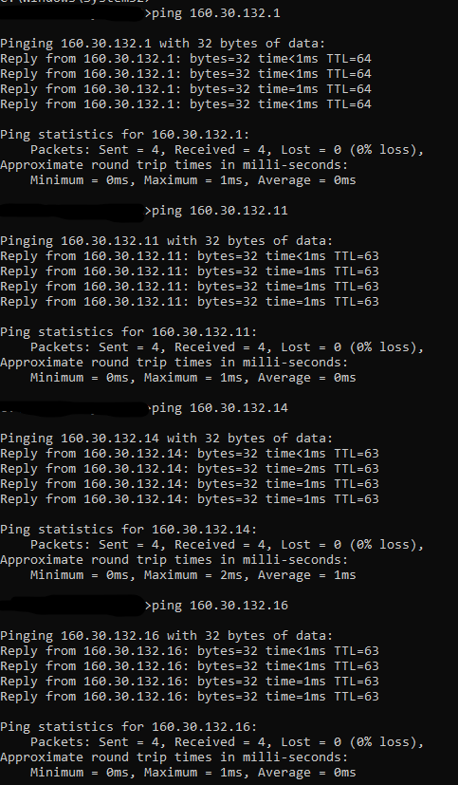

# Configuration MPLS to all Core Routers

## LONDON-BLOCK

CMD

|  |
| --- |
| /mpls ldp add lsr-id=160.30.132.1 transport-addresses=160.30.132.1 comment="Enable MPLS LDP using loopback 160.30.132.1"  /mpls ldp set [find lsr-id=160.30.132.1] disabled=no comment="Enable MPLS LDP using loopback 160.30.132.1" |



Figure 65: Configuration MPLS to LONDON-BLOCK Router Through CMD

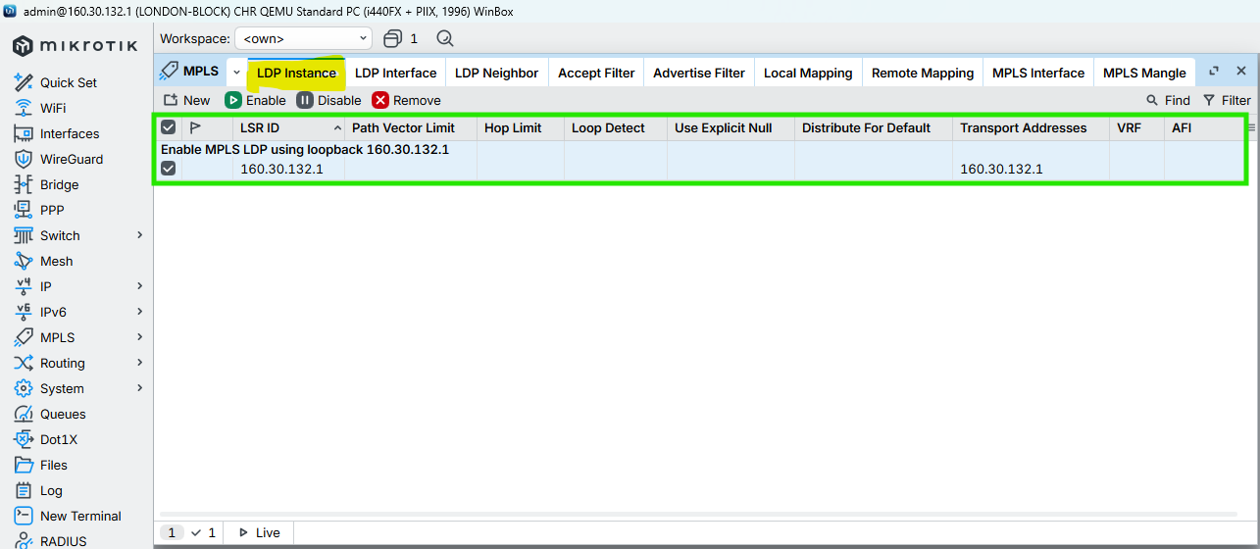

Figure 66: Configuration MPLS to LONDON-BLOCK Router Through WINBOX

## UK-BLOCK

CMD

|  |
| --- |
| /mpls ldp add lsr-id=160.30.132.11 transport-addresses=160.30.132.11 comment="Enable MPLS LDP using loopback 160.30.132.11"  /mpls ldp set [find lsr-id=160.30.132.11] disabled=no comment="Enable MPLS LDP using loopback 160.30.132.11" |



Figure 67: Configuration MPLS to UK-BLOCK Router Through CMD

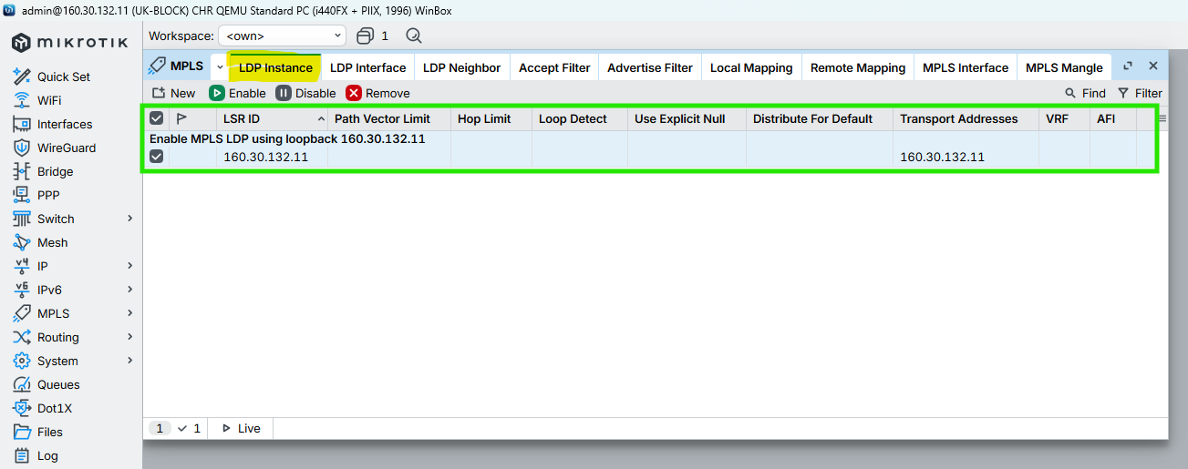

Figure 68: Configuration MPLS to UK-BLOCK Router Through WINBOX

## NEPAL-BLOCK

CMD

|  |
| --- |
| /mpls ldp add lsr-id=160.30.132.12 transport-addresses=160.30.132.12 comment="Enable MPLS LDP using loopback 160.30.132.12"  /mpls ldp set [find lsr-id=160.30.132.12] disabled=no comment="Enable MPLS LDP using loopback 160.30.132.12" |



Figure 69: Configuration MPLS to NEPAL-BLOCK Router Through CMD

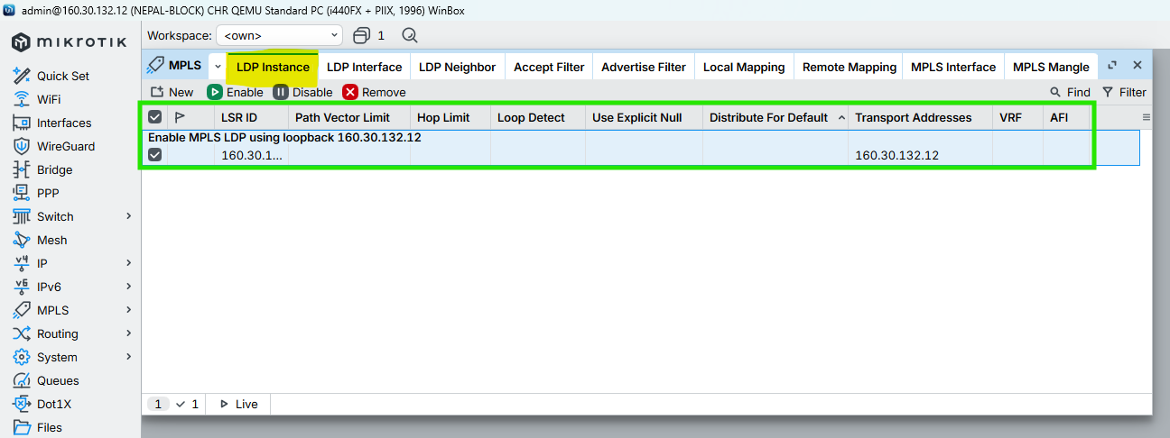

Figure 70: Configuration MPLS to NEPAL-BLOCK Router Through WINBOX

## HIMAL-BLOCK

CMD

|  |
| --- |
| /mpls ldp add lsr-id=160.30.132.13 transport-addresses=160.30.132.13 comment="Enable MPLS LDP using loopback 160.30.132.13"  /mpls ldp set [find lsr-id=160.30.132.13] disabled=no comment="Enable MPLS LDP using loopback 160.30.132.13" |



Figure 71: Configuration MPLS to HIMAL-BLOCK Router Through CMD

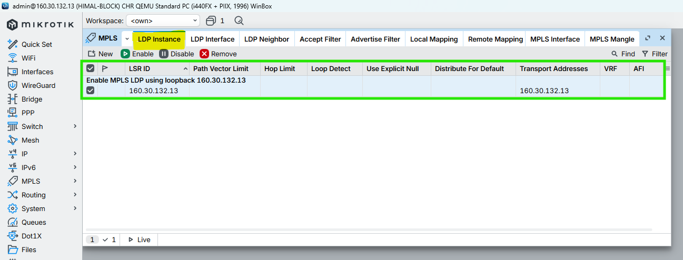

Figure 72: Configuration MPLS to HIMAL-BLOCK Router Through WINBOX

## BRIT-BLOCK

CMD

|  |
| --- |
| /mpls ldp add lsr-id=160.30.132.14 transport-addresses=160.30.132.14 comment="Enable MPLS LDP using loopback 160.30.132.14"  /mpls ldp set [find lsr-id=160.30.132.14] disabled=no comment="Enable MPLS LDP using loopback 160.30.132.14" |



Figure 73: Configuration MPLS to BRIT-BLOCK Router Through CMD

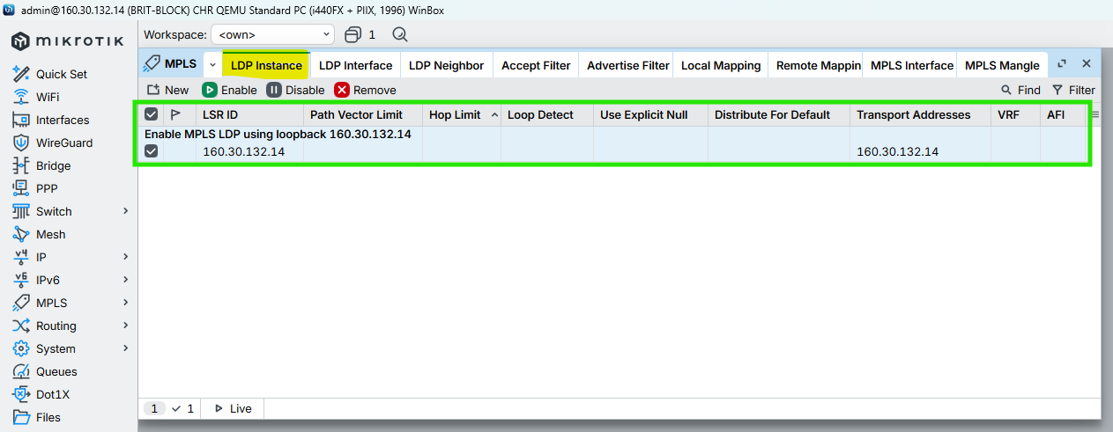

Figure 74: Configuration MPLS to BRIT-BLOCK Router Through WINBOX

## SKILL-BLOCK

CMD

|  |
| --- |
| /mpls ldp add lsr-id=160.30.132.15 transport-addresses=160.30.132.15 comment="Enable MPLS LDP using loopback 160.30.132.15"  /mpls ldp set [find lsr-id=160.30.132.15] disabled=no comment="Enable MPLS LDP using loopback 160.30.132.15" |



Figure 75: Configuration MPLS to SKILL-BLOCK Router Through CMD

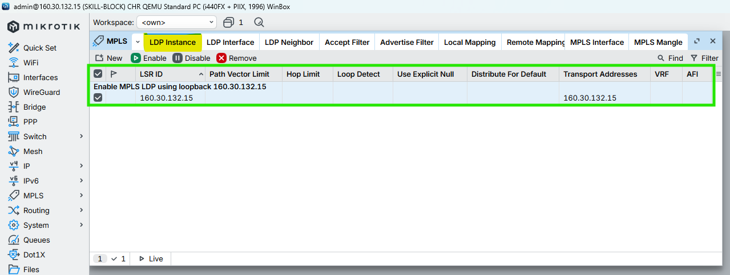

Figure 76: Configuration MPLS to SKILL-BLOCK Router Through WINBOX

## ALUMNI-BLOCK

CMD

|  |
| --- |
| /mpls ldp add lsr-id=160.30.132.16 transport-addresses=160.30.132.16 comment="Enable MPLS LDP using loopback 160.30.132.16"  /mpls ldp set [find lsr-id=160.30.132.16] disabled=no comment="Enable MPLS LDP using loopback 160.30.132.16" |



Figure 77: Configuration MPLS to ALUMNI-BLOCK Router Through CMD

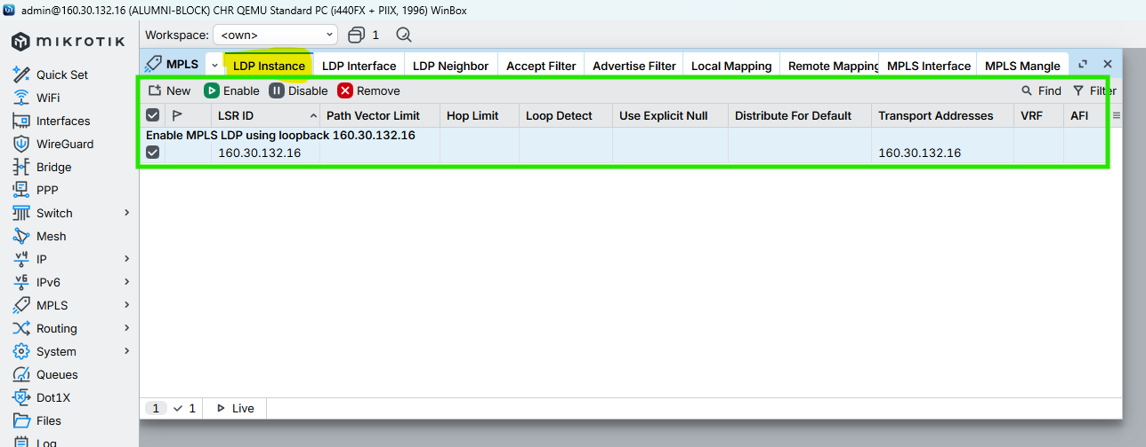

Figure 78: Configuration MPLS to ALUMNI-BLOCK Router Through WINBOX

## KUMARI-BLOCK

CMD

|  |
| --- |
| /mpls ldp add lsr-id=160.30.132.17 transport-addresses=160.30.132.17 comment="Enable MPLS LDP using loopback 160.30.132.17"  /mpls ldp set [find lsr-id=160.30.132.17] disabled=no comment="Enable MPLS LDP using loopback 160.30.132.17" |



Figure 79: Configuration MPLS to KUMARI-BLOCK Router Through CMD

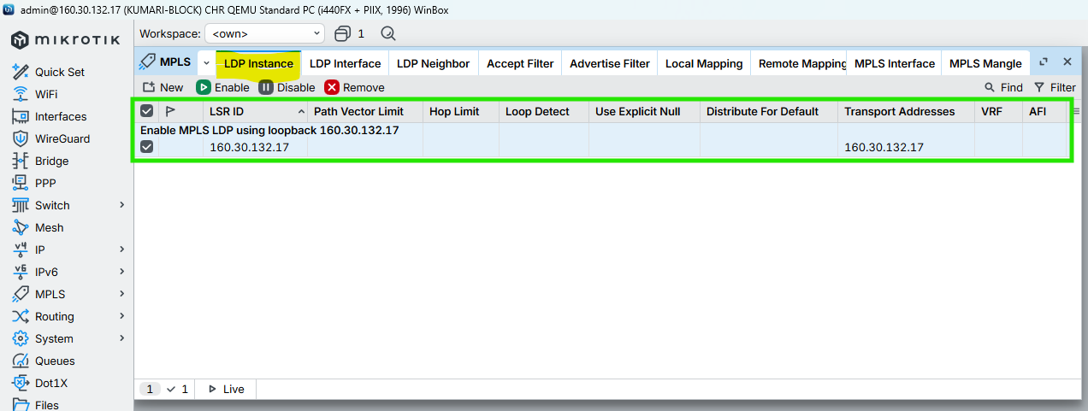

Figure 80: Configuration MPLS to KUMARI-BLOCK Router Through CMD

# MPLS & LDP Configuration on Core Interfaces (with MTU)

This section enables LDP signaling, MPLS forwarding, and configures MPLS MTU (1508) on all core-facing interfaces only to support VPLS without fragmentation.

## LONDON-BLOCK

### Enable LDP on Core Interfaces ONLY

CMD

|  |
| --- |
| /mpls ldp interface  add interface=ether2 comment="LDP_CORE_LINK_LONDON-BLOCK_10.0.0.1/30_TO_UK-BLOCK_10.0.0.2/30"  add interface=ether3 comment="LDP_CORE_LINK_LONDON-BLOCK_10.0.0.5/30_TO_NEPAL-BLOCK_10.0.0.6/30"  add interface=ether4 comment="LDP_CORE_LINK_LONDON-BLOCK_10.0.0.9/30_TO_HIMAL-BLOCK_10.0.0.10/30"  add interface=ether5 comment="LDP_CORE_LINK_LONDON-BLOCK_10.0.0.13/30_TO_BRIT-BLOCK_10.0.0.14/30"  add interface=ether6 comment="LDP_CORE_LINK_LONDON-BLOCK_10.0.0.17/30_TO_SKILL-BLOCK_10.0.0.18/30"  add interface=ether7 comment="LDP_CORE_LINK_LONDON-BLOCK_10.0.0.21/30_TO_ALUMNI-BLOCK_10.0.0.22/30"  add interface=ether8 comment="LDP_CORE_LINK_LONDON-BLOCK_10.0.0.25/30_TO_KUMARI-BLOCK_10.0.0.26/30"  / |

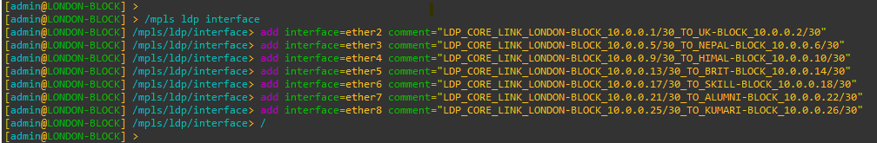

Figure 81: Configuration MPLS LDP Interfaces to LONDON-BLOCK Router Through CMD

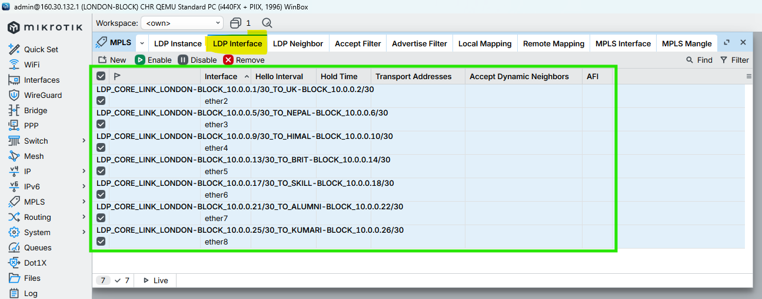

Figure 82: Configuration MPLS LDP nterfaces to LONDON-BLOCK Router Through WINBOX

### Enable MPLS & Set MPLS MTU on interfaces

CMD

|  |
| --- |
| /mpls interface  add interface=ether2 mpls-mtu=1508 comment="MPLS_CORE_LINK_LONDON-BLOCK_TO_UK-BLOCK_MTU1508"  add interface=ether3 mpls-mtu=1508 comment="MPLS_CORE_LINK_LONDON-BLOCK_TO_NEPAL-BLOCK_MTU1508"  add interface=ether4 mpls-mtu=1508 comment="MPLS_CORE_LINK_LONDON-BLOCK_TO_HIMAL-BLOCK_MTU1508"  add interface=ether5 mpls-mtu=1508 comment="MPLS_CORE_LINK_LONDON-BLOCK_TO_BRIT-BLOCK_MTU1508"  add interface=ether6 mpls-mtu=1508 comment="MPLS_CORE_LINK_LONDON-BLOCK_TO_SKILL-BLOCK_MTU1508"  add interface=ether7 mpls-mtu=1508 comment="MPLS_CORE_LINK_LONDON-BLOCK_TO_ALUMNI-BLOCK_MTU1508"  add interface=ether8 mpls-mtu=1508 comment="MPLS_CORE_LINK_LONDON-BLOCK_TO_KUMARI-BLOCK_MTU1508"  / |

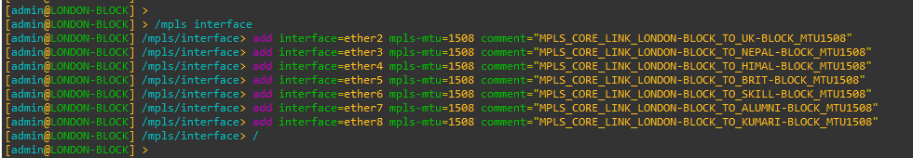

Figure 83: Configuration MPLS MTU on Interfaces to LONDON-BLOCK Router Through CMD

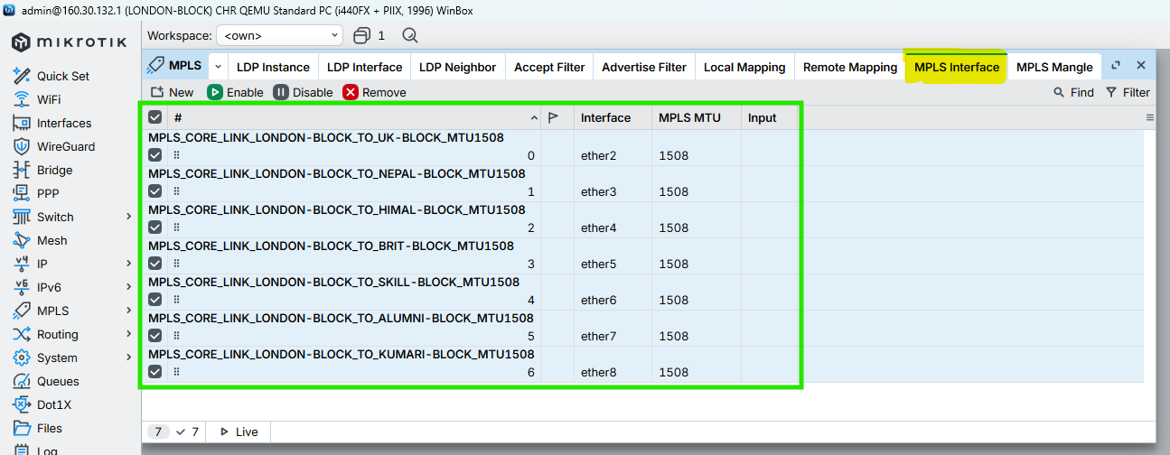

Figure 84: Configuration MPLS MTU on Interfaces to LONDON-BLOCK Router Through WINBOX

## UK-BLOCK

### Enable LDP on Core Interfaces ONLY

CMD

|  |
| --- |
| /mpls ldp interface  add interface=ether2 comment="LDP_CORE_LINK_UK-BLOCK_10.0.0.2/30_TO_LONDON-BLOCK_10.0.0.1/30"  add interface=ether1 comment="LDP_CORE_LINK_UK-BLOCK_10.0.0.29/30_TO_NEPAL-BLOCK_10.0.0.30/30"  add interface=ether3 comment="LDP_CORE_LINK_UK-BLOCK_10.0.0.34/30_TO_HIMAL-BLOCK_10.0.0.33/30"  / |

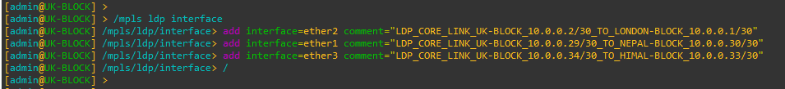

Figure 85: Configuration MPLS LDP Interfaces to UK-BLOCK Router Through CMD

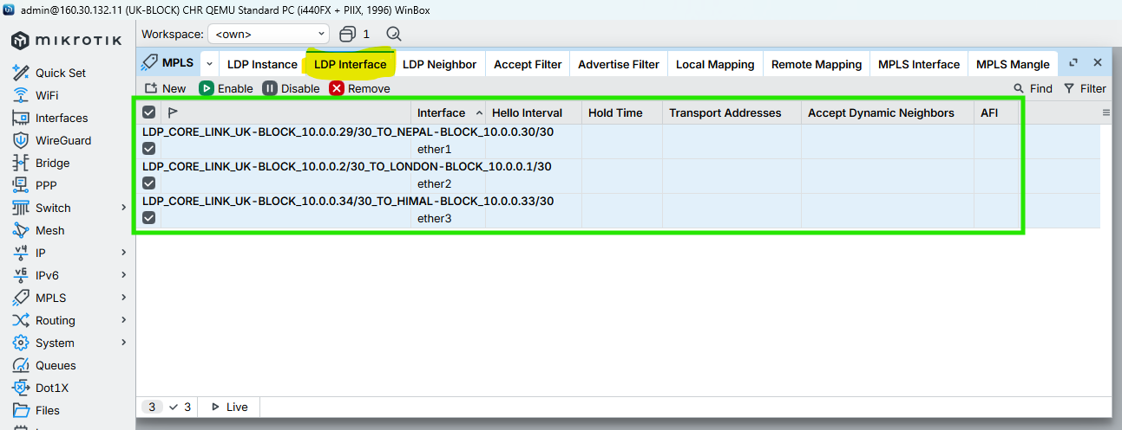

Figure 86: Configuration MPLS LDP Interfaces to UK-BLOCK Router Through WINBOX

### Enable MPLS & Set MPLS MTU on interfaces

CMD

|  |
| --- |
| /mpls interface  add interface=ether2 mpls-mtu=1508 comment="MPLS_CORE_LINK_UK-BLOCK_TO_LONDON-BLOCK_MTU1508"  add interface=ether1 mpls-mtu=1508 comment="MPLS_CORE_LINK_UK-BLOCK_TO_NEPAL-BLOCK_MTU1508"  add interface=ether3 mpls-mtu=1508 comment="MPLS_CORE_LINK_UK-BLOCK_TO_HIMAL-BLOCK_MTU1508"  / |

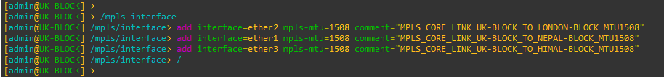

Figure 87: Configuration MPLS MTU on Interfaces to UK-BLOCK Router Through CMD

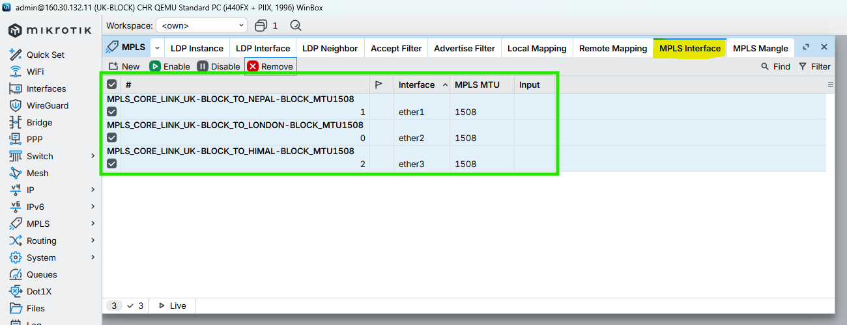

Figure 88: Configuration MPLS MTU on Interfaces to UK-BLOCK Router Through WINBOX

## NEPAL-BLOCK

### Enable LDP on Core Interfaces ONLY

CMD

|  |
| --- |
| /mpls ldp interface  add interface=ether3 comment="LDP_CORE_LINK_NEPAL-BLOCK_10.0.0.6/30_TO_LONDON-BLOCK_10.0.0.5/30"  add interface=ether1 comment="LDP_CORE_LINK_NEPAL-BLOCK_10.0.0.30/30_TO_UK-BLOCK_10.0.0.29/30"  add interface=ether2 comment="LDP_CORE_LINK_NEPAL-BLOCK_10.0.0.37/30_TO_BRIT-BLOCK_10.0.0.38/30"  / |

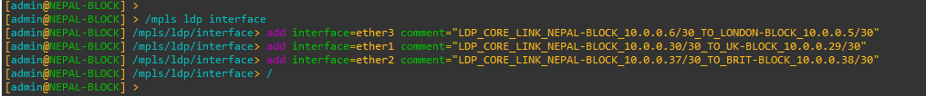

Figure 89: Configuration MPLS LDP Interfaces to NEPAL-BLOCK Router Through CMD

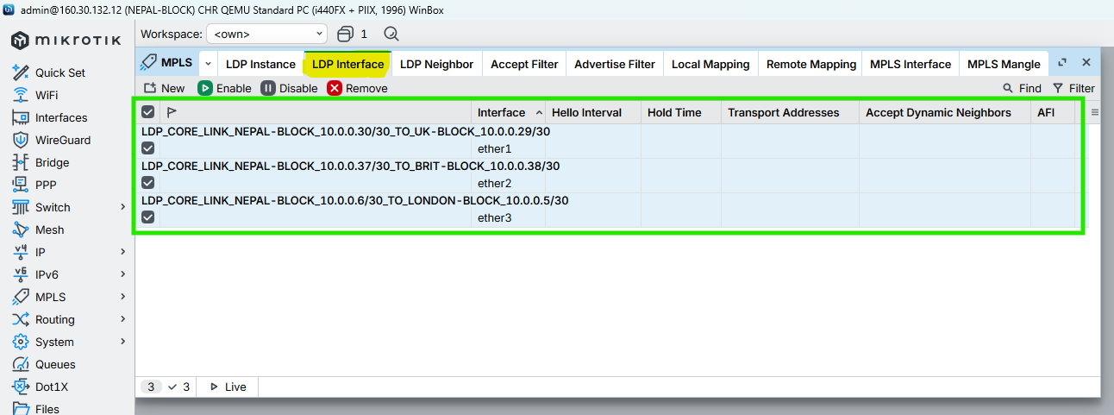

Figure 90: Configuration MPLS LDP Interfaces to NEPAL-BLOCK Router Through WINBOX

### Enable MPLS & Set MPLS MTU on interfaces

CMD

|  |
| --- |
| /mpls interface  add interface=ether3 mpls-mtu=1508 comment="MPLS_CORE_LINK_NEPAL-BLOCK_TO_LONDON-BLOCK_MTU1508"  add interface=ether1 mpls-mtu=1508 comment="MPLS_CORE_LINK_NEPAL-BLOCK_TO_UK-BLOCK_MTU1508"  add interface=ether2 mpls-mtu=1508 comment="MPLS_CORE_LINK_NEPAL-BLOCK_TO_BRIT-BLOCK_MTU1508"  / |

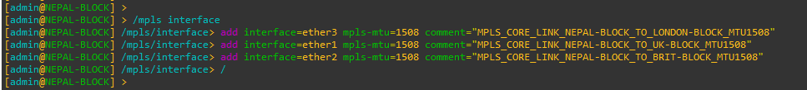

Figure 91: Configuration MPLS MTU on Interfaces to NEPAL-BLOCK Router Through CMD

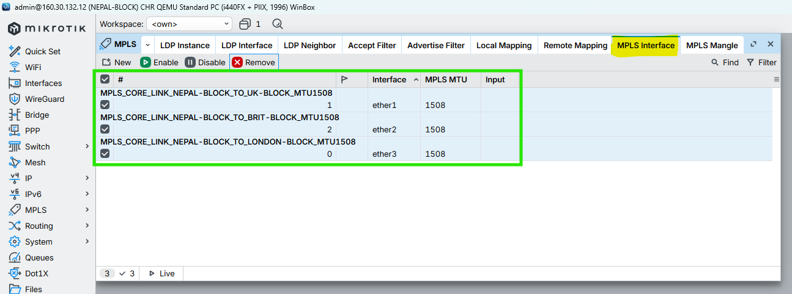

Figure 92: Configuration MPLS MTU on Interfaces to NEPAL-BLOCK Router Through WINBOX

## HIMAL-BLOCK

### Enable LDP on Core Interfaces ONLY

CMD

|  |
| --- |
| /mpls ldp interface  add interface=ether3 comment="LDP_CORE_LINK_HIMAL-BLOCK_10.0.0.33/30_TO_UK-BLOCK_10.0.0.34/30"  add interface=ether4 comment="LDP_CORE_LINK_HIMAL-BLOCK_10.0.0.10/30_TO_LONDON-BLOCK_10.0.0.9/30"  add interface=ether2 comment="LDP_CORE_LINK_HIMAL-BLOCK_10.0.0.42/30_TO_SKILL-BLOCK_10.0.0.41/30"  / |

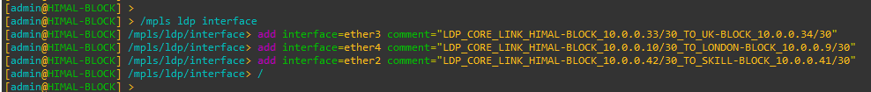

Figure 93: Configuration MPLS LDP Interfaces to HIMAL-BLOCK Router Through CMD

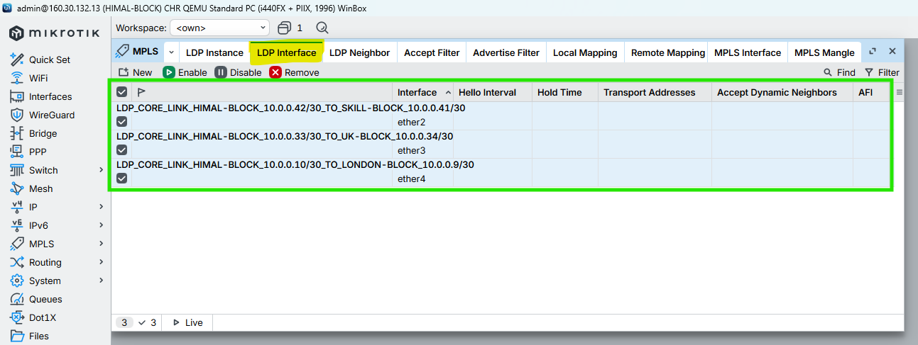

Figure 94: Configuration MPLS LDP Interfaces to HIMAL-BLOCK Router Through WINBOX

### Enable MPLS & Set MPLS MTU on interfaces

CMD

|  |
| --- |
| /mpls interface  add interface=ether3 mpls-mtu=1508 comment="MPLS_CORE_LINK_HIMAL-BLOCK_TO_UK-BLOCK_MTU1508"  add interface=ether4 mpls-mtu=1508 comment="MPLS_CORE_LINK_HIMAL-BLOCK_TO_LONDON-BLOCK_MTU1508"  add interface=ether2 mpls-mtu=1508 comment="MPLS_CORE_LINK_HIMAL-BLOCK_TO_SKILL-BLOCK_MTU1508"  / |

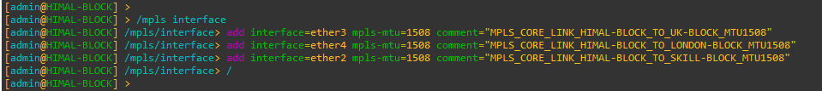

Figure 95: Configuration MPLS MTU on Interfaces to HIMAL-BLOCK Router Through CMD

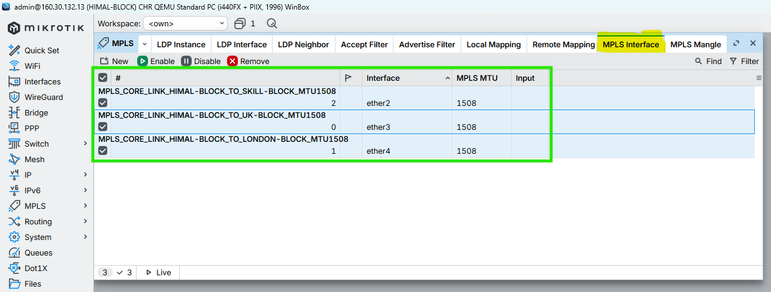

Figure 96: Configuration MPLS MTU on Interfaces to HIMAL-BLOCK Router Through WINBOX

## BRIT-BLOCK

### Enable LDP on Core Interfaces ONLY

CMD

|  |
| --- |
| /mpls ldp interface  add interface=ether2 comment="LDP_CORE_LINK_BRIT-BLOCK_10.0.0.38/30_TO_NEPAL-BLOCK_10.0.0.37/30"  add interface=ether5 comment="LDP_CORE_LINK_BRIT-BLOCK_10.0.0.14/30_TO_LONDON-BLOCK_10.0.0.13/30"  add interface=ether1 comment="LDP_CORE_LINK_BRIT-BLOCK_10.0.0.46/30_TO_KUMARI-BLOCK_10.0.0.44/30"  / |

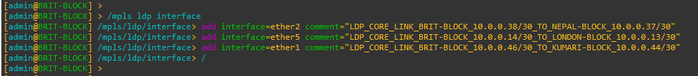

Figure 97: Configuration MPLS LDP Interfaces to BRIT-BLOCK Router Through CMD

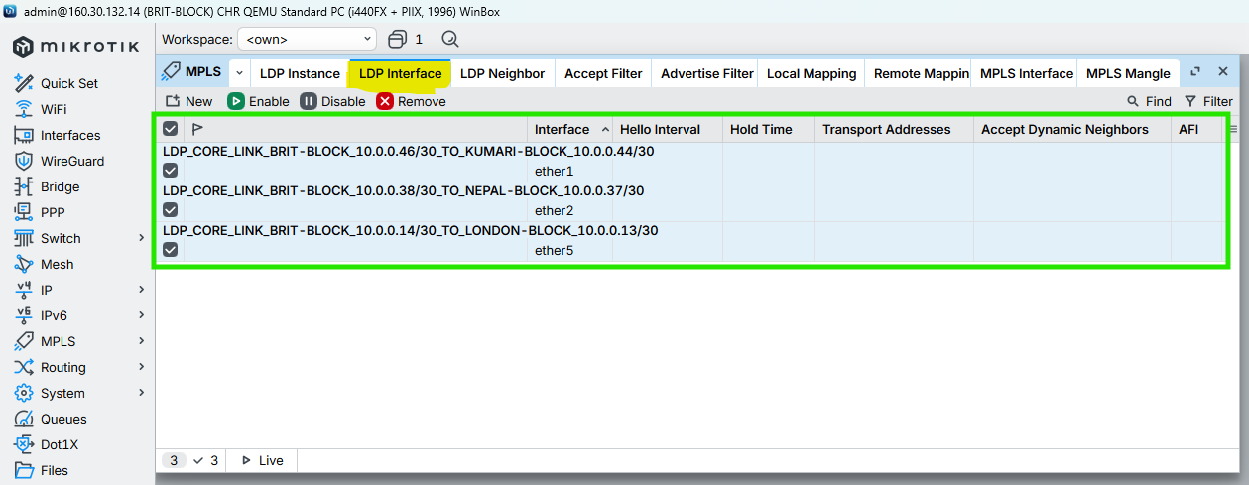

Figure 98: Configuration MPLS LDP Interfaces to BRIT-BLOCK Router Through WINBOX

### Enable MPLS & Set MPLS MTU on interfaces

CMD

|  |
| --- |
| /mpls interface  add interface=ether2 mpls-mtu=1508 comment="MPLS_CORE_LINK_BRIT-BLOCK_TO_NEPAL-BLOCK_MTU1508"  add interface=ether5 mpls-mtu=1508 comment="MPLS_CORE_LINK_BRIT-BLOCK_TO_LONDON-BLOCK_MTU1508"  add interface=ether1 mpls-mtu=1508 comment="MPLS_CORE_LINK_BRIT-BLOCK_TO_KUMARI-BLOCK_MTU1508"  / |

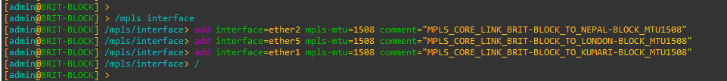

Figure 99: Configuration MPLS MTU on Interfaces to BRIT-BLOCK Router Through CMD

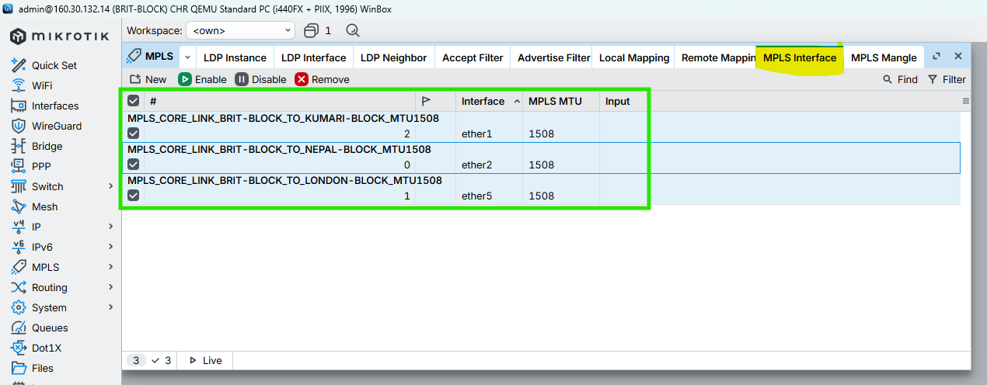

Figure 100: Configuration MPLS MTU on Interfaces to BRIT-BLOCK Router Through WINBOX

## SKILL-BLOCK

### Enable LDP on Core Interfaces ONLY

CMD

|  |
| --- |
| /mpls ldp interface  add interface=ether2 comment="LDP_CORE_LINK_SKILL-BLOCK_10.0.0.41/30_TO_HIMAL-BLOCK_10.0.0.42/30"  add interface=ether6 comment="LDP_CORE_LINK_SKILL-BLOCK_10.0.0.18/30_TO_LONDON-BLOCK_10.0.0.17/30"  add interface=ether1 comment="LDP_CORE_LINK_SKILL-BLOCK_10.0.0.50/30_TO_KUMARI-BLOCK_10.0.0.49/30"  / |

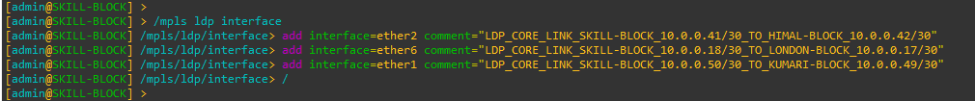

Figure 101: Configuration MPLS LDP Interfaces to SKILL-BLOCK Router Through CMD

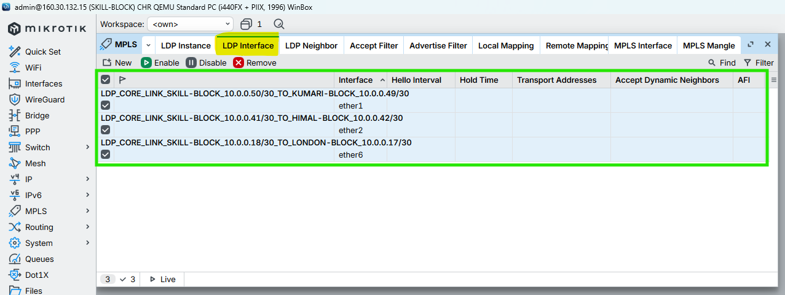

Figure 102: Configuration MPLS LDP Interfaces to SKILL-BLOCK Router Through WINBOX

### Enable MPLS & Set MPLS MTU on interfaces

CMD

|  |
| --- |
| /mpls interface  add interface=ether2 mpls-mtu=1508 comment="MPLS_CORE_LINK_SKILL-BLOCK_TO_HIMAL-BLOCK_MTU1508"  add interface=ether6 mpls-mtu=1508 comment="MPLS_CORE_LINK_SKILL-BLOCK_TO_LONDON-BLOCK_MTU1508"  add interface=ether1 mpls-mtu=1508 comment="MPLS_CORE_LINK_SKILL-BLOCK_TO_KUMARI-BLOCK_MTU1508"  / |

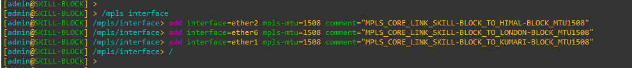

Figure 103: Configuration MPLS MTU on Interfaces to SKILL-BLOCK Router Through CMD

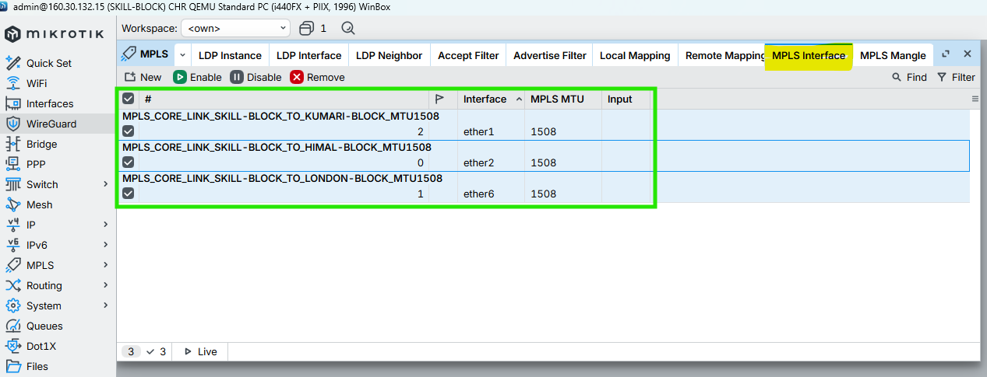

Figure 104: Configuration MPLS MTU on Interfaces to SKILL-BLOCK Router Through WINBOX\

## ALUMNI-BLOCK

### Enable LDP on Core Interfaces ONLY

CMD

|  |
| --- |
| /mpls ldp interface  add interface=ether7 comment="LDP_CORE_LINK_ALUMNI-BLOCK_10.0.0.22/30_TO_LONDON-BLOCK_10.0.0.21/30"  add interface=ether1 comment="LDP_CORE_LINK_ALUMNI-BLOCK_10.0.0.49/30_TO_SKILL-BLOCK_10.0.0.50/30"  add interface=ether2 comment="LDP_CORE_LINK_ALUMNI-BLOCK_10.0.0.53/30_TO_KUMARI-BLOCK_10.0.0.54/30"  / |

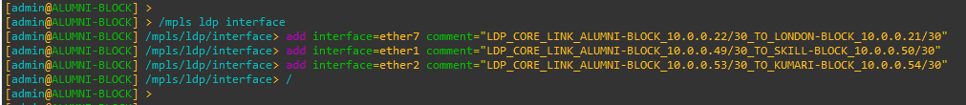

Figure 105: Configuration MPLS LDP Interfaces to ALUMNI-BLOCK Router Through CMD

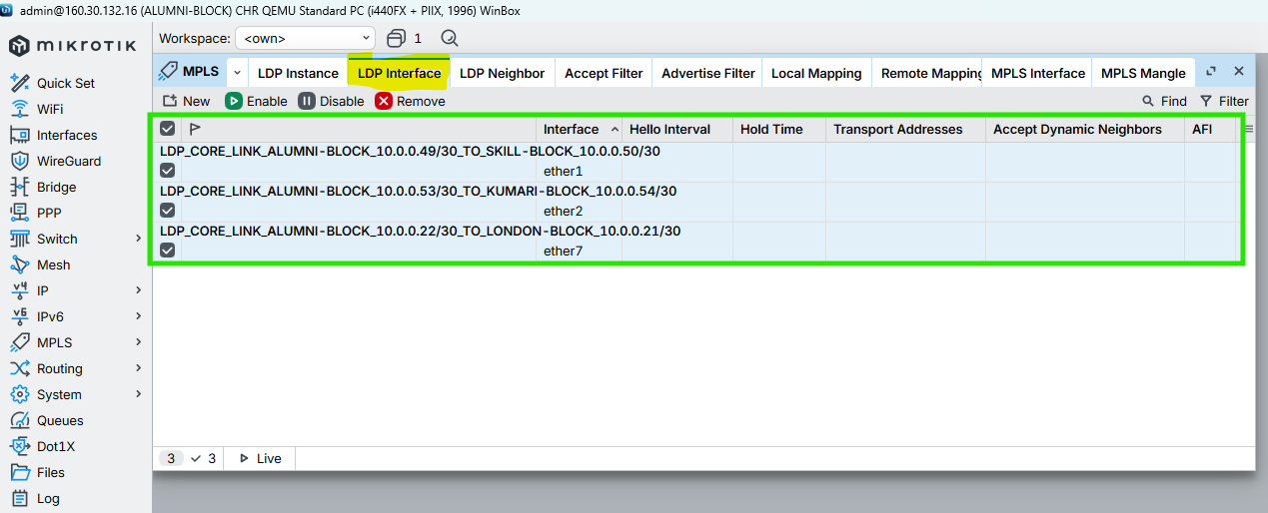

Figure 106: Configuration MPLS LDP Interfaces to ALUMNI-BLOCK Router Through WINBOX

### Enable MPLS & Set MPLS MTU on interfaces

CMD

|  |
| --- |
| /mpls interface  add interface=ether7 mpls-mtu=1508 comment="MPLS_CORE_LINK_ALUMNI-BLOCK_TO_LONDON-BLOCK_MTU1508"  add interface=ether1 mpls-mtu=1508 comment="MPLS_CORE_LINK_ALUMNI-BLOCK_TO_SKILL-BLOCK_MTU1508"  add interface=ether2 mpls-mtu=1508 comment="MPLS_CORE_LINK_ALUMNI-BLOCK_TO_KUMARI-BLOCK_MTU1508"  / |

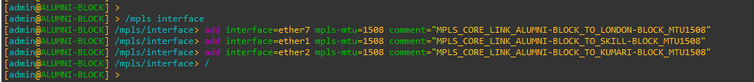

Figure 107: Configuration MPLS MTU on Interfaces to ALUMNI-BLOCK Router Through CMD

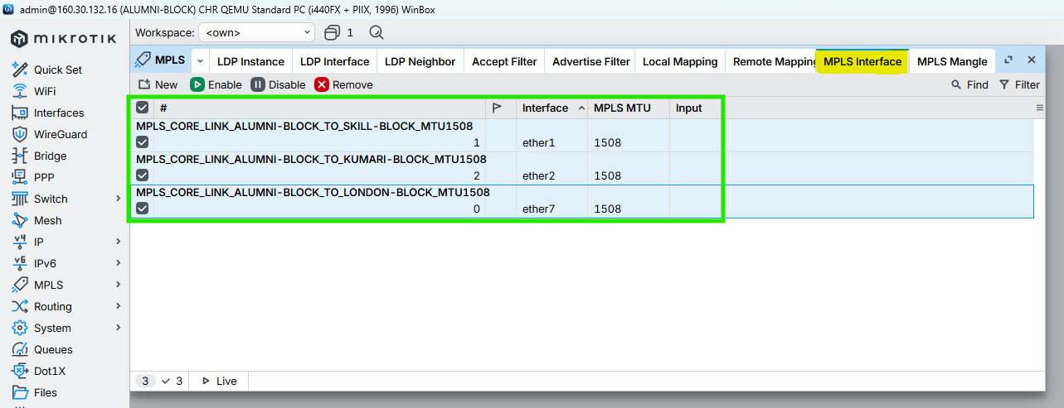

Figure 108: Configuration MPLS MTU on Interfaces to ALUMNI-BLOCK Router Through WINBOX

## KUMARI-BLOCK

### Enable LDP on Core Interfaces ONLY

CMD

|  |
| --- |
| /mpls ldp interface  add interface=ether8 comment="LDP_CORE_LINK_KUMARI-BLOCK_10.0.0.26/30_TO_LONDON-BLOCK_10.0.0.25/30"  add interface=ether2 comment="LDP_CORE_LINK_KUMARI-BLOCK_10.0.0.54/30_TO_ALUMNI-BLOCK_10.0.0.53/30"  add interface=ether1 comment="LDP_CORE_LINK_KUMARI-BLOCK_10.0.0.44/30_TO_BRIT-BLOCK_10.0.0.46/30"  / |

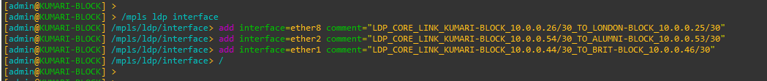

Figure 109: Configuration MPLS LDP Interfaces to KUMARI-BLOCK Router Through CMD

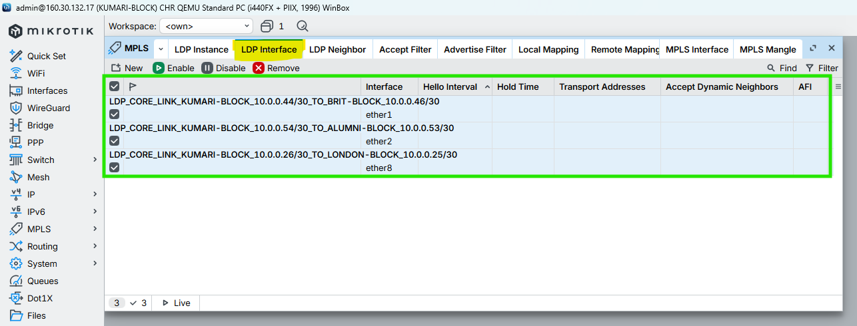

Figure 110: Configuration MPLS LDP Interfaces to KUMARI-BLOCK Router Through WINBOX

### Enable MPLS & Set MPLS MTU on interfaces

CMD

|  |
| --- |
| /mpls interface  add interface=ether8 mpls-mtu=1508 comment="MPLS_CORE_LINK_KUMARI-BLOCK_TO_LONDON-BLOCK_MTU1508"  add interface=ether2 mpls-mtu=1508 comment="MPLS_CORE_LINK_KUMARI-BLOCK_TO_ALUMNI-BLOCK_MTU1508"  add interface=ether1 mpls-mtu=1508 comment="MPLS_CORE_LINK_KUMARI-BLOCK_TO_BRIT-BLOCK_MTU1508"  / |

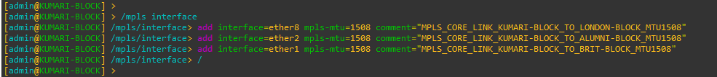

Figure 111: Configuration MPLS MTU on Interfaces to KUMARI-BLOCK Router Through CMD

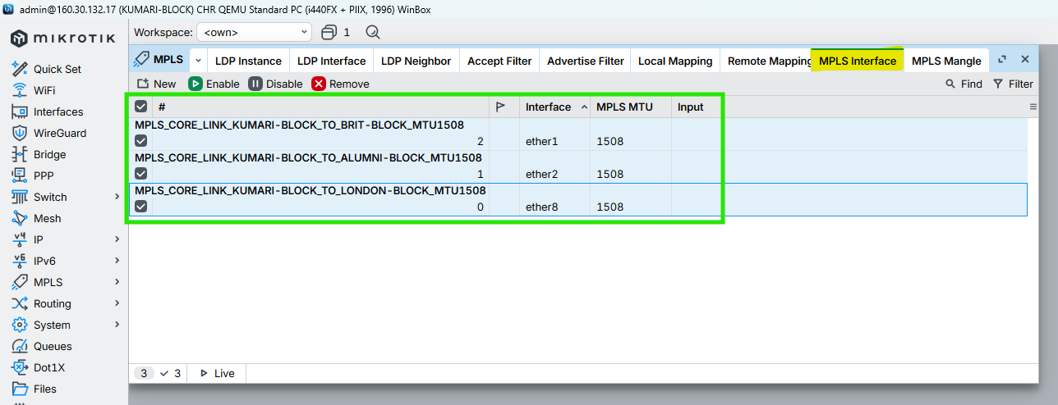

Figure 112: Configuration MPLS MTU on Interfaces to KUMARI-BLOCK Router Through WINBOX

# VPLS Configuration for VLAN Transport (Points to Points) Routers

## LONDON-BLOCK

### Create VPLS BRIDGES (L2 DOMAINS)

CMD

|  |
| --- |
| /interface bridge  add name=BR_VL_STUDENT_100 protocol-mode=none comment="VL_STUDENT_100 - VPLS Bridge"  add name=BR_VL_TEACHER_200 protocol-mode=none comment="VL_TEACHER_200 - VPLS Bridge"  add name=BR_VL_STAFF_300 protocol-mode=none comment="VL_STAFF_300 - VPLS Bridge"  / |

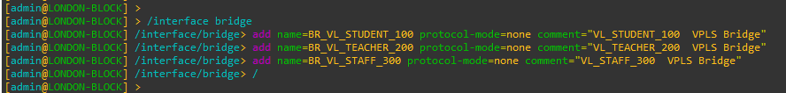

### VPLS Full-Mesh for LONDON-BLOCK

CMD

|  |
| --- |
| /interface vpls  add name=VPLS_UK_VL_STUDENT_100 peer=160.30.132.11 vpls-id=100:11 mtu=1500 bridge=BR_VL_STUDENT_100 comment="VL_STUDENT_100 - London to UK Block"  add name=VPLS_NEPAL_VL_STUDENT_100 peer=160.30.132.12 vpls-id=100:12 mtu=1500 bridge=BR_VL_STUDENT_100 comment="VL_STUDENT_100 - London to Nepal Block"  add name=VPLS_HIMAL_VL_STUDENT_100 peer=160.30.132.13 vpls-id=100:13 mtu=1500 bridge=BR_VL_STUDENT_100 comment="VL_STUDENT_100 - London to Himal Block"  add name=VPLS_BRIT_VL_STUDENT_100 peer=160.30.132.14 vpls-id=100:14 mtu=1500 bridge=BR_VL_STUDENT_100 comment="VL_STUDENT_100 - London to British Block"  add name=VPLS_SKILL_VL_STUDENT_100 peer=160.30.132.15 vpls-id=100:15 mtu=1500 bridge=BR_VL_STUDENT_100 comment="VL_STUDENT_100 - London to Skill Block"  add name=VPLS_ALUMNI_VL_STUDENT_100 peer=160.30.132.16 vpls-id=100:16 mtu=1500 bridge=BR_VL_STUDENT_100 comment="VL_STUDENT_100 - London to Alumni Block"  add name=VPLS_KUMARI_VL_STUDENT_100 peer=160.30.132.17 vpls-id=100:17 mtu=1500 bridge=BR_VL_STUDENT_100 comment="VL_STUDENT_100 - London to Kumari Block"  /interface vpls  add name=VPLS_UK_VL_TEACHER_200 peer=160.30.132.11 vpls-id=200:11 mtu=1500 bridge=BR_VL_TEACHER_200 comment="VL_TEACHER_200 - London to UK"  add name=VPLS_NEPAL_VL_TEACHER_200 peer=160.30.132.12 vpls-id=200:12 mtu=1500 bridge=BR_VL_TEACHER_200 comment="VL_TEACHER_200 - London to Nepal"  add name=VPLS_HIMAL_VL_TEACHER_200 peer=160.30.132.13 vpls-id=200:13 mtu=1500 bridge=BR_VL_TEACHER_200 comment="VL_TEACHER_200 - London to Himal"  add name=VPLS_BRIT_VL_TEACHER_200 peer=160.30.132.14 vpls-id=200:14 mtu=1500 bridge=BR_VL_TEACHER_200 comment="VL_TEACHER_200 - London to British"  add name=VPLS_SKILL_VL_TEACHER_200 peer=160.30.132.15 vpls-id=200:15 mtu=1500 bridge=BR_VL_TEACHER_200 comment="VL_TEACHER_200 - London to Skill"  add name=VPLS_ALUMNI_VL_TEACHER_200 peer=160.30.132.16 vpls-id=200:16 mtu=1500 bridge=BR_VL_TEACHER_200 comment="VL_TEACHER_200 - London to Alumni"  add name=VPLS_KUMARI_VL_TEACHER_200 peer=160.30.132.17 vpls-id=200:17 mtu=1500 bridge=BR_VL_TEACHER_200 comment="VL_TEACHER_200 - London to Kumari"  /interface vpls  add name=VPLS_UK_VL_STAFF_300 peer=160.30.132.11 vpls-id=300:11 mtu=1500 bridge=BR_VL_STAFF_300 comment="VL_STAFF_300 - London to UK"  add name=VPLS_NEPAL_VL_STAFF_300 peer=160.30.132.12 vpls-id=300:12 mtu=1500 bridge=BR_VL_STAFF_300 comment="VL_STAFF_300 - London to Nepal"  add name=VPLS_HIMAL_VL_STAFF_300 peer=160.30.132.13 vpls-id=300:13 mtu=1500 bridge=BR_VL_STAFF_300 comment="VL_STAFF_300 - London to Himal"  add name=VPLS_BRIT_VL_STAFF_300 peer=160.30.132.14 vpls-id=300:14 mtu=1500 bridge=BR_VL_STAFF_300 comment="VL_STAFF_300 - London to British"  add name=VPLS_SKILL_VL_STAFF_300 peer=160.30.132.15 vpls-id=300:15 mtu=1500 bridge=BR_VL_STAFF_300 comment="VL_STAFF_300 - London to Skill"  add name=VPLS_ALUMNI_VL_STAFF_300 peer=160.30.132.16 vpls-id=300:16 mtu=1500 bridge=BR_VL_STAFF_300 comment="VL_STAFF_300 - London to Alumni"  add name=VPLS_KUMARI_VL_STAFF_300 peer=160.30.132.17 vpls-id=300:17 mtu=1500 bridge=BR_VL_STAFF_300 comment="VL_STAFF_300 - London to Kumari"  /  /interface vpls print  /interface bridge port print |

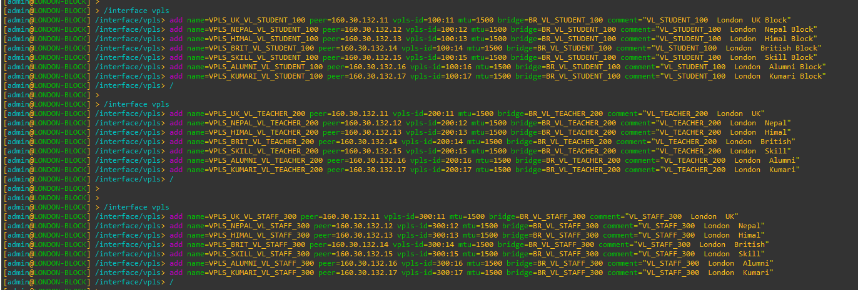

## UK-BLOCK

### Create VPLS BRIDGES (L2 DOMAINS)

CMD

|  |
| --- |
| /interface bridge  add name=BR_VL_STUDENT_100 protocol-mode=none comment="VL_STUDENT_100 - VPLS Bridge"  add name=BR_VL_TEACHER_200 protocol-mode=none comment="VL_TEACHER_200 - VPLS Bridge"  add name=BR_VL_STAFF_300 protocol-mode=none comment="VL_STAFF_300 - VPLS Bridge"  / |

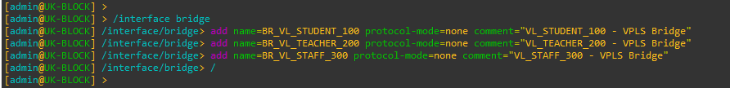

### VPLS Full-Mesh for UK-BLOCK

CMD

|  |
| --- |
| /interface vpls  add name=VPLS_LONDON_VL_STUDENT_100 peer=160.30.132.1 vpls-id=100:11 mtu=1500 bridge=BR_VL_STUDENT_100 comment="VL_STUDENT_100 - UK to London"  add name=VPLS_NEPAL_VL_STUDENT_100 peer=160.30.132.12 vpls-id=100:12 mtu=1500 bridge=BR_VL_STUDENT_100 comment="VL_STUDENT_100 - UK to Nepal"  add name=VPLS_HIMAL_VL_STUDENT_100 peer=160.30.132.13 vpls-id=100:13 mtu=1500 bridge=BR_VL_STUDENT_100 comment="VL_STUDENT_100 - UK to Himal"  add name=VPLS_BRIT_VL_STUDENT_100 peer=160.30.132.14 vpls-id=100:14 mtu=1500 bridge=BR_VL_STUDENT_100 comment="VL_STUDENT_100 - UK to British"  add name=VPLS_SKILL_VL_STUDENT_100 peer=160.30.132.15 vpls-id=100:15 mtu=1500 bridge=BR_VL_STUDENT_100 comment="VL_STUDENT_100 - UK to Skill"  add name=VPLS_ALUMNI_VL_STUDENT_100 peer=160.30.132.16 vpls-id=100:16 mtu=1500 bridge=BR_VL_STUDENT_100 comment="VL_STUDENT_100 - UK to Alumni"  add name=VPLS_KUMARI_VL_STUDENT_100 peer=160.30.132.17 vpls-id=100:17 mtu=1500 bridge=BR_VL_STUDENT_100 comment="VL_STUDENT_100 - UK to Kumari"  /  /interface vpls  add name=VPLS_LONDON_VL_TEACHER_200 peer=160.30.132.1 vpls-id=200:11 mtu=1500 bridge=BR_VL_TEACHER_200 comment="VL_TEACHER_200 - UK to London"  add name=VPLS_NEPAL_VL_TEACHER_200 peer=160.30.132.12 vpls-id=200:12 mtu=1500 bridge=BR_VL_TEACHER_200 comment="VL_TEACHER_200 - UK to Nepal"  add name=VPLS_HIMAL_VL_TEACHER_200 peer=160.30.132.13 vpls-id=200:13 mtu=1500 bridge=BR_VL_TEACHER_200 comment="VL_TEACHER_200 - UK to Himal"  add name=VPLS_BRIT_VL_TEACHER_200 peer=160.30.132.14 vpls-id=200:14 mtu=1500 bridge=BR_VL_TEACHER_200 comment="VL_TEACHER_200 - UK to British"  add name=VPLS_SKILL_VL_TEACHER_200 peer=160.30.132.15 vpls-id=200:15 mtu=1500 bridge=BR_VL_TEACHER_200 comment="VL_TEACHER_200 - UK to Skill"  add name=VPLS_ALUMNI_VL_TEACHER_200 peer=160.30.132.16 vpls-id=200:16 mtu=1500 bridge=BR_VL_TEACHER_200 comment="VL_TEACHER_200 - UK to Alumni"  add name=VPLS_KUMARI_VL_TEACHER_200 peer=160.30.132.17 vpls-id=200:17 mtu=1500 bridge=BR_VL_TEACHER_200 comment="VL_TEACHER_200 - UK to Kumari"  /  /interface vpls  add name=VPLS_LONDON_VL_STAFF_300 peer=160.30.132.1 vpls-id=300:11 mtu=1500 bridge=BR_VL_STAFF_300 comment="VL_STAFF_300 - UK to London"  add name=VPLS_NEPAL_VL_STAFF_300 peer=160.30.132.12 vpls-id=300:12 mtu=1500 bridge=BR_VL_STAFF_300 comment="VL_STAFF_300 - UK to Nepal"  add name=VPLS_HIMAL_VL_STAFF_300 peer=160.30.132.13 vpls-id=300:13 mtu=1500 bridge=BR_VL_STAFF_300 comment="VL_STAFF_300 - UK to Himal"  add name=VPLS_BRIT_VL_STAFF_300 peer=160.30.132.14 vpls-id=300:14 mtu=1500 bridge=BR_VL_STAFF_300 comment="VL_STAFF_300 - UK to British"  add name=VPLS_SKILL_VL_STAFF_300 peer=160.30.132.15 vpls-id=300:15 mtu=1500 bridge=BR_VL_STAFF_300 comment="VL_STAFF_300 - UK to Skill"  add name=VPLS_ALUMNI_VL_STAFF_300 peer=160.30.132.16 vpls-id=300:16 mtu=1500 bridge=BR_VL_STAFF_300 comment="VL_STAFF_300 - UK to Alumni"  add name=VPLS_KUMARI_VL_STAFF_300 peer=160.30.132.17 vpls-id=300:17 mtu=1500 bridge=BR_VL_STAFF_300 comment="VL_STAFF_300 - UK to Kumari"  /  /interface vpls print  /interface bridge port print |

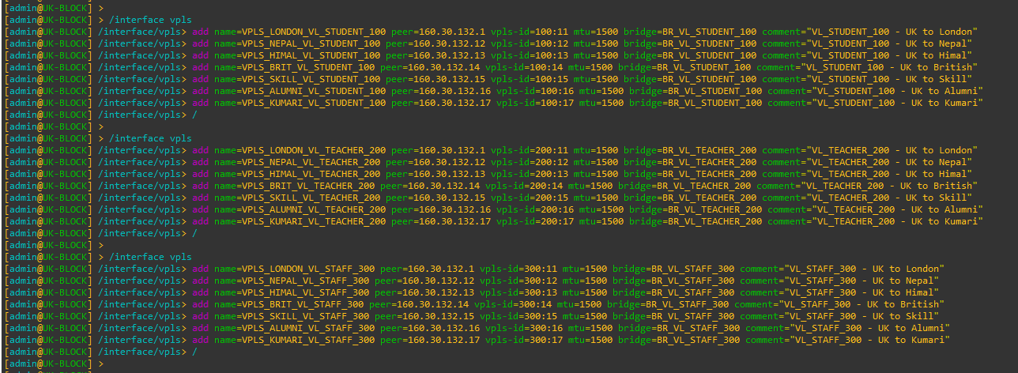

## NEPAL-BLOCK

### Create VPLS BRIDGES (L2 DOMAINS)

CMD

|  |
| --- |
| /interface bridge  add name=BR_VL_STUDENT_100 protocol-mode=none comment="VL_STUDENT_100 - VPLS Bridge"  add name=BR_VL_TEACHER_200 protocol-mode=none comment="VL_TEACHER_200 - VPLS Bridge"  add name=BR_VL_STAFF_300 protocol-mode=none comment="VL_STAFF_300 - VPLS Bridge"  / |

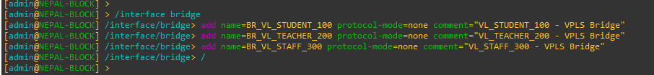

### VPLS Full-Mesh for NEPAL-BLOCK

CMD

|  |
| --- |
| /interface vpls  add name=VPLS_LONDON_VL_STUDENT_100 peer=160.30.132.1 vpls-id=100:12 mtu=1500 bridge=BR_VL_STUDENT_100 comment="VL_STUDENT_100 - Nepal To London"  add name=VPLS_UK_VL_STUDENT_100 peer=160.30.132.11 vpls-id=100:11 mtu=1500 bridge=BR_VL_STUDENT_100 comment="VL_STUDENT_100 - Nepal To UK"  add name=VPLS_HIMAL_VL_STUDENT_100 peer=160.30.132.13 vpls-id=100:13 mtu=1500 bridge=BR_VL_STUDENT_100 comment="VL_STUDENT_100 - Nepal To Himal"  add name=VPLS_BRIT_VL_STUDENT_100 peer=160.30.132.14 vpls-id=100:14 mtu=1500 bridge=BR_VL_STUDENT_100 comment="VL_STUDENT_100 - Nepal To British"  add name=VPLS_SKILL_VL_STUDENT_100 peer=160.30.132.15 vpls-id=100:15 mtu=1500 bridge=BR_VL_STUDENT_100 comment="VL_STUDENT_100 - Nepal To Skill"  add name=VPLS_ALUMNI_VL_STUDENT_100 peer=160.30.132.16 vpls-id=100:16 mtu=1500 bridge=BR_VL_STUDENT_100 comment="VL_STUDENT_100 - Nepal To Alumni"  add name=VPLS_KUMARI_VL_STUDENT_100 peer=160.30.132.17 vpls-id=100:17 mtu=1500 bridge=BR_VL_STUDENT_100 comment="VL_STUDENT_100 - Nepal To Kumari"  /  /interface vpls  add name=VPLS_LONDON_VL_TEACHER_200 peer=160.30.132.1 vpls-id=200:12 mtu=1500 bridge=BR_VL_TEACHER_200 comment="VL_TEACHER_200 - Nepal To London"  add name=VPLS_UK_VL_TEACHER_200 peer=160.30.132.11 vpls-id=200:11 mtu=1500 bridge=BR_VL_TEACHER_200 comment="VL_TEACHER_200 - Nepal To UK"  add name=VPLS_HIMAL_VL_TEACHER_200 peer=160.30.132.13 vpls-id=200:13 mtu=1500 bridge=BR_VL_TEACHER_200 comment="VL_TEACHER_200 - Nepal To Himal"  add name=VPLS_BRIT_VL_TEACHER_200 peer=160.30.132.14 vpls-id=200:14 mtu=1500 bridge=BR_VL_TEACHER_200 comment="VL_TEACHER_200 - Nepal To British"  add name=VPLS_SKILL_VL_TEACHER_200 peer=160.30.132.15 vpls-id=200:15 mtu=1500 bridge=BR_VL_TEACHER_200 comment="VL_TEACHER_200 - Nepal To Skill"  add name=VPLS_ALUMNI_VL_TEACHER_200 peer=160.30.132.16 vpls-id=200:16 mtu=1500 bridge=BR_VL_TEACHER_200 comment="VL_TEACHER_200 - Nepal To Alumni"  add name=VPLS_KUMARI_VL_TEACHER_200 peer=160.30.132.17 vpls-id=200:17 mtu=1500 bridge=BR_VL_TEACHER_200 comment="VL_TEACHER_200 - Nepal To Kumari"  /  /interface vpls  add name=VPLS_LONDON_VL_STAFF_300 peer=160.30.132.1 vpls-id=300:12 mtu=1500 bridge=BR_VL_STAFF_300 comment="VL_STAFF_300 - Nepal To London"  add name=VPLS_UK_VL_STAFF_300 peer=160.30.132.11 vpls-id=300:11 mtu=1500 bridge=BR_VL_STAFF_300 comment="VL_STAFF_300 - Nepal To UK"  add name=VPLS_HIMAL_VL_STAFF_300 peer=160.30.132.13 vpls-id=300:13 mtu=1500 bridge=BR_VL_STAFF_300 comment="VL_STAFF_300 - Nepal To Himal"  add name=VPLS_BRIT_VL_STAFF_300 peer=160.30.132.14 vpls-id=300:14 mtu=1500 bridge=BR_VL_STAFF_300 comment="VL_STAFF_300 - Nepal To British"  add name=VPLS_SKILL_VL_STAFF_300 peer=160.30.132.15 vpls-id=300:15 mtu=1500 bridge=BR_VL_STAFF_300 comment="VL_STAFF_300 - Nepal To Skill"  add name=VPLS_ALUMNI_VL_STAFF_300 peer=160.30.132.16 vpls-id=300:16 mtu=1500 bridge=BR_VL_STAFF_300 comment="VL_STAFF_300 - Nepal To Alumni"  add name=VPLS_KUMARI_VL_STAFF_300 peer=160.30.132.17 vpls-id=300:17 mtu=1500 bridge=BR_VL_STAFF_300 comment="VL_STAFF_300 - Nepal To Kumari"  /  /interface vpls print  /interface bridge port print |

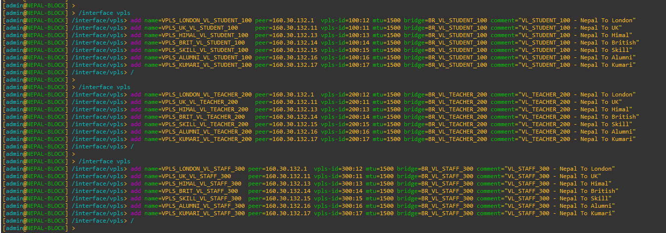

## HIMAL-BLOCK

### Create VPLS BRIDGES (L2 DOMAINS)

CMD

|  |
| --- |
| /interface bridge  add name=BR_VL_STUDENT_100 protocol-mode=none comment=”VL_STUDENT_100 – VPLS Bridge”  add name=BR_VL_TEACHER_200 protocol-mode=none comment=”VL_TEACHER_200 – VPLS Bridge”  add name=BR_VL_STAFF_300 protocol-mode=none comment=”VL_STAFF_300 – VPLS Bridge”  / |

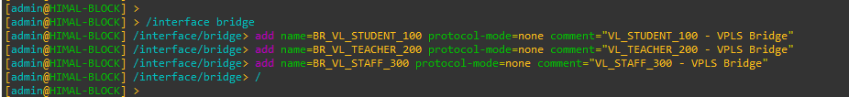

### VPLS Full-Mesh for HIMAL-BLOCK

CMD

|  |
| --- |
| /interface vpls  add name=VPLS_LONDON_VL_STUDENT_100 peer=160.30.132.1 vpls-id=100:13 mtu=1500 bridge=BR_VL_STUDENT_100 comment="VL_STUDENT_100 - Himal To London"  add name=VPLS_UK_VL_STUDENT_100 peer=160.30.132.11 vpls-id=100:11 mtu=1500 bridge=BR_VL_STUDENT_100 comment="VL_STUDENT_100 - Himal To UK"  add name=VPLS_NEPAL_VL_STUDENT_100 peer=160.30.132.12 vpls-id=100:12 mtu=1500 bridge=BR_VL_STUDENT_100 comment="VL_STUDENT_100 - Himal To Nepal"  add name=VPLS_BRIT_VL_STUDENT_100 peer=160.30.132.14 vpls-id=100:14 mtu=1500 bridge=BR_VL_STUDENT_100 comment="VL_STUDENT_100 - Himal To British"  add name=VPLS_SKILL_VL_STUDENT_100 peer=160.30.132.15 vpls-id=100:15 mtu=1500 bridge=BR_VL_STUDENT_100 comment="VL_STUDENT_100 - Himal To Skill"  add name=VPLS_ALUMNI_VL_STUDENT_100 peer=160.30.132.16 vpls-id=100:16 mtu=1500 bridge=BR_VL_STUDENT_100 comment="VL_STUDENT_100 - Himal To Alumni"  add name=VPLS_KUMARI_VL_STUDENT_100 peer=160.30.132.17 vpls-id=100:17 mtu=1500 bridge=BR_VL_STUDENT_100 comment="VL_STUDENT_100 - Himal To Kumari"  /  /interface vpls  add name=VPLS_LONDON_VL_TEACHER_200 peer=160.30.132.1 vpls-id=200:13 mtu=1500 bridge=BR_VL_TEACHER_200 comment="VL_TEACHER_200 - Himal To London"  add name=VPLS_UK_VL_TEACHER_200 peer=160.30.132.11 vpls-id=200:11 mtu=1500 bridge=BR_VL_TEACHER_200 comment="VL_TEACHER_200 - Himal To UK"  add name=VPLS_NEPAL_VL_TEACHER_200 peer=160.30.132.12 vpls-id=200:12 mtu=1500 bridge=BR_VL_TEACHER_200 comment="VL_TEACHER_200 - Himal To Nepal"  add name=VPLS_BRIT_VL_TEACHER_200 peer=160.30.132.14 vpls-id=200:14 mtu=1500 bridge=BR_VL_TEACHER_200 comment="VL_TEACHER_200 - Himal To British"  add name=VPLS_SKILL_VL_TEACHER_200 peer=160.30.132.15 vpls-id=200:15 mtu=1500 bridge=BR_VL_TEACHER_200 comment="VL_TEACHER_200 - Himal To Skill"  add name=VPLS_ALUMNI_VL_TEACHER_200 peer=160.30.132.16 vpls-id=200:16 mtu=1500 bridge=BR_VL_TEACHER_200 comment="VL_TEACHER_200 - Himal To Alumni"  add name=VPLS_KUMARI_VL_TEACHER_200 peer=160.30.132.17 vpls-id=200:17 mtu=1500 bridge=BR_VL_TEACHER_200 comment="VL_TEACHER_200 - Himal To Kumari"  /  /interface vpls  add name=VPLS_LONDON_VL_STAFF_300 peer=160.30.132.1 vpls-id=300:13 mtu=1500 bridge=BR_VL_STAFF_300 comment="VL_STAFF_300 - Himal To London"  add name=VPLS_UK_VL_STAFF_300 peer=160.30.132.11 vpls-id=300:11 mtu=1500 bridge=BR_VL_STAFF_300 comment="VL_STAFF_300 - Himal To UK"  add name=VPLS_NEPAL_VL_STAFF_300 peer=160.30.132.12 vpls-id=300:12 mtu=1500 bridge=BR_VL_STAFF_300 comment="VL_STAFF_300 - Himal To Nepal"  add name=VPLS_BRIT_VL_STAFF_300 peer=160.30.132.14 vpls-id=300:14 mtu=1500 bridge=BR_VL_STAFF_300 comment="VL_STAFF_300 - Himal To British"  add name=VPLS_SKILL_VL_STAFF_300 peer=160.30.132.15 vpls-id=300:15 mtu=1500 bridge=BR_VL_STAFF_300 comment="VL_STAFF_300 - Himal To Skill"  add name=VPLS_ALUMNI_VL_STAFF_300 peer=160.30.132.16 vpls-id=300:16 mtu=1500 bridge=BR_VL_STAFF_300 comment="VL_STAFF_300 - Himal To Alumni"  add name=VPLS_KUMARI_VL_STAFF_300 peer=160.30.132.17 vpls-id=300:17 mtu=1500 bridge=BR_VL_STAFF_300 comment="VL_STAFF_300 - Himal To Kumari"  /  /interface vpls print  /interface bridge port print |

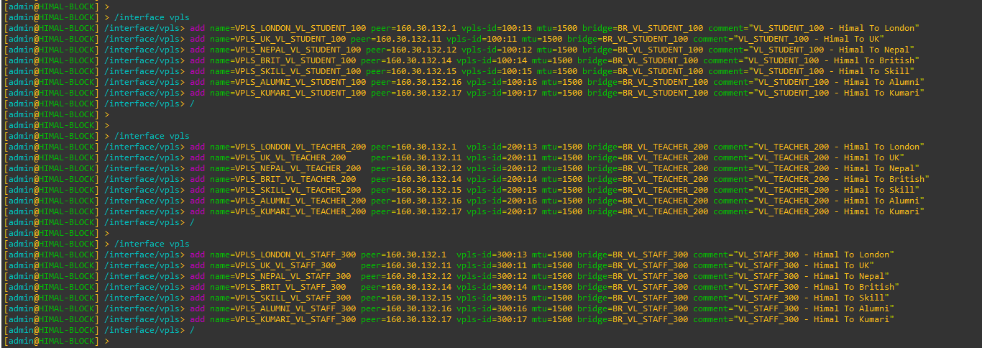

## BRIT-BLOCK

### Create VPLS BRIDGES (L2 DOMAINS)

CMD

|  |
| --- |
| /interface bridge  add name=BR_VL_STUDENT_100 protocol-mode=none comment=”VL_STUDENT_100 – VPLS Bridge”  add name=BR_VL_TEACHER_200 protocol-mode=none comment=”VL_TEACHER_200 – VPLS Bridge”  add name=BR_VL_STAFF_300 protocol-mode=none comment=”VL_STAFF_300 – VPLS Bridge”  / |

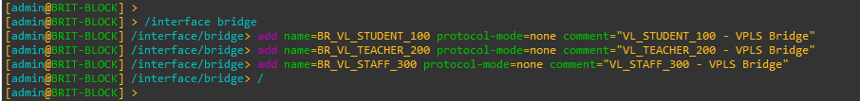

### VPLS Full-Mesh for BRIT-BLOCK

CMD

|  |
| --- |
| /interface vpls  add name=VPLS_LONDON_VL_STUDENT_100 peer=160.30.132.1 vpls-id=100:14 mtu=1500 bridge=BR_VL_STUDENT_100 comment="VL_STUDENT_100 - British To London"  add name=VPLS_UK_VL_STUDENT_100 peer=160.30.132.11 vpls-id=100:11 mtu=1500 bridge=BR_VL_STUDENT_100 comment="VL_STUDENT_100 - British To UK"  add name=VPLS_HIMAL_VL_STUDENT_100 peer=160.30.132.13 vpls-id=100:13 mtu=1500 bridge=BR_VL_STUDENT_100 comment="VL_STUDENT_100 - British To Himal"  add name=VPLS_NEPAL_VL_STUDENT_100 peer=160.30.132.12 vpls-id=100:12 mtu=1500 bridge=BR_VL_STUDENT_100 comment="VL_STUDENT_100 - British To Nepal"  add name=VPLS_SKILL_VL_STUDENT_100 peer=160.30.132.15 vpls-id=100:15 mtu=1500 bridge=BR_VL_STUDENT_100 comment="VL_STUDENT_100 - British To Skill"  add name=VPLS_ALUMNI_VL_STUDENT_100 peer=160.30.132.16 vpls-id=100:16 mtu=1500 bridge=BR_VL_STUDENT_100 comment="VL_STUDENT_100 - British To Alumni"  add name=VPLS_KUMARI_VL_STUDENT_100 peer=160.30.132.17 vpls-id=100:17 mtu=1500 bridge=BR_VL_STUDENT_100 comment="VL_STUDENT_100 - British To Kumari"  /  /interface vpls  add name=VPLS_LONDON_VL_TEACHER_200 peer=160.30.132.1 vpls-id=200:14 mtu=1500 bridge=BR_VL_TEACHER_200 comment="VL_TEACHER_200 - British To London"  add name=VPLS_UK_VL_TEACHER_200 peer=160.30.132.11 vpls-id=200:11 mtu=1500 bridge=BR_VL_TEACHER_200 comment="VL_TEACHER_200 - British To UK"  add name=VPLS_HIMAL_VL_TEACHER_200 peer=160.30.132.13 vpls-id=200:13 mtu=1500 bridge=BR_VL_TEACHER_200 comment="VL_TEACHER_200 - British To Himal"  add name=VPLS_NEPAL_VL_TEACHER_200 peer=160.30.132.12 vpls-id=200:12 mtu=1500 bridge=BR_VL_TEACHER_200 comment="VL_TEACHER_200 - British To Nepal"  add name=VPLS_SKILL_VL_TEACHER_200 peer=160.30.132.15 vpls-id=200:15 mtu=1500 bridge=BR_VL_TEACHER_200 comment="VL_TEACHER_200 - British To Skill"  add name=VPLS_ALUMNI_VL_TEACHER_200 peer=160.30.132.16 vpls-id=200:16 mtu=1500 bridge=BR_VL_TEACHER_200 comment="VL_TEACHER_200 - British To Alumni"  add name=VPLS_KUMARI_VL_TEACHER_200 peer=160.30.132.17 vpls-id=200:17 mtu=1500 bridge=BR_VL_TEACHER_200 comment="VL_TEACHER_200 - British To Kumari"  /  /interface vpls  add name=VPLS_LONDON_VL_STAFF_300 peer=160.30.132.1 vpls-id=300:14 mtu=1500 bridge=BR_VL_STAFF_300 comment="VL_STAFF_300 - British To London"  add name=VPLS_UK_VL_STAFF_300 peer=160.30.132.11 vpls-id=300:11 mtu=1500 bridge=BR_VL_STAFF_300 comment="VL_STAFF_300 - British To UK"  add name=VPLS_HIMAL_VL_STAFF_300 peer=160.30.132.13 vpls-id=300:13 mtu=1500 bridge=BR_VL_STAFF_300 comment="VL_STAFF_300 - British To Himal"  add name=VPLS_NEPAL_VL_STAFF_300 peer=160.30.132.12 vpls-id=300:12 mtu=1500 bridge=BR_VL_STAFF_300 comment="VL_STAFF_300 - British To Nepal"  add name=VPLS_SKILL_VL_STAFF_300 peer=160.30.132.15 vpls-id=300:15 mtu=1500 bridge=BR_VL_STAFF_300 comment="VL_STAFF_300 - British To Skill"  add name=VPLS_ALUMNI_VL_STAFF_300 peer=160.30.132.16 vpls-id=300:16 mtu=1500 bridge=BR_VL_STAFF_300 comment="VL_STAFF_300 - British To Alumni"  add name=VPLS_KUMARI_VL_STAFF_300 peer=160.30.132.17 vpls-id=300:17 mtu=1500 bridge=BR_VL_STAFF_300 comment="VL_STAFF_300 - British To Kumari"  /  /interface vpls print  /interface bridge port print |

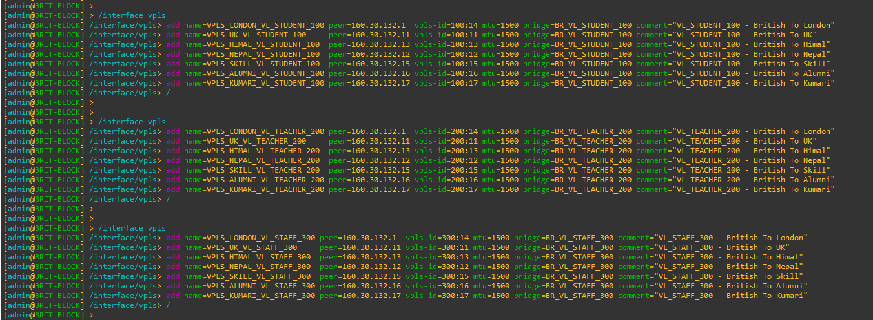

## SKILL-BLOCK

### Create VPLS BRIDGES (L2 DOMAINS)

CMD

|  |
| --- |
| /interface bridge  add name=BR_VL_STUDENT_100 protocol-mode=none comment="VL_STUDENT_100 - VPLS Bridge"  add name=BR_VL_TEACHER_200 protocol-mode=none comment="VL_TEACHER_200 - VPLS Bridge"  add name=BR_VL_STAFF_300 protocol-mode=none comment="VL_STAFF_300 - VPLS Bridge"  / |

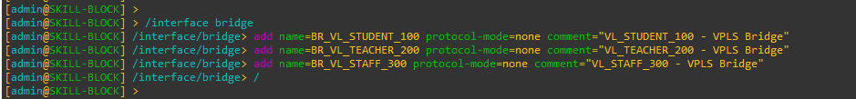

### VPLS Full-Mesh for SKILL-BLOCK

CMD

|  |
| --- |
| /interface vpls  add name=VPLS_LONDON_VL_STUDENT_100 peer=160.30.132.1 vpls-id=100:1 mtu=1500 bridge=BR_VL_STUDENT_100 comment="VL_STUDENT_100 - Skill To London"  add name=VPLS_UK_VL_STUDENT_100 peer=160.30.132.11 vpls-id=100:11 mtu=1500 bridge=BR_VL_STUDENT_100 comment="VL_STUDENT_100 - Skill To UK"  add name=VPLS_HIMAL_VL_STUDENT_100 peer=160.30.132.13 vpls-id=100:13 mtu=1500 bridge=BR_VL_STUDENT_100 comment="VL_STUDENT_100 - Skill To Himal"  add name=VPLS_NEPAL_VL_STUDENT_100 peer=160.30.132.12 vpls-id=100:12 mtu=1500 bridge=BR_VL_STUDENT_100 comment="VL_STUDENT_100 - Skill To Nepal"  add name=VPLS_BRITISH_VL_STUDENT_100 peer=160.30.132.14 vpls-id=100:14 mtu=1500 bridge=BR_VL_STUDENT_100 comment="VL_STUDENT_100 - Skill To British"  add name=VPLS_ALUMNI_VL_STUDENT_100 peer=160.30.132.16 vpls-id=100:16 mtu=1500 bridge=BR_VL_STUDENT_100 comment="VL_STUDENT_100 - Skill To Alumni"  add name=VPLS_KUMARI_VL_STUDENT_100 peer=160.30.132.17 vpls-id=100:17 mtu=1500 bridge=BR_VL_STUDENT_100 comment="VL_STUDENT_100 - Skill To Kumari"  /  /interface vpls  add name=VPLS_LONDON_VL_TEACHER_200 peer=160.30.132.1 vpls-id=200:1 mtu=1500 bridge=BR_VL_TEACHER_200 comment="VL_TEACHER_200 - Skill To London"  add name=VPLS_UK_VL_TEACHER_200 peer=160.30.132.11 vpls-id=200:11 mtu=1500 bridge=BR_VL_TEACHER_200 comment="VL_TEACHER_200 - Skill To UK"  add name=VPLS_HIMAL_VL_TEACHER_200 peer=160.30.132.13 vpls-id=200:13 mtu=1500 bridge=BR_VL_TEACHER_200 comment="VL_TEACHER_200 - Skill To Himal"  add name=VPLS_NEPAL_VL_TEACHER_200 peer=160.30.132.12 vpls-id=200:12 mtu=1500 bridge=BR_VL_TEACHER_200 comment="VL_TEACHER_200 - Skill To Nepal"  add name=VPLS_BRITISH_VL_TEACHER_200 peer=160.30.132.14 vpls-id=200:14 mtu=1500 bridge=BR_VL_TEACHER_200 comment="VL_TEACHER_200 - Skill To British"  add name=VPLS_ALUMNI_VL_TEACHER_200 peer=160.30.132.16 vpls-id=200:16 mtu=1500 bridge=BR_VL_TEACHER_200 comment="VL_TEACHER_200 - Skill To Alumni"  add name=VPLS_KUMARI_VL_TEACHER_200 peer=160.30.132.17 vpls-id=200:17 mtu=1500 bridge=BR_VL_TEACHER_200 comment="VL_TEACHER_200 - Skill To Kumari"  /  /interface vpls  add name=VPLS_LONDON_VL_STAFF_300 peer=160.30.132.1 vpls-id=300:1 mtu=1500 bridge=BR_VL_STAFF_300 comment="VL_STAFF_300 - Skill To London"  add name=VPLS_UK_VL_STAFF_300 peer=160.30.132.11 vpls-id=300:11 mtu=1500 bridge=BR_VL_STAFF_300 comment="VL_STAFF_300 - Skill To UK"  add name=VPLS_HIMAL_VL_STAFF_300 peer=160.30.132.13 vpls-id=300:13 mtu=1500 bridge=BR_VL_STAFF_300 comment="VL_STAFF_300 - Skill To Himal"  add name=VPLS_NEPAL_VL_STAFF_300 peer=160.30.132.12 vpls-id=300:12 mtu=1500 bridge=BR_VL_STAFF_300 comment="VL_STAFF_300 - Skill To Nepal"  add name=VPLS_BRITISH_VL_STAFF_300 peer=160.30.132.14 vpls-id=300:14 mtu=1500 bridge=BR_VL_STAFF_300 comment="VL_STAFF_300 - Skill To British"  add name=VPLS_ALUMNI_VL_STAFF_300 peer=160.30.132.16 vpls-id=300:16 mtu=1500 bridge=BR_VL_STAFF_300 comment="VL_STAFF_300 - Skill To Alumni"  add name=VPLS_KUMARI_VL_STAFF_300 peer=160.30.132.17 vpls-id=300:17 mtu=1500 bridge=BR_VL_STAFF_300 comment="VL_STAFF_300 - Skill To Kumari"  /  /interface vpls print  /interface bridge port print |

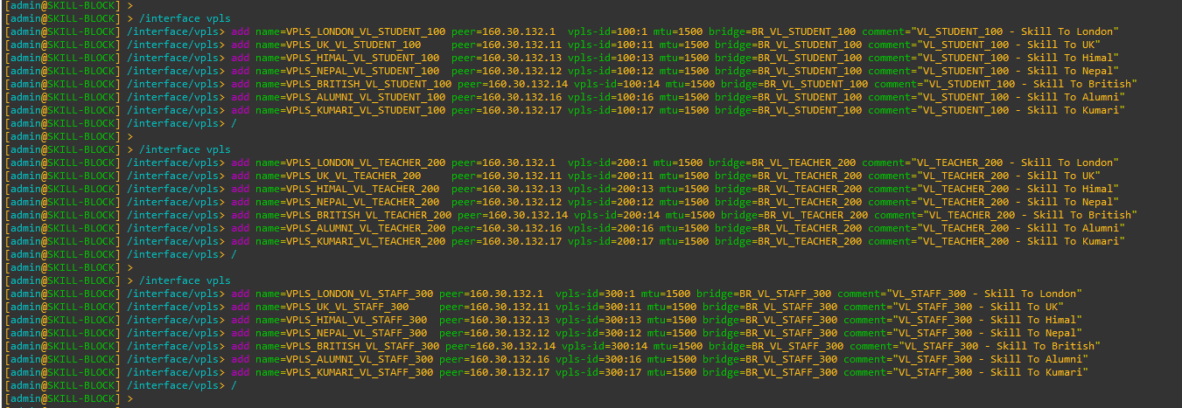

## ALUMNI-BLOCK

### Create VPLS BRIDGES (L2 DOMAINS)

CMD

|  |
| --- |
| /interface bridge  add name=BR_VL_STUDENT_100 protocol-mode=none comment=”VL_STUDENT_100 – VPLS Bridge”  add name=BR_VL_TEACHER_200 protocol-mode=none comment=”VL_TEACHER_200 – VPLS Bridge”  add name=BR_VL_STAFF_300 protocol-mode=none comment=”VL_STAFF_300 – VPLS Bridge”  / |

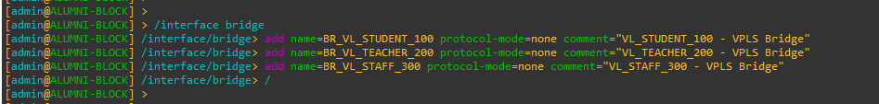

### VPLS Full-Mesh for ALUMNI-BLOCK

CMD

|  |
| --- |
| /interface vpls  add name=VPLS_LONDON_VL_STUDENT_100 peer=160.30.132.1 vpls-id=100:1 mtu=1500 bridge=BR_VL_STUDENT_100 comment="VL_STUDENT_100 - Alumni To London"  add name=VPLS_UK_VL_STUDENT_100 peer=160.30.132.11 vpls-id=100:11 mtu=1500 bridge=BR_VL_STUDENT_100 comment="VL_STUDENT_100 - Alumni To UK"  add name=VPLS_HIMAL_VL_STUDENT_100 peer=160.30.132.13 vpls-id=100:13 mtu=1500 bridge=BR_VL_STUDENT_100 comment="VL_STUDENT_100 - Alumni To Himal"  add name=VPLS_NEPAL_VL_STUDENT_100 peer=160.30.132.12 vpls-id=100:12 mtu=1500 bridge=BR_VL_STUDENT_100 comment="VL_STUDENT_100 - Alumni To Nepal"  add name=VPLS_BRITISH_VL_STUDENT_100 peer=160.30.132.14 vpls-id=100:14 mtu=1500 bridge=BR_VL_STUDENT_100 comment="VL_STUDENT_100 - Alumni To British"  add name=VPLS_SKILL_VL_STUDENT_100 peer=160.30.132.15 vpls-id=100:15 mtu=1500 bridge=BR_VL_STUDENT_100 comment="VL_STUDENT_100 - Alumni To Skill"  add name=VPLS_KUMARI_VL_STUDENT_100 peer=160.30.132.17 vpls-id=100:17 mtu=1500 bridge=BR_VL_STUDENT_100 comment="VL_STUDENT_100 - Alumni To Kumari"  /  /interface vpls  add name=VPLS_LONDON_VL_TEACHER_200 peer=160.30.132.1 vpls-id=200:1 mtu=1500 bridge=BR_VL_TEACHER_200 comment="VL_TEACHER_200 - Alumni To London"  add name=VPLS_UK_VL_TEACHER_200 peer=160.30.132.11 vpls-id=200:11 mtu=1500 bridge=BR_VL_TEACHER_200 comment="VL_TEACHER_200 - Alumni To UK"  add name=VPLS_HIMAL_VL_TEACHER_200 peer=160.30.132.13 vpls-id=200:13 mtu=1500 bridge=BR_VL_TEACHER_200 comment="VL_TEACHER_200 - Alumni To Himal"  add name=VPLS_NEPAL_VL_TEACHER_200 peer=160.30.132.12 vpls-id=200:12 mtu=1500 bridge=BR_VL_TEACHER_200 comment="VL_TEACHER_200 - Alumni To Nepal"  add name=VPLS_BRITISH_VL_TEACHER_200 peer=160.30.132.14 vpls-id=200:14 mtu=1500 bridge=BR_VL_TEACHER_200 comment="VL_TEACHER_200 - Alumni To British"  add name=VPLS_SKILL_VL_TEACHER_200 peer=160.30.132.15 vpls-id=200:15 mtu=1500 bridge=BR_VL_TEACHER_200 comment="VL_TEACHER_200 - Alumni To Skill"  add name=VPLS_KUMARI_VL_TEACHER_200 peer=160.30.132.17 vpls-id=200:17 mtu=1500 bridge=BR_VL_TEACHER_200 comment="VL_TEACHER_200 - Alumni To Kumari"  /  /interface vpls  add name=VPLS_LONDON_VL_STAFF_300 peer=160.30.132.1 vpls-id=300:1 mtu=1500 bridge=BR_VL_STAFF_300 comment="VL_STAFF_300 - Alumni To London"  add name=VPLS_UK_VL_STAFF_300 peer=160.30.132.11 vpls-id=300:11 mtu=1500 bridge=BR_VL_STAFF_300 comment="VL_STAFF_300 - Alumni To UK"  add name=VPLS_HIMAL_VL_STAFF_300 peer=160.30.132.13 vpls-id=300:13 mtu=1500 bridge=BR_VL_STAFF_300 comment="VL_STAFF_300 - Alumni To Himal"  add name=VPLS_NEPAL_VL_STAFF_300 peer=160.30.132.12 vpls-id=300:12 mtu=1500 bridge=BR_VL_STAFF_300 comment="VL_STAFF_300 - Alumni To Nepal"  add name=VPLS_BRITISH_VL_STAFF_300 peer=160.30.132.14 vpls-id=300:14 mtu=1500 bridge=BR_VL_STAFF_300 comment="VL_STAFF_300 - Alumni To British"  add name=VPLS_SKILL_VL_STAFF_300 peer=160.30.132.15 vpls-id=300:15 mtu=1500 bridge=BR_VL_STAFF_300 comment="VL_STAFF_300 - Alumni To Skill"  add name=VPLS_KUMARI_VL_STAFF_300 peer=160.30.132.17 vpls-id=300:17 mtu=1500 bridge=BR_VL_STAFF_300 comment="VL_STAFF_300 - Alumni To Kumari"  /  /interface vpls print  /interface bridge port print |

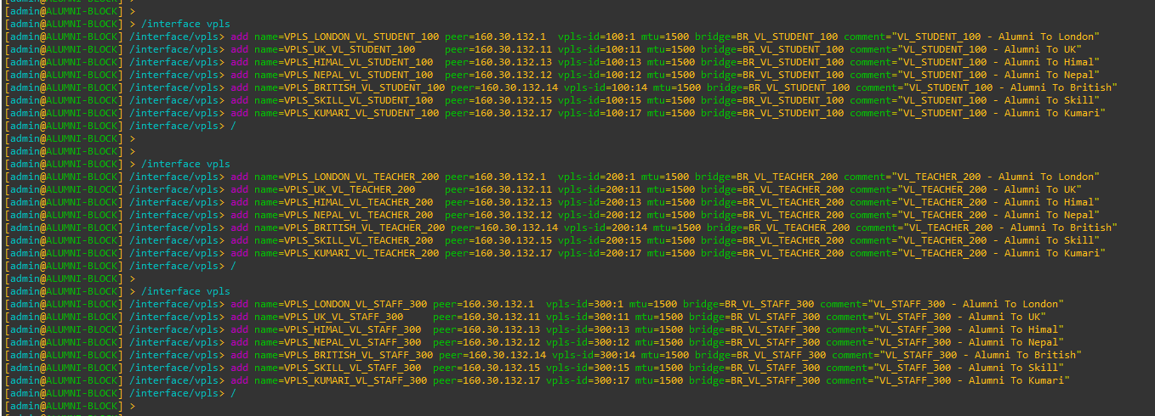

## KUMARI-BLOCK

### Create VPLS BRIDGES (L2 DOMAINS)

CMD

|  |
| --- |
| /interface bridge  add name=BR_VL_STUDENT_100 protocol-mode=none comment="VL_STUDENT_100 - VPLS Bridge"  add name=BR_VL_TEACHER_200 protocol-mode=none comment="VL_TEACHER_200 - VPLS Bridge"  add name=BR_VL_STAFF_300 protocol-mode=none comment="VL_STAFF_300 - VPLS Bridge"  / |

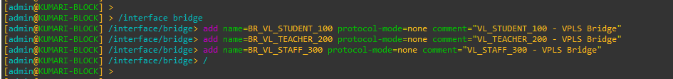

### VPLS Full-Mesh for KUMARI -BLOCK

CMD

|  |
| --- |
| /interface vpls  add name=VPLS_LONDON_VL_STUDENT_100 peer=160.30.132.1 vpls-id=100:1 mtu=1500 bridge=BR_VL_STUDENT_100 comment="VL_STUDENT_100 - Kumari To London"  add name=VPLS_UK_VL_STUDENT_100 peer=160.30.132.11 vpls-id=100:11 mtu=1500 bridge=BR_VL_STUDENT_100 comment="VL_STUDENT_100 - Kumari To UK"  add name=VPLS_HIMAL_VL_STUDENT_100 peer=160.30.132.13 vpls-id=100:13 mtu=1500 bridge=BR_VL_STUDENT_100 comment="VL_STUDENT_100 - Kumari To Himal"  add name=VPLS_NEPAL_VL_STUDENT_100 peer=160.30.132.12 vpls-id=100:12 mtu=1500 bridge=BR_VL_STUDENT_100 comment="VL_STUDENT_100 - Kumari To Nepal"  add name=VPLS_BRITISH_VL_STUDENT_100 peer=160.30.132.14 vpls-id=100:14 mtu=1500 bridge=BR_VL_STUDENT_100 comment="VL_STUDENT_100 - Kumari To British"  add name=VPLS_SKILL_VL_STUDENT_100 peer=160.30.132.15 vpls-id=100:15 mtu=1500 bridge=BR_VL_STUDENT_100 comment="VL_STUDENT_100 - Kumari To Skill"  add name=VPLS_ALUMNI_VL_STUDENT_100 peer=160.30.132.16 vpls-id=100:16 mtu=1500 bridge=BR_VL_STUDENT_100 comment="VL_STUDENT_100 - Kumari To Alumni"  /  /interface vpls  add name=VPLS_LONDON_VL_TEACHER_200 peer=160.30.132.1 vpls-id=200:1 mtu=1500 bridge=BR_VL_TEACHER_200 comment="VL_TEACHER_200 - Kumari To London"  add name=VPLS_UK_VL_TEACHER_200 peer=160.30.132.11 vpls-id=200:11 mtu=1500 bridge=BR_VL_TEACHER_200 comment="VL_TEACHER_200 - Kumari To UK"  add name=VPLS_HIMAL_VL_TEACHER_200 peer=160.30.132.13 vpls-id=200:13 mtu=1500 bridge=BR_VL_TEACHER_200 comment="VL_TEACHER_200 - Kumari To Himal"  add name=VPLS_NEPAL_VL_TEACHER_200 peer=160.30.132.12 vpls-id=200:12 mtu=1500 bridge=BR_VL_TEACHER_200 comment="VL_TEACHER_200 - Kumari To Nepal"  add name=VPLS_BRITISH_VL_TEACHER_200 peer=160.30.132.14 vpls-id=200:14 mtu=1500 bridge=BR_VL_TEACHER_200 comment="VL_TEACHER_200 - Kumari To British"  add name=VPLS_SKILL_VL_TEACHER_200 peer=160.30.132.15 vpls-id=200:15 mtu=1500 bridge=BR_VL_TEACHER_200 comment="VL_TEACHER_200 - Kumari To Skill"  add name=VPLS_ALUMNI_VL_TEACHER_200 peer=160.30.132.16 vpls-id=200:16 mtu=1500 bridge=BR_VL_TEACHER_200 comment="VL_TEACHER_200 - Kumari To Alumni"  /  /interface vpls  add name=VPLS_LONDON_VL_STAFF_300 peer=160.30.132.1 vpls-id=300:1 mtu=1500 bridge=BR_VL_STAFF_300 comment="VL_STAFF_300 - Kumari To London"  add name=VPLS_UK_VL_STAFF_300 peer=160.30.132.11 vpls-id=300:11 mtu=1500 bridge=BR_VL_STAFF_300 comment="VL_STAFF_300 - Kumari To UK"  add name=VPLS_HIMAL_VL_STAFF_300 peer=160.30.132.13 vpls-id=300:13 mtu=1500 bridge=BR_VL_STAFF_300 comment="VL_STAFF_300 - Kumari To Himal"  add name=VPLS_NEPAL_VL_STAFF_300 peer=160.30.132.12 vpls-id=300:12 mtu=1500 bridge=BR_VL_STAFF_300 comment="VL_STAFF_300 - Kumari To Nepal"  add name=VPLS_BRITISH_VL_STAFF_300 peer=160.30.132.14 vpls-id=300:14 mtu=1500 bridge=BR_VL_STAFF_300 comment="VL_STAFF_300 - Kumari To British"  add name=VPLS_SKILL_VL_STAFF_300 peer=160.30.132.15 vpls-id=300:15 mtu=1500 bridge=BR_VL_STAFF_300 comment="VL_STAFF_300 - Kumari To Skill"  add name=VPLS_ALUMNI_VL_STAFF_300 peer=160.30.132.16 vpls-id=300:16 mtu=1500 bridge=BR_VL_STAFF_300 comment="VL_STAFF_300 - Kumari To Alumni"  /  /interface vpls print  /interface bridge port print |

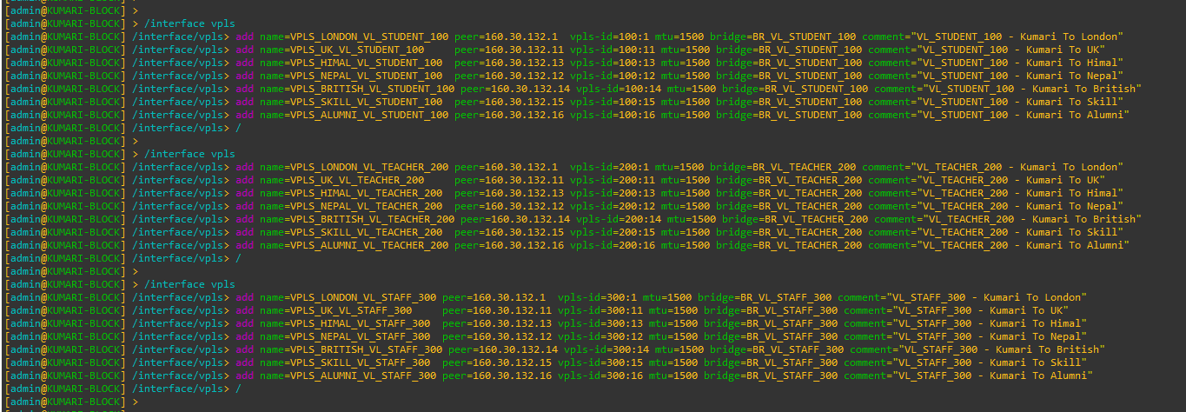

# Switch TO Router Configuration of Each Block

## LONDON-BLOCK

CMD

|  |
| --- |
| enable  configure terminal  hostname LONDON-BLOCK-SW  no ip domain-lookup  ip domain name isling-london-block-sw.com  crypto key generate rsa  1024  ip ssh version 2  line vty 0 15  transport input all  login local  exit  vlan 100  name STUDENTS  exit  vlan 200  name TEACHERS  exit  vlan 300  name STAFFS  exit  vlan 999  name MANAGEMENT-IP  exit  interface GigabitEthernet0/0  description TRUNK_to_LONDON_BLOCK_Router_P10  no shutdown  switchport trunk encapsulation dot1q  switchport mode trunk  switchport trunk allowed vlan 100,200,300,999  switchport trunk native vlan 999  spanning-tree guard root  exit  interface range GigabitEthernet0/1-3  no shutdown  switchport trunk encapsulation dot1q  switchport mode trunk  switchport trunk allowed vlan 100,200,300,999  switchport trunk native vlan 999  spanning-tree guard root  exit  interface range GigabitEthernet1/0-3  no shutdown  description STUDENTS  switchport mode access  switchport access vlan 100  spanning-tree portfast  spanning-tree bpduguard enable  exit  interface range GigabitEthernet2/0-3  no shutdown  description TEACHERS  switchport mode access  switchport access vlan 200  spanning-tree portfast  spanning-tree bpduguard enable  exit  interface range GigabitEthernet3/0-3  no shutdown  description STAFF  switchport mode access  switchport access vlan 300  spanning-tree portfast  spanning-tree bpduguard enable  exit  spanning-tree mode rapid-pvst  spanning-tree portfast default  do show interface description  do show interface gigabitEthernet0/0  do show interface gigabitEthernet0/1  do show interface trunk |

|  |  |
| --- | --- |
| Figure 113: Configuration of Switch to Router Links at LONDON-BLOCK (i) | Figure 114: Configuration of Switch to Router Links at LONDON-BLOCK (ii) |

## UK-BLOCK

CMD

|  |
| --- |
| enable  configure terminal  hostname UK-BLOCK-SW  no ip domain-lookup  ip domain name isling-uk-block-sw.com  crypto key generate rsa  1024  ip ssh version 2  line vty 0 15  transport input all  login local  exit  vlan 100  name STUDENTS  exit  vlan 200  name TEACHERS  exit  vlan 300  name STAFFS  exit  vlan 999  name MANAGEMENT-IP  exit  interface GigabitEthernet0/0  description TRUNK_to_UK_BLOCK_Router  no shutdown  switchport trunk encapsulation dot1q  switchport mode trunk  switchport trunk allowed vlan 100,200,300,999  switchport trunk native vlan 999  spanning-tree guard root  exit  interface GigabitEthernet0/1  description TRUNK_to_NEPAL_BLOCK_Router  no shutdown  switchport trunk encapsulation dot1q  switchport mode trunk  switchport trunk allowed vlan 100,200,300,999  switchport trunk native vlan 999  spanning-tree guard root  exit  interface range GigabitEthernet1/0-3  no shutdown  description STUDENTS  switchport mode access  switchport access vlan 100  spanning-tree portfast  spanning-tree bpduguard enable  exit  interface range GigabitEthernet2/0-3  no shutdown  description TEACHERS  switchport mode access  switchport access vlan 200  spanning-tree portfast  spanning-tree bpduguard enable  exit  interface range GigabitEthernet3/0-3  no shutdown  description STAFF  switchport mode access  switchport access vlan 300  spanning-tree portfast  spanning-tree bpduguard enable  exit  spanning-tree mode rapid-pvst  spanning-tree portfast default  do show interface description  do show interface gigabitEthernet0/0  do show interface gigabitEthernet0/1  do show interface trunk |

|  |  |
| --- | --- |
| Figure 115: Configuration of Switch to Router Links at UK-BLOCK (i) | Figure 116: Configuration of Switch to Router Links at UK-BLOCK (ii) |

## NEPAL-BLOCK

CMD

|  |
| --- |
| enable  configure terminal  hostname NEPAL-BLOCK-SW  no ip domain-lookup  ip domain name isling-nepal-block-sw.com  crypto key generate rsa  1024  ip ssh version 2  line vty 0 15  transport input all  login local  exit  vlan 100  name STUDENTS  exit  vlan 200  name TEACHERS  exit  vlan 300  name STAFFS  exit  vlan 999  name MANAGEMENT-IP  exit  interface GigabitEthernet0/0  description TRUNK_to_NEPAL_BLOCK_Router_P8  no shutdown  switchport trunk encapsulation dot1q  switchport mode trunk  switchport trunk allowed vlan 100,200,300,999  switchport trunk native vlan 999  spanning-tree guard root  exit  interface GigabitEthernet0/1  description TRUNK_to_BRIT_BLOCK_Router_p7  no shutdown  switchport trunk encapsulation dot1q  switchport mode trunk  switchport trunk allowed vlan 100,200,300,999  switchport trunk native vlan 999  spanning-tree guard root  exit  interface range GigabitEthernet1/0-3  no shutdown  description STUDENTS  switchport mode access  switchport access vlan 100  spanning-tree portfast  spanning-tree bpduguard enable  exit  interface range GigabitEthernet2/0-3  no shutdown  description TEACHERS  switchport mode access  switchport access vlan 200  spanning-tree portfast  spanning-tree bpduguard enable  exit  interface range GigabitEthernet3/0-3  no shutdown  description STAFF  switchport mode access  switchport access vlan 300  spanning-tree portfast  spanning-tree bpduguard enable  exit  spanning-tree mode rapid-pvst  spanning-tree portfast default  do show interface description  do show interface gigabitEthernet0/0  do show interface gigabitEthernet0/1  do show interface trunk |

|  |  |
| --- | --- |
| Figure 117: Configuration of Switch to Router Links at NEPAL-BLOCK (i) | Figure 118: Configuration of Switch to Router Links at NEPAL-BLOCK (ii) |

## HIMAL-BLOCK

CMD

|  |
| --- |
| enable  configure terminal  hostname HIMAL-BLOCK-SW  no ip domain-lookup  ip domain name isling-himal-block-sw.com  crypto key generate rsa  1024  ip ssh version 2  line vty 0 15  transport input all  login local  exit  vlan 100  name STUDENTS  exit  vlan 200  name TEACHERS  exit  vlan 300  name STAFFS  exit  vlan 999  name MANAGEMENT-IP  exit  interface GigabitEthernet0/0  description TRUNK_to_HIMAL_BLOCK_Router_P8  no shutdown  switchport trunk encapsulation dot1q  switchport mode trunk  switchport trunk allowed vlan 100,200,300,999  switchport trunk native vlan 999  spanning-tree guard root  exit  interface GigabitEthernet0/1  description TRUNK_to_UK_BLOCK_Router_p7  no shutdown  switchport trunk encapsulation dot1q  switchport mode trunk  switchport trunk allowed vlan 100,200,300,999  switchport trunk native vlan 999  spanning-tree guard root  exit  interface range GigabitEthernet1/0-3  no shutdown  description STUDENTS  switchport mode access  switchport access vlan 100  spanning-tree portfast  spanning-tree bpduguard enable  exit  interface range GigabitEthernet2/0-3  no shutdown  description TEACHERS  switchport mode access  switchport access vlan 200  spanning-tree portfast  spanning-tree bpduguard enable  exit  interface range GigabitEthernet3/0-3  no shutdown  description STAFF  switchport mode access  switchport access vlan 300  spanning-tree portfast  spanning-tree bpduguard enable  exit  spanning-tree mode rapid-pvst  spanning-tree portfast default  do show interface description  do show interface gigabitEthernet0/0  do show interface gigabitEthernet0/1  do show interface trunk |

|  |  |
| --- | --- |
| Figure 119: Configuration of Switch to Router Links at HIMAL-BLOCK (i) | Figure 120: Configuration of Switch to Router Links at HIMAL-BLOCK (ii) |

## BRIT-BLOCK

CMD

|  |
| --- |
| enable  configure terminal  hostname BRIT-BLOCK-SW  no ip domain-lookup  ip domain name isling-brit-block-sw.com  crypto key generate rsa  1024  ip ssh version 2  line vty 0 15  transport input all  login local  exit  vlan 100  name STUDENTS  exit  vlan 200  name TEACHERS  exit  vlan 300  name STAFFS  exit  vlan 999  name MANAGEMENT-IP  exit  interface GigabitEthernet0/0  description TRUNK_to_BRIT_BLOCK_Router_P8  no shutdown  switchport trunk encapsulation dot1q  switchport mode trunk  switchport trunk allowed vlan 100,200,300,999  switchport trunk native vlan 999  spanning-tree guard root  exit  interface GigabitEthernet0/1  description TRUNK_to_KUMARI_BLOCK_Router_p6  no shutdown  switchport trunk encapsulation dot1q  switchport mode trunk  switchport trunk allowed vlan 100,200,300,999  switchport trunk native vlan 999  spanning-tree guard root  exit  interface range GigabitEthernet1/0-3  no shutdown  description STUDENTS  switchport mode access  switchport access vlan 100  spanning-tree portfast  spanning-tree bpduguard enable  exit  interface range GigabitEthernet2/0-3  no shutdown  description TEACHERS  switchport mode access  switchport access vlan 200  spanning-tree portfast  spanning-tree bpduguard enable  exit  interface range GigabitEthernet3/0-3  no shutdown  description STAFF  switchport mode access  switchport access vlan 300  spanning-tree portfast  spanning-tree bpduguard enable  exit  spanning-tree mode rapid-pvst  spanning-tree portfast default  do show interface description  do show interface gigabitEthernet0/0  do show interface gigabitEthernet0/1  do show interface trunk |

|  |  |
| --- | --- |
| Figure 121: Configuration of Switch to Router Links at BRIT-BLOCK (i) | Figure 122: Configuration of Switch to Router Links at BRIT-BLOCK (ii) |

## SKILL-BLOCK

CMD

|  |
| --- |
| enable  configure terminal  hostname SKILL-BLOCK-SW  no ip domain-lookup  ip domain name isling-skill-block-sw.com  crypto key generate rsa  1024  ip ssh version 2  line vty 0 15  transport input all  login local  exit  vlan 100  name STUDENTS  exit  vlan 200  name TEACHERS  exit  vlan 300  name STAFFS  exit  vlan 999  name MANAGEMENT-IP  exit  interface GigabitEthernet0/0  description TRUNK_to_SKILL_BLOCK_Router_P8  no shutdown  switchport trunk encapsulation dot1q  switchport mode trunk  switchport trunk allowed vlan 100,200,300,999  switchport trunk native vlan 999  spanning-tree guard root  exit  interface GigabitEthernet0/1  description TRUNK_to_HIMAL_BLOCK_Router_p7  no shutdown  switchport trunk encapsulation dot1q  switchport mode trunk  switchport trunk allowed vlan 100,200,300,999  switchport trunk native vlan 999  spanning-tree guard root  exit  interface range GigabitEthernet1/0-3  no shutdown  description STUDENTS  switchport mode access  switchport access vlan 100  spanning-tree portfast  spanning-tree bpduguard enable  exit  interface range GigabitEthernet2/0-3  no shutdown  description TEACHERS  switchport mode access  switchport access vlan 200  spanning-tree portfast  spanning-tree bpduguard enable  exit  interface range GigabitEthernet3/0-3  no shutdown  description STAFF  switchport mode access  switchport access vlan 300  spanning-tree portfast  spanning-tree bpduguard enable  exit  spanning-tree mode rapid-pvst  spanning-tree portfast default  do show interface description  do show interface gigabitEthernet0/0  do show interface gigabitEthernet0/1  do show interface trunk |

|  |  |
| --- | --- |
| Figure 123: Configuration of Switch to Router Links at SKILL-BLOCK (i) | Figure 124: Configuration of Switch to Router Links at SKILL-BLOCK (ii) |

## ALUMNI-BLOCK

CMD

|  |
| --- |
| ip ssh version 2  line vty 0 15  transport input all  login local  exit  vlan 100  name STUDENTS  exit  vlan 200  name TEACHERS  exit  vlan 300  name STAFFS  exit  vlan 999  name MANAGEMENT-IP  exit  interface GigabitEthernet0/0  description TRUNK_to_ALUMNI_BLOCK_Router_P8  no shutdown  switchport trunk encapsulation dot1q  switchport mode trunk  switchport trunk allowed vlan 100,200,300,999  switchport trunk native vlan 999  spanning-tree guard root  exit  interface GigabitEthernet0/1  description TRUNK_to_SKILL_BLOCK_Router_p7  no shutdown  switchport trunk encapsulation dot1q  switchport mode trunk  switchport trunk allowed vlan 100,200,300,999  switchport trunk native vlan 999  spanning-tree guard root  exit  interface range GigabitEthernet1/0-3  no shutdown  description STUDENTS  switchport mode access  switchport access vlan 100  spanning-tree portfast  spanning-tree bpduguard enable  exit  interface range GigabitEthernet2/0-3  no shutdown  description TEACHERS  switchport mode access  switchport access vlan 200  spanning-tree portfast  spanning-tree bpduguard enable  exit  interface range GigabitEthernet3/0-3  no shutdown  description STAFF  switchport mode access  switchport access vlan 300  spanning-tree portfast  spanning-tree bpduguard enable  exit  spanning-tree mode rapid-pvst  spanning-tree portfast default  do show interface description  do show interface gigabitEthernet0/0  do show interface gigabitEthernet0/1  do show interface trunk |

|  |  |
| --- | --- |
| Figure 125: Configuration of Switch to Router Links at ALUMNI-BLOCK (i) | Figure 126: Configuration of Switch to Router Links at ALUMNI-BLOCK (ii) |

## KUMARI-BLOCK

CMD

|  |
| --- |
| enable  configure terminal  hostname KUMARI-BLOCK-SW  no ip domain-lookup  ip domain name isling-kumari-block-sw.com  crypto key generate rsa  1024  ip ssh version 2  line vty 0 15  transport input all  login local  exit  vlan 100  name STUDENTS  exit  vlan 200  name TEACHERS  exit  vlan 300  name STAFFS  exit  vlan 999  name MANAGEMENT-IP  exit  interface GigabitEthernet0/0  description TRUNK_to_KUMARI_BLOCK_Router_P7  no shutdown  switchport trunk encapsulation dot1q  switchport mode trunk  switchport trunk allowed vlan 100,200,300,999  switchport trunk native vlan 999  spanning-tree guard root  exit  interface GigabitEthernet0/1  description TRUNK_to_ALUMNI_BLOCK_Router_p6  no shutdown  switchport trunk encapsulation dot1q  switchport mode trunk  switchport trunk allowed vlan 100,200,300,999  switchport trunk native vlan 999  spanning-tree guard root  exit  interface range GigabitEthernet1/0-3  no shutdown  description STUDENTS  switchport mode access  switchport access vlan 100  spanning-tree portfast  spanning-tree bpduguard enable  exit  interface range GigabitEthernet2/0-3  no shutdown  description TEACHERS  switchport mode access  switchport access vlan 200  spanning-tree portfast  spanning-tree bpduguard enable  exit  interface range GigabitEthernet3/0-3  no shutdown  description STAFF  switchport mode access  switchport access vlan 300  spanning-tree portfast  spanning-tree bpduguard enable  exit  spanning-tree mode rapid-pvst  spanning-tree portfast default  do show interface description  do show interface gigabitEthernet0/0  do show interface gigabitEthernet0/1  do show interface trunk |

|  |  |
| --- | --- |
| Figure 127: Configuration of Switch to Router Links at KUMARI-BLOCK (i) | Figure 128: Configuration of Switch to Router Links at KUMARI-BLOCK (ii) |

# Router TO Switch Configuration of Each Block

## LONDON-BLOCK

## UK-BLOCK

### UK-BLOCK (VLAN 100 ACTIVE HERE)

|  |
| --- |
| # Create VLAN subinterfaces on trunk port (to UK switch)  /interface vlan  add name=UK-SW.v100 interface=ether8 vlan-id=100 comment="UK-BLOCK trunk to UK switch - VLAN 100 STUDENT"  add name=UK-SW.v200 interface=ether8 vlan-id=200 comment="UK-BLOCK trunk to UK switch - VLAN 200 TEACHER"  add name=UK-SW.v300 interface=ether8 vlan-id=300 comment="UK-BLOCK trunk to UK switch - VLAN 300 STAFF"  # Add VLANs into correct VPLS bridges  /interface bridge port  add bridge=BR_VL_STUDENT_100 interface=UK-SW.v100 comment="UK-BLOCK VLAN100 to VPLS STUDENT bridge"  add bridge=BR_VL_TEACHER_200 interface=UK-SW.v200 comment="UK-BLOCK VLAN200 to VPLS TEACHER bridge"  add bridge=BR_VL_STAFF_300 interface=UK-SW.v300 comment="UK-BLOCK VLAN300 to VPLS STAFF bridge"  # STP priorities (UK preferred for VLAN 100)  /interface bridge  set BR_VL_STUDENT_100 protocol-mode=rstp priority=0x1000 comment="UK-BLOCK ROOT for VLAN100 STUDENT"  set BR_VL_TEACHER_200 protocol-mode=rstp priority=0x8000 comment="UK-BLOCK SECONDARY for VLAN200 TEACHER"  set BR_VL_STAFF_300 protocol-mode=rstp priority=0x8000 comment="UK-BLOCK SECONDARY for VLAN300 STAFF" |

### NEPAL-BLOCK (VLAN 200 & 300 ACTIVE HERE)

|  |
| --- |
| # Create VLAN subinterfaces on trunk port (to UK switch)  /interface vlan  add name=NP-SW.v100 interface=ether7 vlan-id=100 comment="NEPAL-BLOCK trunk to UK switch - VLAN 100 STUDENT"  add name=NP-SW.v200 interface=ether7 vlan-id=200 comment="NEPAL-BLOCK trunk to UK switch - VLAN 200 TEACHER"  add name=NP-SW.v300 interface=ether7 vlan-id=300 comment="NEPAL-BLOCK trunk to UK switch - VLAN 300 STAFF"  # Add VLANs into correct VPLS bridges  /interface bridge port  add bridge=BR_VL_STUDENT_100 interface=NP-SW.v100 comment="NEPAL-BLOCK VLAN100 to VPLS STUDENT bridge"  add bridge=BR_VL_TEACHER_200 interface=NP-SW.v200 comment="NEPAL-BLOCK VLAN200 to VPLS TEACHER bridge"  add bridge=BR_VL_STAFF_300 interface=NP-SW.v300 comment="NEPAL-BLOCK VLAN300 to VPLS STAFF bridge"  # STP priorities (NEPAL preferred for VLAN 200 & 300)  /interface bridge  set BR_VL_STUDENT_100 protocol-mode=rstp priority=0x8000 comment="NEPAL-BLOCK SECONDARY for VLAN100 STUDENT"  set BR_VL_TEACHER_200 protocol-mode=rstp priority=0x1000 comment="NEPAL-BLOCK ROOT for VLAN200 TEACHER"  set BR_VL_STAFF_300 protocol-mode=rstp priority=0x1000 comment="NEPAL-BLOCK ROOT for VLAN300 STAFF" |

## NEPAL-BLOCK

## HIMAL-BLOCK

## BRIT-BLOCK

## SKILL-BLOCK

## ALUMNI-BLOCK

## KUMARI-BLOCK

# Centralized DHCP Server Configuration

## LONDON-BLOCK

## UK-BLOCK

## NEPAL-BLOCK

## HIMAL-BLOCK

## BRIT-BLOCK

## SKILL-BLOCK

## ALUMNI-BLOCK

## KUMARI-BLOCK

# Redundancy and Load Balancing

## LONDON-BLOCK

## UK-BLOCK

## NEPAL-BLOCK

## HIMAL-BLOCK

## BRIT-BLOCK

## SKILL-BLOCK

## ALUMNI-BLOCK

## KUMARI-BLOCK

# End-to-End Verification and Traffic Analysis

## LONDON-BLOCK

## UK-BLOCK

## NEPAL-BLOCK

## HIMAL-BLOCK

## BRIT-BLOCK

## SKILL-BLOCK

## ALUMNI-BLOCK

## KUMARI-BLOCK

# Network Topology and Diagrams

## Full Network Topology Diagram

## MPLS LSP Paths Illustration

## VPLS VLAN Extension Diagram

# Troubleshooting Guide

## Common OSPF Issues

## MPLS / LDP Problems

## VPLS VLAN Bridging Errors

## DHCP Failures

## ECMP / Load Balancing Verification Tips

# Security and Access Control

## Management Access (SSH / Winbox)

## ACLs / Firewall Rules for Router Interfaces

# 

# Conclusion and Future Enhancements

# a